|  |  |  |
| --- | --- | --- |
|  | **10th International Conference on Short and Medium Span Bridges**  **Quebec City, Quebec, Canada,**  **July 31 – August 3, 2018** |  |

DETERIORATION OF GLASS FIBER REINFORCED POLUMER (gfrp) BARS IN CONCRETE ENVIRONMENT

Paulina Arczewska1,2

1 Wood PLC.

2 [paulina.arczewska@woodplc.com](mailto:paulina.arczewska@woodplc.com%20)

**Abstract:** The high cost of reinforced concrete (RC) structures rehabilitation results in the increased utilization of non-metallic reinforcement. Composite bars, contrary to conventional steel, when used in structures exposed to aggressive environments can significantly increase their durability and lifetime. However, the use of GFRP bars in concrete structures is still limited due to unspecified durability properties of this relatively new material. Thus, an influence of environment on composite bars properties is of great interest in the effective design of structures with non-metallic reinforcement. Since long-term durability data are not readily available, accelerated aging tests have been used in this research to study GFRP bar degradation. To predict the long-term behavior or service lifetime of a material using results from accelerated aging tests, statistical or analytical models must be employed. In this research, a model developed by Davalos et al. (2011) was applied to study GFRP bar durability. The main objectives of this study are focused on GFRP bars tensile, shear and flexure strength durability. The test results show that the high pH of the concrete pore water has an adverse influence on GFRP bars properties.

# **INTRODUCTION**

Aging of reinforced concrete (RC) structures, especially the steel corrosion and expenses related to structural rehabilitation, results in an increased utilization of non-metallic reinforcement. Glass Fiber Reinforced Polymer (GFRP) bars, due to their relatively low cost (when compared to competitors) and good durability, have become a popular alternative to conventional steel reinforcement in structures where steel corrosion is a substantial issue. Composite bars have already been utilized in several reinforced concrete structures, especially bridges were de-icing chemicals significantly increase the deterioration rate of elements exposed to aggressive environment. In many bridges in Ontario GFRP bars were used as a reinforcement in parapet/barrier walls, sidewalks/medians and decks. As for example Luis St Laurent Twin Bridges in Milton, Ontario (Figure 1) designed by Wood PLC in 2009/2017 (former Amec Foster Wheeler) or Hwy 7/Hwy 400 Overpass (Figure 2) designed by Wood PLC in 2017.

Regardless many benefits of this relatively new material, widespread utilization of GFRP reinforcement is partially impeded by the relative uncertainty about bars’ long-term properties. Thus, the influence of environment on composite bar properties is of great interest in the effective design of structures with non-metallic reinforcements. Since the function of GFRP bars is not only to carry tensile stresses, degradation of different bar properties should be investigated. Thus, the main objectives of this study are focused on GFRP bar tensile and shear strength durability.

Since long-term (75 to 100 years) performance data for GFRP materials is not available, accelerated tests are used to predict GFRP materials durability in practice. The accelerated tests shorten the degradation process by using accelerating factors and short-term measurements to predict long-term behavior (Bank et al. 2003, Benmokrane et al. 2017). Typical accelerating factors are mechanical load, voltage, temperature, weathering and the use of high concentration chemical environments (Nelson, 1990). Since the degradation rate of GFRP materials depends mostly on diffusion and chemical reaction, to speed the degradation process, two accelerating factors were used: chemical environment and temperature. To predict the lifetime of a material using results from accelerated tests, statistical or analytical model needs be employed. In this research, a model developed by Davalos et al. (2011) was applied to study GFRP bar durability. The program is aimed at investigating the tensile, shear and flexure long-term properties. Tests of non-degraded bars were performed by Arczewska et al. (2017) and the results of this testing are used as ‘control data’ for this study.

a)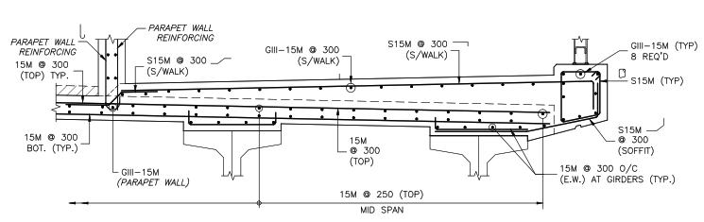

b) 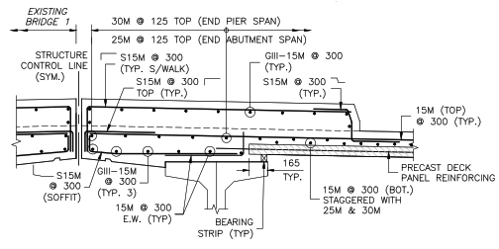

c) 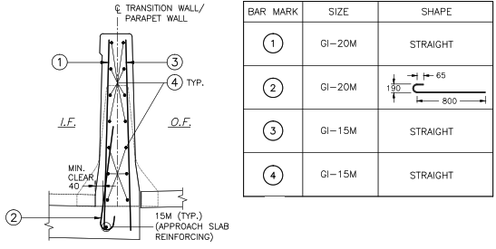

Figure 1: GFRP bars in a) sidewalk, b) median and c) parapet wall – Luis St Lauren Twin Bridge in Milton, Ontario

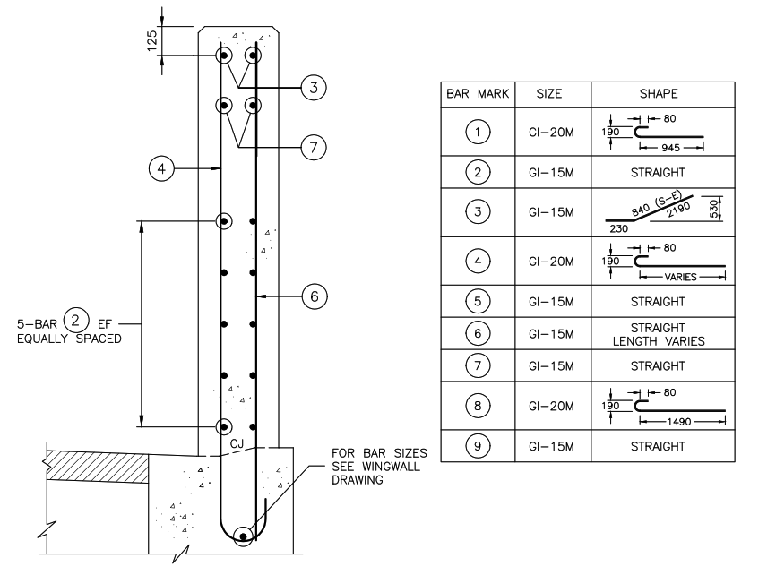

Figure 2: GFRP bars in parapet wall – Hwy 7/Hwy 400 Overpass Vaughan, Ontario

# **EXPERYMENTAL STUDY**

## **Material description**

The specimens for this study were provided by a major GFRP bar manufacturer in Canada. All GFRP bar specimens were straight; however, some bars were manufactured via strait bar manufacturing (pultrusion) whereas some were obtained from the straight portion of bent bars (Figure 3). Two different nominal bar diameters were used: 12 mm and 16 mm bars. The bent bars were manufactured in a custom-made system specific for the manufacturer. The material characteristics of all bar specimens as specified by the supplier are shown in Table 1.

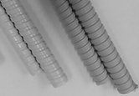

Bent

Straight

Figure 3: Straight and bent bars

Table 1: Nominal physical and mechanical properties of GFRP bars

|  |  |  |  |
| --- | --- | --- | --- |
| Straight bars | | | |
| Properties | Size | | units |
| M12 | M16 |
| Nominal bar diameter | 12 | 16 | mm |
| Nominal cross - section area | 113 | 201 | mm2 |
| Tensile strain | 2.61 | 2.61 | % |
| Ultimate tensile strength | 1000 | 1000 | MPa |
| Modulus of elasticity | 60 | 60 | GPa |
| Glass fiber content (by weight) | >85 | >85 | % |
| Glass transition temperature | >110 | >110 | °C |
| Bent bars | | | |
| Nominal bar diameter | 12 | 16 | mm |
| Ultimate tensile strength (straight portion) | 1000 | 900 | MPa |
| Ultimate tensile strength (bent portion) | 700 | 550 | MPa |
| Modulus of elasticity | >50 | >50 | GPa |
| Glass fiber content (by volume) | >65 | >65 | % |
| Glass transition temperature | >110 | >110 | °C |

## **Testing procedure**

The alkaline immersion test has been chosen as an accelerated aging test. Testing methodology used in this research followed the CSA S806-12 (CSA 2012) standard Annex M. Temperature was chosen as the accelerating factor. The alkaline bath with approximately 13 pH was considered as an equivalent to the concrete environment. Investigation of GFRP bar property deterioration was conducted at 50°, 60° and 70°C. The duration of the alkaline immersion test for each temperature was 1, 3 and 5 months. Tensile, shear and flexure test strengths were chosen as durability indicators. After each immersion period, bars were taken out of the alkaline environment and individual property retention was investigated within 24 hours after removal from the conditioning.

Tensile tests were performed according to Annex C of CSA S806-12 (CSA 2012). Specimens were fitted with steel DOM tubes at each end and attached to the testing machine by an anchorage device, which assures pure tensile stress. Shear tests were performed according to Annex L of CSA S806-12 (CSA 2012), and following Gentry (2011). Double shear was applied to each specimen using a specially manufactured shear test device. The flexure tests were performed accordingly to ASTM D4476 (ASTM 2012), in a three-point bending machine setup. To assure the tensile failure of the outer fibers of GFRP bar a less than semi-circular cross-section of the samples were used. A minimum of five repetitions were performed for each test case (Arczewska et al. 2017).

# **RESULTS AND DISCUSSION**

## **Alkaline immersion test results**

The direct results from GFRP bar tensile, shear and flexure property deterioration tests are shown below in Table 2, Table 3 and Table 4 for all three temperatures. The graphical interpretation of the results is presented in Figure 4 just for tensile strength retention, as an example. Based on direct results from the alkaline immersion test it can be noticed that the high pH solution has an adverse influence on GFRP bar properties and the speed of property deterioration increases with the increase of temperature. In the case of the all tests, smaller diameter bars deteriorate faster than larger diameter bars. It is a common observation for all bar types and tests the strength directly depends on the bar diameter. This phenomenon is caused by the ratio of a degraded to an un-degraded area of the bar, which is higher for smaller bars.

Table 2: Tensile strength deterioration for SB bars

|  |  |  |  |  |  |  |  |  |  |  |  |  |  |
| --- | --- | --- | --- | --- | --- | --- | --- | --- | --- | --- | --- | --- | --- |
| Temp. |  | Ultimate capacity [kN] | | | | Strength degradation [MPa] | | | | Strength retention [%] | | | |
|  | Time [days] | 0 | 30 | 90 | 150 | 0 | 30 | 90 | 150 | 0 | 30 | 90 | 150 |
| 50 °C | SB M12 | 138 | 134 | 131 | 130 | 1223 | 1186 | 1167 | 1157 | 100 | 96.9 | 95.4 | 94.6 |
| SB M16 | 255 | 252 | 249 | 248 | 1270 | 1253 | 1240 | 1235 | 100 | 98.7 | 97.6 | 97.2 |
| 60 °C | SB M12 | 138 | 131 | 127 | 124 | 1223 | 1158 | 1122 | 1097 | 100 | 94.7 | 91.8 | 89.7 |
| SB M16 | 255 | 247 | 241 | 237 | 1270 | 1229 | 1199 | 1181 | 100 | 96.8 | 94.4 | 93 |
| 70 °C | SB M12 | 138 | 130 | 120 | 113 | 1223 | 1148 | 1059 | 1004 | 100 | 93.9 | 86.6 | 82.1 |
| SB M16 | 255 | 243 | 228 | 220 | 1270 | 1209 | 1136 | 1098 | 100 | 95.2 | 89.5 | 86.4 |

Table 3: Shear strength deterioration

|  |  |  |  |  |  |  |  |  |  |  |  |  |  |
| --- | --- | --- | --- | --- | --- | --- | --- | --- | --- | --- | --- | --- | --- |
| Temp. |  | Ultimate capacity [kN] | | | | Strength degradation [MPa] | | | | Strength retention [%] | | | |
|  | Time [days] | 0 | 30 | 90 | 150 | 0 | 30 | 90 | 150 | 0 | 30 | 90 | 150 |
| 50 °C | SB M12 | 50 | 48.5 | 47.5 | 47 | 221 | 214 | 210 | 208 | 100 | 97.1 | 95.2 | 94.5 |
| SB M16 | 84 | 83 | 81.5 | 81 | 210 | 206 | 203 | 201 | 100 | 97.9 | 96.4 | 95.5 |
| BB M12 | 65 | 63 | 62 | 61 | 289 | 280 | 274 | 270 | 100 | 96.8 | 94.7 | 93.4 |
| BB M16 | 112 | 110 | 108 | 106 | 280 | 273 | 267 | 264 | 100 | 97.4 | 95.3 | 94.1 |
| 60 °C | SB M12 | 50 | 47 | 46 | 45 | 221 | 208 | 202 | 199 | 100 | 94.5 | 91.7 | 90.4 |
| SB M16 | 84 | 81 | 79 | 78 | 210 | 201 | 196 | 193 | 100 | 95.6 | 93.1 | 92.0 |
| BB M12 | 65 | 62 | 61 | 60 | 289 | 275 | 268 | 262 | 100 | 94.9 | 92.7 | 90.5 |
| BB M16 | 112 | 109 | 106 | 104 | 280 | 270 | 264 | 259 | 100 | 96.2 | 94.0 | 92.3 |
| 70 °C | SB M12 | 50 | 46 | 43 | 41 | 221 | 203 | 188 | 183 | 100 | 91.9 | 85.4 | 83.1 |
| SB M16 | 84 | 79 | 76 | 74 | 210 | 197 | 189 | 184 | 100 | 93.7 | 89.8 | 87.5 |
| BB M12 | 65 | 61 | 58 | 57 | 289 | 270 | 257 | 251 | 100 | 93.5 | 88.9 | 86.9 |
| BB M16 | 112 | 107 | 102 | 99 | 280 | 267 | 255 | 247 | 100 | 95.2 | 90.9 | 88.1 |

Table 4: Flexure strength deterioration

|  |  |  |  |  |  |  |  |  |  |
| --- | --- | --- | --- | --- | --- | --- | --- | --- | --- |
| Temp. |  | Strength degradation [MPa] | | | | Strength retention [%] | | | |
|  | Time [days] | 0 | 30 | 90 | 150 | 0 | 30 | 90 | 150 |
| 50 °C | SB M12 | 1927 | 1851 | 1818 | 1779 | 100 | 96.1 | 94.4 | 92.3 |
| SB M16 | 1836 | 1791 | 1756 | 1725 | 100 | 97.5 | 95.7 | 94.0 |
| BB M12 | 1684 | 1603 | 1564 | 1517 | 100 | 95.2 | 92.9 | 90.1 |
| BB M16 | 1572 | 1523 | 1476 | 1444 | 100 | 96.9 | 93.9 | 91.8 |
| 60 °C | SB M12 | 1927 | 1796 | 1709 | 1665 | 100 | 93.2 | 88.7 | 86.4 |
| SB M16 | 1836 | 1737 | 1672 | 1648 | 100 | 94.6 | 91.1 | 89.8 |
| BB M12 | 1684 | 1573 | 1499 | 1431 | 100 | 93.4 | 89.0 | 84.9 |
| BB M16 | 1572 | 1485 | 1432 | 1395 | 100 | 94.4 | 91.1 | 88.7 |
| 70 °C | SB M12 | 1927 | 1720 | 1607 | 1518 | 100 | 89.3 | 83.4 | 78.8 |
| SB M16 | 1836 | 1666 | 1553 | 1490 | 100 | 90.8 | 84.6 | 81.2 |
| BB M12 | 1684 | 1497 | 1359 | 1316 | 100 | 88.9 | 80.7 | 78.2 |
| BB M16 | 1572 | 1429 | 1317 | 1272 | 100 | 90.9 | 83.8 | 80.9 |

Figure 4: Tensile strength retention

## **GFRP bars Long-term durability**

The test results presented above represent only bar property deterioration after an alkaline immersion test. To obtain GFRP bar long-term behaviour from these results, an appropriate strength prediction model should be employed. In this research, a model developed by Davalos et al. (2011) was applied to study GFRP bar durability. The procedure described below is using the test data obtained from the tensile testing of SB. Same procedures are employed subsequently for shear strength predictions for both SB and BB.

[1] $Y=100{\left(1-\frac{\int_{0}^{t}{fdt}}{r_{0}}\right)}^{2}= 100{\left(1-\frac{{βt}^{α+1}}{\left(α+1\right)r_{0}}\right)}^{2}= 100{\left(1-{jt}^{α+1}\right)}^{2}$

[2] $f=βt^{α}$

were $Y$ is property retention, $r_{0}$ is bar radius, $t$ is time, $j$ is a temperature factor.

The temperature factor “j” introduced in Eq.1 is, in fact, a combination of the integration product directly correlated with the constant rate “β”, and the radius of the bar. Thus, Eq.1 takes the form (Eq.3):

[3] $Y=100{\left(1-\frac{\int_{0}^{t}{fdt}}{r_{0}}\right)}^{2}=100{\left(1-\frac{{βt}^{-0.5+1}}{\left(-0.5+1\right)r_{0}}\right)}^{2}=100{\left(1-\frac{{2βt}^{0.5}}{r_{0}}\right)}^{2}$

Parameter “β” was determined by curve fitting to the data points obtained from the alkaline immersion test, with a coefficient of correlation greater than 0.8. The rate parameter “β” and the correlation coefficient for three different temperatures (50˚C, 60˚C, and 70˚C) are reported in Table 5.

Table 5: Rate constant “β”

|  |  |  |  |
| --- | --- | --- | --- |
| Temperature | β[mm/s] | R2 for M12 | R2 for M16 |
| 50˚C | 7.87 * (10-8) | 0.83 | 0.82 |
| 60˚C | 1.562 * (10-7) | 0.97 | 0.93 |
| 70˚C | 2.315 * (10-7) | 0.89 | 0.92 |

The tensile strength retention curves calculated from Equation 3 and the data points from alkaline immersion test are now plotted in Figure 5.

It can be concluded that because the standard error of the regression for all curves is less than 1.5, the strength retention models represent the data with sufficient accuracy and can be used for further investigation.

Figure 5: Tensile strength retention a) SB M12, b) SB M6 bars

The time to reach a specific strength retention (Table 6) at different temperatures can be approximately calculated through Eq.5 after a transformation of Eq.4:

[4] $t={\left(\frac{1-\sqrt{\frac{Y}{100}} x r_{0}}{2β}\right)}^{2}$

Table 6: Required time in alkaline solution bath to reach specific tensile strength retention

|  |  |  |  |  |  |  |
| --- | --- | --- | --- | --- | --- | --- |
| Retention | SB M12 - 50 | SB M12 - 60 | SB M12 - 70 | SB M16 - 50 | SB M16 - 60 | SB M16 - 70 |
| Time to reach specific retention [days] | | | | | |
| 95 | 124.79 | 31.66 | 14.43 | 221.84 | 56.29 | 25.65 |
| 85 | 1185.55 | 300.80 | 137.05 | 2107.65 | 534.75 | 243.64 |
| 75 | 3493.57 | 886.38 | 403.86 | 6210.79 | 1575.79 | 717.97 |

The next step is to use the data obtained from the GFRP bar strength retention in the Arrhenius relationship Eq. 5.

[5] $k=Aexp\left(\frac{{-E}_{a}}{RT}\right)$

Where: $k$- the Arrhenius degradation rate constant; $E_{a}$- the activation energy; $R$- universal gas constant (8.3145 J/K/mol); $T$- temperature in K; $A$- constant base on test conditions

From Eq.5, it can be further observed that the logarithm of inverse time is a linear function with slope of ($\frac{E_{a}}{R}$). The Arrhenius plot of the logarithm of reaction rate vs the inverse of immersion temperature (in K) is shown on Figure 6.

Figure 6: Arrhenius plot for a) M12 and b) M16 bars

Analyzing Figure 6 it can be noticed that the regression lines in the Arrhenius plots for different strength retentions are nearly parallel to each other. The calculated coefficient of determination (R2) for all regression lines is close to 1 (Table 7), and the slopes of the lines are equal to ($\frac{E_{a}}{R}$). This implies that the Arrhenius model can be used to describe the degradation rate of the GFRP bars, as the degradation mechanism of the model does not seem to change with temperature or time during the alkaline immersion. Thus, the model can be successfully used to describe the GFRP bar long-term durability.

Table 7: Slope $\left(\frac{E_{a}}{R}\right)$ and correlation coefficient

|  |  |  |  |  |
| --- | --- | --- | --- | --- |
| Temperature | $\left(\frac{E_{a}}{R}\right)$ for M12 | R2 for M12 | for M16 | R2 for M16 |
| 50˚C | 11962 | 0.98 | 11962 | 0.98 |
| 60˚C | 11963 | 0.98 | 11962 | 0.98 |
| 70˚C | 11962 | 0.98 | 11961 | 0.98 |

Known activation energy ($\frac{E_{a}}{R}$) allows to obtain the acceleration factor (AF) for the alkaline immersion test at three different temperatures from the previously obtained Arrhenius plots by using Eq. 6. Since the fitted lines in the Arrhenius plots (Figure 6) are nearly parallel to each other, the calculated acceleration factor is constant for all strength retention values (95%, 85%, 75%). The acceleration factor values for all three temperatures related to 20˚C are listed in Table 8.

[6] $F=\frac{τ}{τ^{'}}=\frac{\frac{c}{k}}{\frac{c}{k^{'}}}=\frac{k^{'}}{k}=\frac{Aexp \left(-\frac{Ea}{RT'}\right)}{Aexp\left(-\frac{Ea}{RT}\right)}=\exp\left(\left(\frac{Ea}{R}\right)\left(\frac{1}{T}-\frac{1}{T^{'}}\right)\right)$

where: $k$- the Arrhenius degradation rate; $Ea$- the activation energy of the chemical reaction; $R$- universal gas constant (8.3145 J/K/mol); $c$- critical amount of diffusion; $A$- constant of the test conditions

Table 8: Acceleration Factors

|  |  |
| --- | --- |
| Temperature | AF |
| 50˚C | 44 |
| 60˚C | 134 |
| 70˚C | 382 |

Once the AF values for 50˚C, 60˚C, and 70˚C were obtained, the long-term durability can be predicted by multiplying the times of exposure at 50˚C, 60˚C, and 70˚C by the corresponding AF values (Table 9). Master curves (Figure 7) for tensile strength retention for two bar diameters M12 and M16 versus exposure time at 20˚C were obtained from Eq.3 with the material parameter α equal to -0.5 and the speed of penetration β = 1.22*10-8.

Table 9: Long-term tensile strength retention

|  |  |  |  |
| --- | --- | --- | --- |
| Tensile strength retention | | | |
| Time in Bath | Time in Construction | SB M12 [%] | SB M16 [%] |
| [days] | [years] | 50˚C | |
| 30 | 3.6 | 97 | 99 |
| 90 | 10.9 | 95 | 98 |
| 150 | 18.2 | 95 | 97 |
| [days] | [years] | 60˚C | |
| 30 | 11 | 95 | 97 |
| 90 | 33.1 | 92 | 94 |
| 150 | 55.2 | 90 | 93 |
| [days] | [years] | 70˚C | |
| 30 | 31.4 | 94 | 95 |
| 90 | 94.3 | 87 | 90 |
| 150 | 157.1 | 82 | 86 |

Figure 7: Long-term tensile strength retention at 20˚C

The standard error of the regression for both master curves in Figure 9 representing long-term tensile strength retention (Eq. 3) is less than 1. Thus, the durability model can be considered as a accurate prediction for the long-term durability. The master curves from Figure 9 can be used to predict tensile strength retention for any exposure time at 20˚C. For example, at year 100, SB M12 bars will lose 13%, and SB M16 10% of their original capacity. Using the same methodology, the long-term durability was obtained for the shear and flexure strength, respectively (Figure 10, and Figure 11). Finally, the property retention after 100 years has been obtained for tensile, shear and flexure strength, and reported in Table 9

Figure 10: Long-term shear strength retention at 20˚C

Figure 8: Long-term flexure strength retention at 20˚C

Table 10: Long-term property retention

|  |  |  |
| --- | --- | --- |
| Property | Bar type & size | 100 years |
| Tensile strength deterioration [%] | SB M12 | 13.06 |
| SB M16 | 9.88 |
| Shear strength deterioration [%] | SB M12 | 13 |
| SB M16 | 9.84 |
| BB M12 | 30.54 |
| BB M16 | 23.43 |
| Flexure strength deterioration [%] | SB M12 | 17.87 |
| SB M16 | 13.85 |
| BB M12 | 40.4 |
| BB M16 | 32.13 |

# **CONCLUSIONS**

The strength deterioration of GFRP bars was examined by performing tensile, shear and flexure testing on new bars and on bars exposed to an alkaline solution for extended periods of time and at elevated temperatures. Subsequently, the detailed long-term strength prediction procedure was described in this paper. This procedure is used to assess GFRP bar property durability. The speed of degradation for different properties of composite reinforcements is evaluated for different bar sizes, bar types, and surface finishing. Based on the obtained results the following conclusions were formulated:

• Highly alkaline solution with pH up to 13 that represents the pore water environment in concrete, has an adverse effect on GFRP bar durability. Bars kept in the solution for up to 150 days exhibited decrease in strength. An elevated temperature speeds up the degradation process. Thus, both alkaline solution and temperature can be used effectively as accelerating agents.

• Model developed by Davalos et al. (2011) was identified as appropriate approximation for long-term durability prediction of GFRP reinforcement. It should be noted however, that in the presented work on GFRP bar durability only one deterioration mechanism, namely diffusion, was considered.

• Based on the obtained results from both short and long-term degradation analysis of GFRP bars it was observed that the smaller bar diameters are characterized by larger speeds of degradation.

• Bent bars, characterized by different resin properties and smaller fiber content, exhibit a more significant degradation than straight bars.

• An additional surface finishing (polyethylene sleeve on bend bars) has a small influence on GFRP bar deterioration (shear test).

• Tensile and shear properties of GFRP bars deteriorate in a similar way making shear test an attractive alternative to tensile testing when used for determination of strength degradation.

## **Acknowledgements**

The author would like to acknowledge the support, valuable guidelines and sheared knowledge throughout this research program from the former Ph.D. supervisor Prof. Maria Anna Polak, and the financial support from the Ministry of Transportation Ontario (MTO), Ontario Centers of Excellence (OCE), and Schoeck Canada Inc.

## **References**

Arczewska P. 2017. Practical Performance Criteria and Durability Prediction Modeling Of Glass Fiber

Reinforced Polymer (GFRP) Bars, PhD Thesis, University of Waterloo.

Arczewska P., Polak M., Penlidis A. 2017. Determination Of Properties and Quality Of Glass Fiber

Reinforced Polymer Composite Reinforcing Bars. *International Journal of Material Engineering and*

*Technology*; **15**, (4): 225-261.

ASTM D7705/D7705M. 2012. Standard Test Method For Alkali Resistance Of Fiber Reinforced Polymer

(FRP) Matrix Composite Bars used in Concrete Construction

Bank, LC, Gentry, T.R., Thompson, B.P., Russell, S.J. 2003. A Model Specification For FRP

Composites For Civil Engineering Structures. *Construction and Building Materials*, **17**: 405-437.

Benmokrane B., Ali A.H., Mohamed, H.M., ElSafty, A. 2017. Laboratory Assessment And Durability

Performance Of Vinyl-ester, Polyester, And Epoxy Glass-FRP Bars For Concrete Structures.

*Composites*. **114**: 163 -174

CSA. 2012. Design And Construction Of Building Structures With Fibre – Reinforced Polymer

Davalos J.F, Chen Y., and Ray I. 2011. Long-term Durability Prediction Models for GFRP Bars In

Concrete Environment. *Journal of Composites Article Materials*. **46**: 1899

Gentry T.R., 2011. Transvers Shear Of GFRP Rods: Test Method Development And Potential Durability

Assessment. *Durability and sustainability of fiber reinforced polymer (FRP) composites for construction*

*and rehabilitation CDCC*: 221 – 228.

Nelson W. 1990. Accelerated Testing. Statistic models, test plans and data analyses.