|  |  |  |
| --- | --- | --- |
|  | **10th International Conference on Short and Medium Span Bridges**  **Quebec City, Quebec, Canada,**  **July 31 – August 3, 2018** |  |

**DESIGN LOADING FOR BRIDGES WITH TRAFFIC FLOWING IN MUTIPLE LANES IN THE SAME DIRECTION**

Algohi, Basheer1,2, Bakht, Baidar1, Khalid, Huma1, and Mufti, Aftab1

1 University of Manitoba, Canada

2 [Basheer.Algohi@umanitoba.ca](mailto:Basheer.Algohi@umanitoba.ca)

**Abstract:** In both the Canadian and American design codes for highway bridges, the design live load is based on the assumption that the number of truck loads are equally divided in all lanes of a bridge. The same assumption is true for the live loads specified for the evaluation of the load carrying capacities of existing bridges. Recent long-term monitoring of an instrumented bridge in the Canadian province of Manitoba has confirmed that in a bridge with traffic flowing in the same direction in more than one lane, a very large proportion of trucks travel in the right-hand lane, which is the most travelled lane in North America. The implications of this observation are both negative and positive. The paper shows that the negative implication relates to the fatigue resistance of steel components and concrete deck slabs, for which the current design specifications under-estimate the No. of load cycles by a large margin. The positive implication applies mainly to the evaluation of the load carrying capacities of existing bridges, for which the modification factor for loading in two lanes can be dropped from 0.90 for Class A and B Highways to 0.75.

**1 INTRODUCTION**

In both the Canadian Highway Bridge Design Code (CHBDC), S6-14, and the American Bridge Design Specifications (AASHTO), the design live loading is based on the assumption that truck loads on a bridge are distributed uniformly in all its lanes. The probability of the simultaneous occurrence of heavy trucks in more than one lane of a bridge is accounted for by the modification factors, the values of which depend upon the number of loaded lanes. In the CHBDC, the modification factors for multiple-lane loading are also used for evaluating the load carrying capacities of existing bridges, for which the factors also depend upon the class of highway that in turn depends upon the volume of traffic. The values of the CHBDC modification factors for multiple-lane loading for bridge evaluation and design are listed in Table 1, which also lists the No. of average daily truck traffic (ADTT) per lane for various classes of highways. For new designs, it is assumed that the bridge is on Class A highway.

The CHBDC modification factors are based on the work of Jaeger and Bakht (1987) and Bakht and Jaeger (1990), who had developed the factors for the Ontario Highway Bridge Design Code (OHBDC, 1989) by assuming that all lanes of a given bridge carry equal number of trucks. As discussed in the following, this assumption is not valid for bridges that carry traffic in more than one lane in the same direction. Bakht and Jaeger (1990) had proposed different modification factors for OHBDC and AASHTO, but Werchsler (1990) had argued that the same factors should be used for both documents; he had also argued that different modification factors should be used for short-span and medium-span bridges. The basis of reasoning was that medium-span bridges carrying more multiple trucks in one lane is less likely to have the same loading in different lanes reduced by the modification factor, than short-span bridges in which only one truck can be present in one lane. The modification factors proposed by Werchsler had smaller values for medium-span bridges than those for short span bridges. This paper deals with only short-span bridges, expecting that the proposed values of modification factors will be conservative, i.e. safe, for medium-span bridges.

Table 1: Modification factors for multiple-lane loading specified by the CHBDC

|  |  |  |  |  |
| --- | --- | --- | --- | --- |
| **Class of highway** | **ADTT**  **(No. of vehicles)** | **Modification factors for No. of lanes loaded** | | |
| 1 | 2 | 3 |
| **A** | >1,000 | 1.00 | 0.90 | 0.80 |
| **B** | >250-1,000 | 1.00 | 0.90 | 0.80 |
| **C** | 50-250 | 1.00 | 0.85 | 0.70 |
| **D** | <50 | 1.00 | 0.85 | 0.70 |

**2 AN INSTRUMENTED BRIDGE IN MANITOBA**

A highway bridge with ADTT of over 1000 trucks, in the Canadian province of Manitoba, being Winnipeg Bridge 1, has been instrumented to study its long-term performance and for bridge weighing-in-motion (BWIM). The bridge comprises steel girders and composite concrete deck slab, and has both simply supported and continuous spans. A photograph of the bridge is presented in Figure 1 (a) and its cross-section in Figure 1 (b). Data from this bridge is being monitored continually for the past four or so years. A part of the plan and elevation of the Winnipeg Bridge 1, showing the two instrumented sections of the simply supported Span No. 2 are presented in Figure 2, which shows the numbering scheme for the four lanes of the bridge.

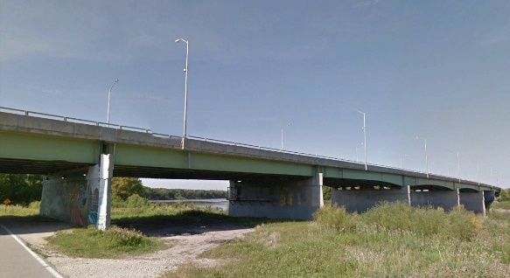 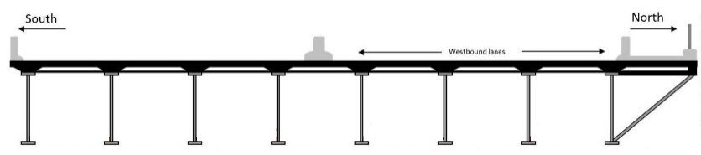

Two East-bound lanes Two West-bound lanes

1. (b)

Figure 1: Winnipeg Bridge 1: (a) photograph, (b) cross-section

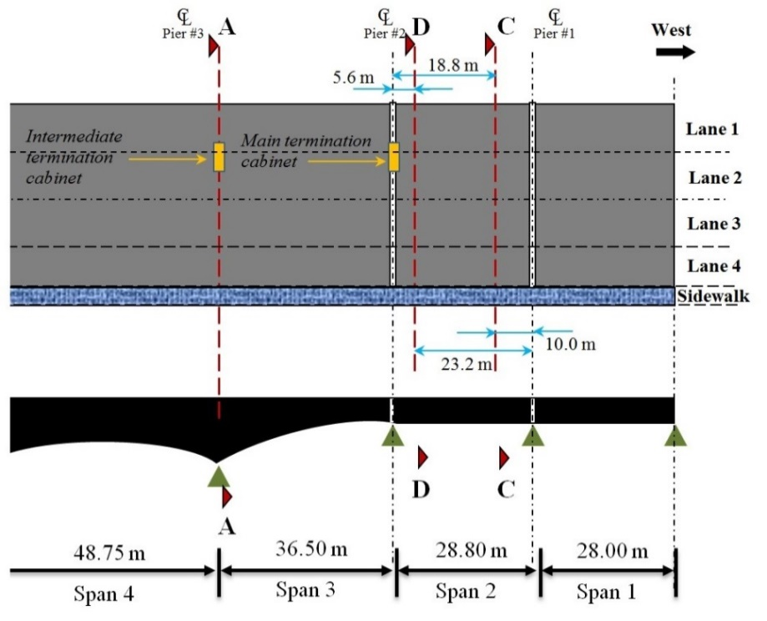

Figure 2: Plan and elevation of a part of Winnipeg Bridge 1

The instrumented span of Winnipeg Bridge 1 was analysed by the semi-continuum method, which is incorporated in the program SECAN (Mufti et al. 2016). In the initial analysis, in which the transverse diaphragms were ignored and the effective thickness of the deck slab was assumed to be its own thickness (200 mm), the distribution factors (DFs) for strains near the bottom flanges of the girders were found to be significantly different than those obtained from observed strains. To account for the transverse diaphragms and the increased effective thickness of the externally restrained deck slab, the instrumented span was analysed several times by gradually increasing the effective thickness of the deck slab, until it was found that the observed patterns of the transverse distribution of DFs matched with those obtained from analysis. As shown in Figure 3, the operative effective thickness of the deck slab was found to be 600 mm, indicating that the bridge has excellent transverse distribution characteristics. Karim Helmi et al. (2014) performed a calibration test to calculate BWIM parameters. Two trucks were used in the calibration test and the trucks traveled over the bridge several times with different velocity and at different location on the bridge. It is noted that in Test 3, the test vehicle was in the middle of the right lane of the East-bound traffic lanes. Similarly, in Test 12, the test vehicle was in the middle of the right lane of the West-bound traffic lanes.

Table 2: DFs for longitudinal strains near the bottom of girders of the Winnipeg Bridge 1

|  |  |  |  |  |  |  |  |  |  |
| --- | --- | --- | --- | --- | --- | --- | --- | --- | --- |
| Test No. | Girder No. | | | | | | | | Sum |
| 1 | 2 | 3 | 4 | 5 | 6 | 7 | 8 |
| 3 | 0.23 | 0.30 | 0.24 | 0.11 | 0.06 | 0.03 | 0.02 | 0.00 | 1.00 |
| 6 | 0.07 | 0.13 | 0.28 | 0.29 | 0.15 | 0.06 | 0.03 | 0.00 | 1.00 |
| 3+6 | 0.30 | 0.43 | 0.52 | 0.40 | 0.21 | 0.09 | 0.05 | 0.00 | 2.00 |

Bakht et al. (2013) have presented the DFs for longitudinal strains near the bottom flanges of the Winnipeg Bridge 1 due to a test vehicle in various transverse positions. The DFs due to the vehicle in the middle of the two East-bound traffic lanes are designated as Test Nos. 3 and 6, respectively. The DFs due to the single truck corresponding to these two Test Nos. are given in Table 2, along with their sums, which correspond to two side-by-side trucks travelling in the middle of the two East-bound traffic lanes. The DFs given in Table 2 are used later in the paper while discussing modification factors for multi-lane loading.

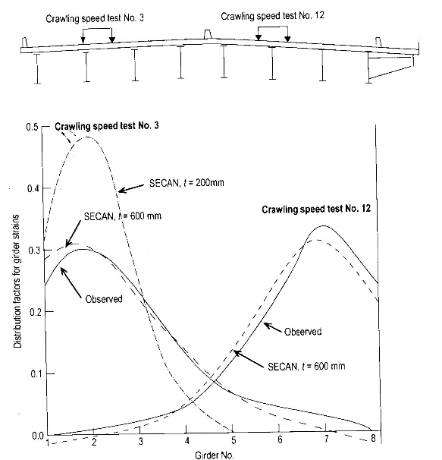

Figure 3: Comparison of DFs for strains near bottom flanges of Winnipeg Bridge 1

**3 LONG-TERM MONITORING OF GVWs**

As can be seen in Figure 1(b), the Winnipeg Bridge 1 has two East-bound lanes of traffic in its one half and two West-bound lanes of traffic in the other half. The traffic in the two directions is separated by a traffic barrier. The histogram of gross vehicle weights (GVWs) calculated from observed data on Span No. 2 of the bridge during the month of March, 2016, is presented in Figure 4 (a), which also shows the statistics of the corresponding probability curve for GVWs. The coefficient of variation (COV) for GVWs for one month is 0.29. The probability curve for GVWs for March 2016 is shown in Figure 4 (b), along with the probability curves for GVWs for the previous 27 months. The combined statistics for GVWs collected over 28 months is also presented in this figure, which shows that the COV of GVWs over 28 months is 0.30. The fact that the COV of GVWs for one month is nearly the same as that for GVWs for 28 months not only confirms the validity of the data, but also shows that the statistics of vehicle loads collected over a one month period are representative of a much longer period. The latter observation is relevant in studying the safety index of existing bridges, as discussed by Mufti et al. (2018). The BWIM observation on the Winnipeg Bridge 1 also showed that the number of trucks travelling in one direction are not the same in the two lanes.

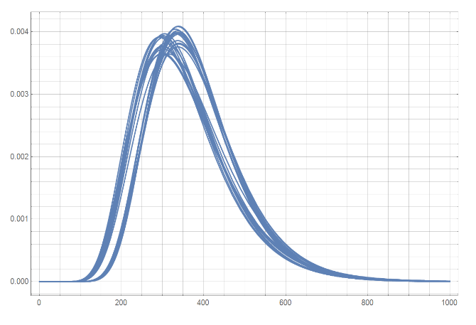

GVW in kN

Mean = 372 kN

SD = 112 kN

COV = 0.30

|  |  |  |  |  |  |
| --- | --- | --- | --- | --- | --- |
| 0 | 200 | 400 | 600 | 800 | 1000 |

|  |
| --- |
| 0.004 |
| 0.003 |
| 0.002 |
| 0.001 |
| 0.000 |

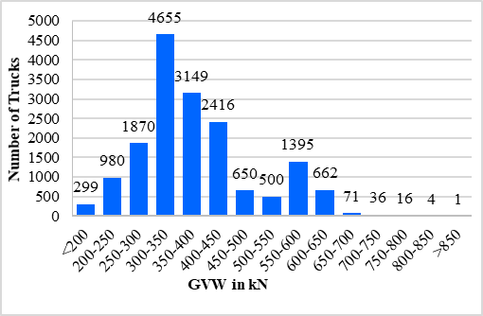

Mean = 383 kN

SD = 110 kN

COV = 0.29

(a) (b)

Figure 4: GVWs: (a) histogram for March-2016; (b) distribution curves for GVWs for 28 months

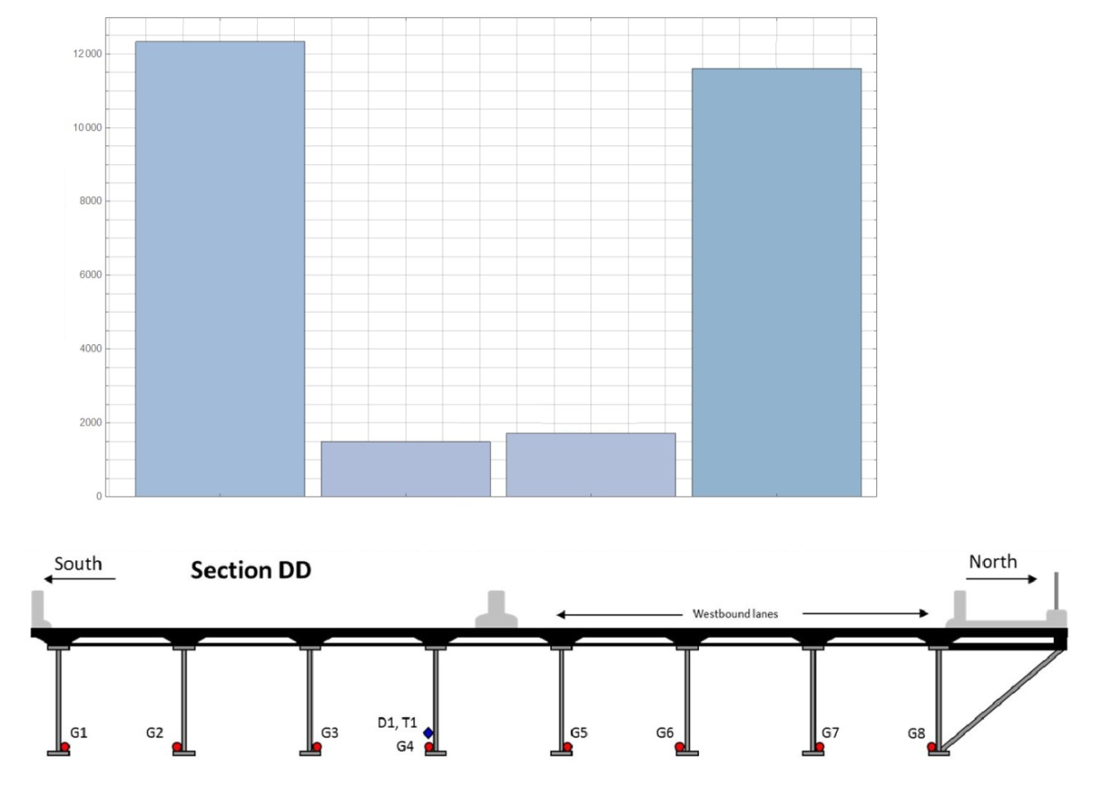

No. of trucks

Lane No. 1 2 3 4

12,324 trucks

1,482 trucks

1,723 trucks

11,604 trucks

Girder No. 1 2 3 4 5 6 7 8

|  |
| --- |
| 12000 |
| 10000 |
| 8000 |
| 6000 |
| 4000 |
| 2000 |
| 0 |

Westbound lanes

Figure 5: No. of trucks observed in different lanes of the Winnipeg Bridge 1 in one month

Figure 5 shows the distribution of 27,133 trucks observed during a one month period in different lanes. In the East-bound lanes, 12,324 and 1482 trucks travelled in the right and left lanes respectively, representing 45 and 6% of the total No. of trucks, respectively. Similarly, 43 and 6% of the West-bound trucks travelled in the right and left lanes, respectively. The outcome of this observation is that the right, i.e., the most travelled, lane is subjected to about 80% more trucks than assumed in design or evaluation. Consequently, about 25% fewer trucks than assumed travel on the lane next to the most travelled lane.

**4 NEGATIVE CONSEQUENCES**

The consequences of trucks not travelling in equal numbers on especially the evaluation of the load carrying capacities of existing bridges are both negative and positive. On the negative side is the fatigue assessment of components lying under the most travelled lanes. For example, the number of ADTT for assessing the fatigue damage of steel components for Class A, B, C and D highways is specified in the CHBDC to be 4,000, 1,000, 200 and 50, respectively. As noted in S6.1-14, the commentary to the CHBDC, these numbers are larger than the ADTT listed in Table 1 because ‘the single passage of a truck can produce more than one stress range’. It can be seen in Figure 5 that in one moth, Lane No. 1 carries 12,324 trucks whereas Lane No. 2, the second lane carrying East-bound traffic, carries only 1,432 trucks, so that the average No. of trucks in each lane is 6,903. The actual No. of trucks in Lane No. 1, i.e. 12,324, is about 80% larger than the average No. of trucks. If a steel component lies under the most travelled lane, then then the number of ADTT for assessing fatigue damage in steel components should be larger by about 80% than specified in the code. This observation is also relevant to the design of new bridges.

Similarly, the fatigue damage of the concrete deck slabs, not addressed by the current design codes, should be examined for the larger number of trucks that the slab is likely to be subjected to in the most travelled lanes. It is noted that through tests on full-scale models of concrete deck slabs of girder bridges Limaye (2004) and Memon (2005) have shown that concrete deck slabs do fail under fatigue, and that increasing the amount and stiffness of reinforcement in deck slabs reduces their fatigue resistance.

**5 POSITIVE CONSEQUENCES**

The positive consequence of most of trucks travelling in the right-hand lanes is that the modification factor for multiple loading in two side-by-side lanes can be reduced, as described in the following.

A histogram of maximum observed strains near the bottom flange of Girder No. 2 of the Winnipeg Bridge 1 due to single trucks is presented in Figure 6 (a) for one month in 2017. A similar histogram for maximum strains in the same girder, and for the same duration, due to multiple trucks is presented in Figure 6 (b). It can be seen in these two figures that the highest strain due to single trucks is 72 , whereas that due to multiple trucks is 78  It is conservatively assumed that the strains due to multiple trucks are induced by two side-by-side trucks travelling in the same direction. It can be seen in Figure 3 that trucks travelling in Lane 4 induce little strains in girders under Lane 1.

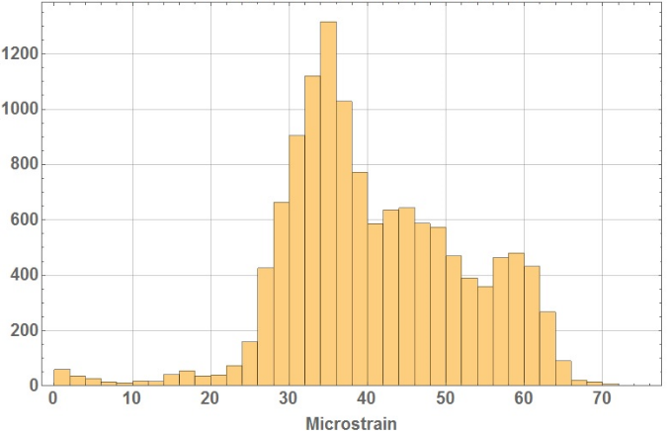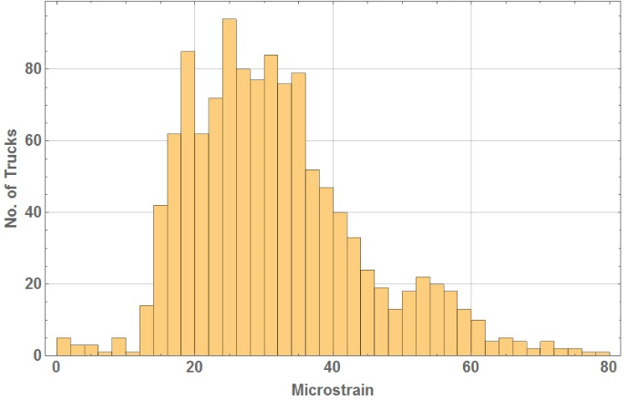

(a) (b)

Figure 6: Histograms of maximum stresses in Girder No. 2 of the Winnipeg Bridge 1: (a) under single trucks; (b) under two side-by-side trucks

From Table 2, it can be seen that the DF for Girder No. 2 in Test No. 3, in which the truck is directly over the girder, is 0.30. When there are two full trucks in the two adjacent lanes, i.e. in Test Nos. 3 and 6, the DF for Girder No. 2 is 0.43. The modification factor for loading in two lanes is designated as *mf*. It can be readily appreciated that the maximum observed strain in Girder No. 2 due to single trucks, i.e. 72 , should be related to maximum strain observed in the same girder due to multiple trucks, i.e. 78 , by the following equation.

78 = *mf* × 72 × (0.43 / 0.30) [1]

The above equation is based on the assumption that the maximum strains in a girder by multiple trucks are induced by two similar trucks, the weights of each of which is reduced by *mf*, the value of which is given by the above equation to be 0.75. The Winnipeg Bridge 1 is on a Class A highway, for which CHBDC specifies *mf* to be 0.90 for loading in two lanes. In light of the above observations, this value can be safely reduced to 0.75 for bridges in which two lanes carry the traffic in the same direction. Since the recommended modification factor is based on trucks in all of its four lanes, there is no need to consider multi-lane loading in more than two lanes. It is important to note that the above recommendation is for a bridge with excellent load distribution characteristic. For bridges with poor load distribution characteristics, the value of *mf* will be even smaller.

**6 CONCLUSIONS**

Through long-term monitoring of bridge in the Canadian province of Manitoba, Canada, it has been shown that for evaluating the load carrying capacity of bridges carrying at least two lanes of traffic in the same direction and preferably the traffic in two directions separated by a traffic barrier, the modification factor for loading in two lanes can be safely reduced from 0.90 to 0.75. It has also been shown that in the design and evaluation of such bridges, the number of fatigue cycles should be increased considerably.

**Acknowledgements**

It is acknowledged that Manitoba Infrastructure provided the funding the project.

**References**

AASHTO. 2016. Standard specifications for highway bridges. American Association of State Highway and Transportation Officials. Washington, D.C.

Bakht, B., Mufti, A., Jaeger, L.G., and Helmi, K. 2013. Determining gross vehicle weight by BWIM, ISIS Canada Resource Centre, the University of Manitoba, Canada.

Bakht, B. and Jaeger, L.G. 1990. Bridge evaluation for multipresence of vehicles. *ASCE Journal of Structural Engineering,* Vol. 116, No. 3, pp. 803-818.

Canadian Highway Bridge Code (CHBDC) CAN/CSA-S6-14. 2014. Canadian Standards Association, Mississauga, Ontario, Canada.

Commentary on CAN/CSA-S6-14, S6.1-14. 2014. Canadian Standards Association, Mississauga, Ontario, Canada.

Jaeger, L.G., and Bakht, B. 1987. Multi-presence reduction factors for bridges. Proceedings, Structural Congress ’87.ST Div/ASCE, Orlando, Florida, August 17-20, 1987.

Helmi, K., Bakht, B., Mufti, A. 2014. Accurate measurements of gross vehicle weights through Bridge Weigh in motion: a case study. Volume 4, Issue 3, pp 195–208, Journal of Civil Structural Health Monitoring

Limaye, V.N. 2004. Steel-free decks under cyclic loading: a study of crack propagation and strength degradation. Thesis submitted in partial fulfillment of the requirements for the degree of Ph.D., Dalhousie University, Canada.

Memon, A.H. 2005. Comparative fatigue performance of steel-reinforced and steel-free concrete bridge deck slabs. Thesis submitted in partial fulfillment of the requirements for the degree of Ph.D., University of Manitoba, Canada.

Mufti, A., Bakht, B., Algohi, B., and Khalid, H. 2018. A case for adding an inspection level to SHM for bridge evaluation. To be presented at the 10th International Conference on Short and Medium Span Bridges, to be held in Quebec City, Canada.

Mufti, A., Bakht, B., Jaeger, L.G., Jalali, J., and Khalid, H. 2016. User manual for SECAN, SIMTReC, University of Manitoba, Canada.

Ontario Highway Bridge Design Code. 1979. Ministry of Transportation and Communications, Downsview, Ontario, Canada.