**SIMPLIFIED EQUATIONS FOR MOMENT AND SHEAR VALUES IN BRIDGE GIRDERS RESULTING FROM TRUCK LOADING**

Diab, Ahmed1,3, Sennah, Khaled2

1 M.A.SC. Student, Civil Engineering Department, Ryerson University, Canada

2 Professor, Civil Engineering Department, Ryerson University, Canada

3 [adiab@ryerson.ca](mailto:adiab@ryerson.ca)

**Abstract:** In bridge analysis, designers require the calculations of maximum bending moment, MT, and shear force, VT, of a bridge girder subjected to truck loading, then use the available truck load fraction, FT, as calculated by the simplified method of analysis in Chapter 5 of the Canadian Highway Bridge Design Code (CHBDC) to generate the design longitudinal live load effects. This paper presents a summary of structural analysis of different bridge girder configurations subjected to (i) CL-625 truck loading used in all Canada’s Provinces except Ontario and Alberta, (ii) CL625-ONT truck loading used in Ontario, and (iii) CL-800 truck loading used in Alberta. The key parameters in this parametric study include number of girder spans, bridge span length and truck loading type. Bridge girder geometries include single span and two equal spans, with span length ranging from 12 to 48 m in two-meter increments. A sensitivity study was conducted regarding the use of the moving load method specified in SAP2000 software or the conventional influence-line method to determine the load scenarios to maximize the moment and shear effects. The results from the sensitivity study showed that the two methods had very similar results. However, the results from the moving load method were slightly higher in value. After conducting the sensitivity study and modelling different bridge girder configurations, the results for maximum shear, and positive and negative moments were plotted and then used to develop polynomial equations to best represent their values. The developed equations are a function of bridge span length so that only one variable is needed to obtain a quick and reliable estimation of the required load effects. This research is on-going with ultimate goal of creating ready-to-use tables that assist engineers on deciding upon preliminary section sizes for bidding purposes for the three truck configurations mentioned above.

# **INTRODUCTION**

In the current state of the bidding sequence for bridges, bidders do not have a quick and accurate way of determining the correct steel section sizes for slab-on-girder bridges to obtain a somewhat accurate cost prediction to bid in projects. The aim of this research is to obtain an accurate value for the design live load moment and shear using the three most used trucks in Canada, namely: CL-625, CL-625-ONT and CL-800. CL-625 truck is used for the design of bridges in all provinces and territories except Ontario and Alberta, while CL-625-ONT truck is used for the design of bridges in Ontario (CSA 2014). CL-800 is identical to CL-625 truck but with gross weight of 800 kN and is used to design bridges in Alberta (Alberta Transportation 2015). These truck configurations are shown in Figure 1.

The Canadian Highway Bridge Design Code, CHBDC, (CSA 2014) specifies that the live load moment per girder, ML, is calculated based on the following equation:

[1] $M_{L}=F_{T}M_{T}$

The longitudinal moment generated by one lane of CL-W loading, $M_{T}$, is the maximum moment obtained from a congested and a non-congested state of a truck loading over the bridge. The non-congested state (referred to as Truck Load), consists of the truck that is being located at the location of maximum moment and is magnified with a dynamic load allowance referred to as DLA as follows:

[2] $M_{T1}=M_{truck}*\left(1+DLA\right)$

In the case where the bridge span does not accommodate a full truck, a reduced version of the truck is used where some axles are removed. Few loading cases were considered of which axles to remove to obtain a maximized value for the moment per lane.

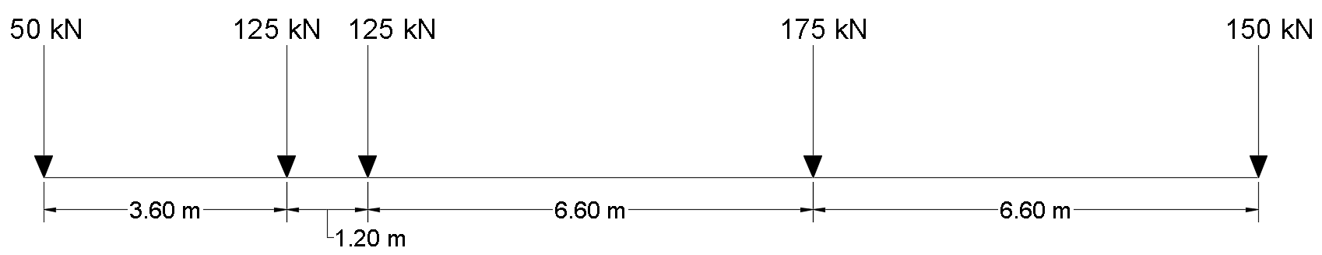

1. CL-625 Truck (CSA 2014)

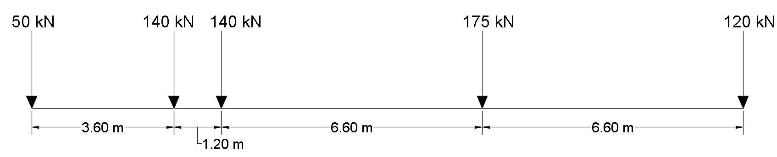

1. CL-625-ONT Truck(CSA 2014)

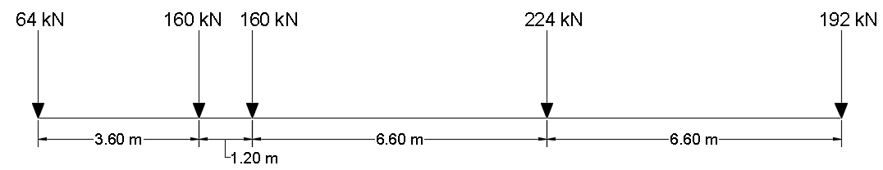

1. CL-800 Truck (Alberta Transportation 2015)

Figure 1: Truck configurations considered in this study

The second case to be considered is the congested state where a distributed load of 9 kN/m is assumed to be acting on the bridge in addition to 80% of the truck weight. The following equation represents the resulting moment for a loaded lane based on this loading case.

$$\left[3\right] M_{T2}=0.8*M_{truck}+M_{\frac{9kN}{m}}$$

The 9 kN/m load is only applied to locations where it would magnify the loading effect when determining the positive moment within the bridge span and the negative moment at the support.

Based on the above-mentioned loading cases, the maximum longitudinal moment generated by one lane of CL-W loading is considered the greatest values of all loading cases considered in girder analysis as follows:

$$\left[4\right] M_{T}=max\left({M_{T1} \atop M_{T2}}\right)$$

A similar procedure is used to obtain the maximum longitudinal shear generated by one lane of CL-W loading, $V_{T}$. The objective of this research was to develop finite-element (FE) models, using SAP2000 software (SAP2000 2017), to obtain $M_{T}$ and $V_{T}$ values for single span and, two-Span girders with span length between ranging from 12 to 48 m. FE Models of girders were created for three truck types, namely: CL-625, CL-625-ONT and CL-800. The values obtained were to be tabulated and used to create mathematical models to provide quick estimate of steel girder sizes at the bidding stage on projects. The ultimate goal is to create an easy-to-use estimation method to obtain design live load effects without the need to perform detailed calculations and modelling needed for bidding on the project and in the preliminary estimation of girder size in the final design.

# **APPLICATION OF INFLUENCE LINE METHODOLOGY**

Influence Line (IL) diagrams were utilized to assist in locating the truck axles over the bridge girder to maximize the moment and shear effect. Figures 2 through 7 shows examples of the use of Influence Line diagrams in location CL-W axles in single span and two span bridge girders of 30 m span length. SAP2000 Software was used in conjunction with equations 1 through 4 to obtain accurate results for maximum moment and shear values due to live load per lane.

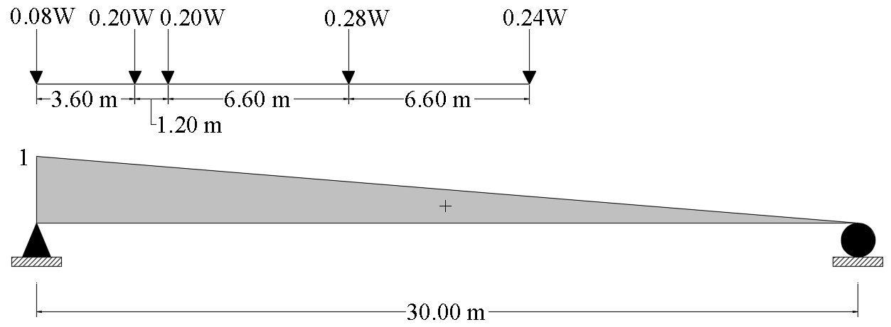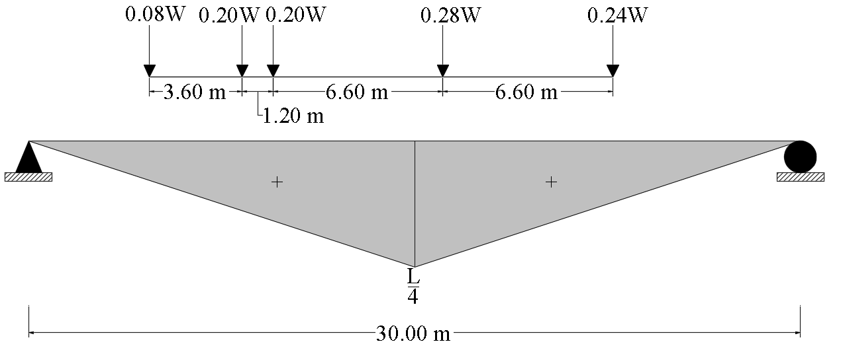

|  |  |
| --- | --- |
| Figure 2: Shear and Reaction I.L. Diagram of a 30-m single span bridge and associated CL-W truck axle locations | Figure 3: Moment I.L. Diagram of a 30-m single span bridge and associated CL-W truck axle locations |

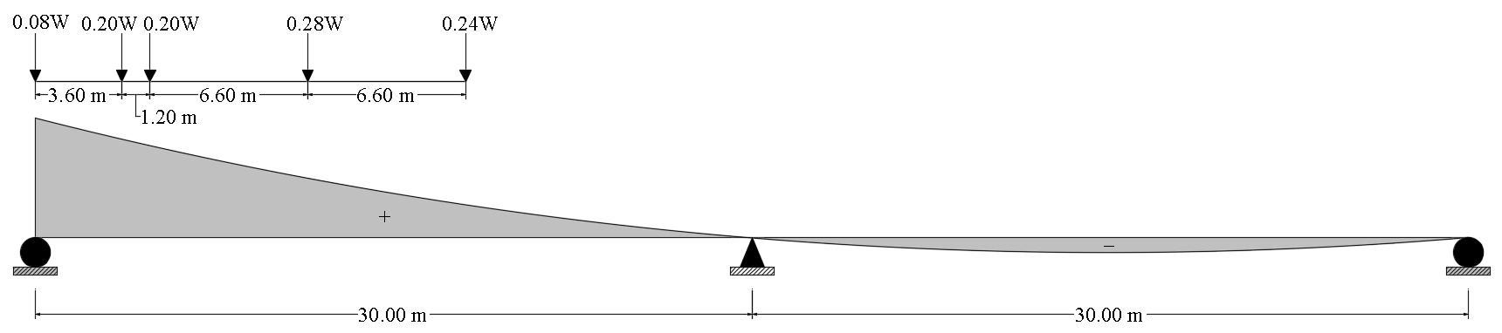

Figure 4: Exterior Reaction and Shear I.L. Diagram of a Two-Span bridge and associated CL-W truck axle locations

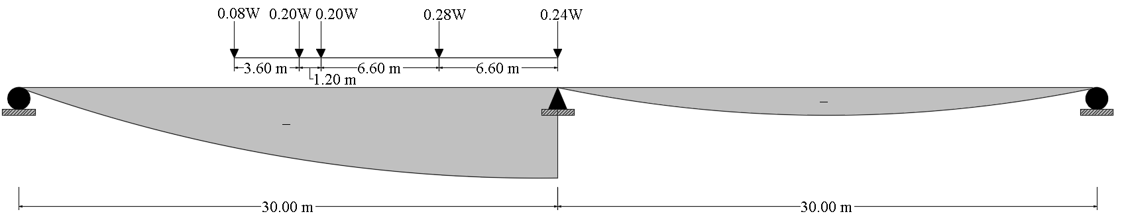

Figure 5: Interior Shear I.L. Diagram of a Two-Span bridge and associated CL-W truck axle locations

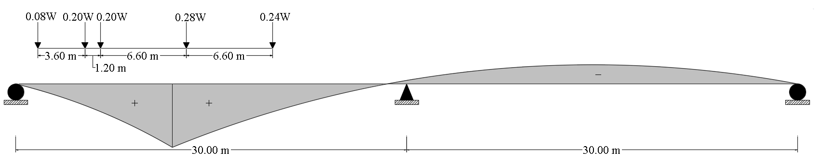

Figure 6: Maximum Positive Moment I.L. Diagram of a Two-Span bridge and associated CL-W truck axle locations

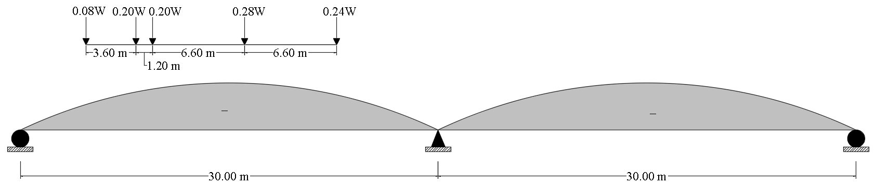

Figure 7: Maximum Negative Moment I.L. Diagram of a Two-Span bridge and associated CL-W truck axle locations

## **RESULTS FROM FINITE ELEMENT MODELLING**

Models were created for the bridge lengths ranging from 12 to 48 m at 2 meter increments. The results for the CL-625 truck cases are listed in Table 1 for single span girders. In this table, Vtruck and Mtruck are the maximum shear and moment due to truck axle weights without the DLA factor and Vlane and Mlane are the values for shear and moment due to uniform loading of 9 kN/m and 80% of the truck loading without DLA factor. Table 2 summarizes positive and negative moments exterior and interior shear forces generated by one lane of CL-625 loading in a two-equal-span girder bridges. Similar results were obtained from the CL-625-ONT truck and the CL-800 truck and can be found elsewhere (Diab 2018).

# **DEVELOPMENT OF EMPIRICAL EQUATIONS FOR LONGITUDINAL MOMENT AND SHEAR GENERATED BY ONE LANE OF CL-W LOADING**

The results obtained from modelling girders under CL-W loading were plotted and a curve of best fit was created using third degree polynomials. Following that, regression analysis was performed on the results to obtain the correlation factor between the best fit curve and the actual results obtained from SAP2000 software. The following subsections summarize the findings of this data analysis.

## **Single Span Bridge**

Using the results obtained from SAP2000 software, the following equations were developed to obtain the maximum longitudinal moment generated by one lane of CL-W loading as a function of the girder span for the three truck configurations considered in this study. In this particular case, the correlation factor showed the developed equations are 99.95% representative of the SAP2000 software results. The developed equations ensured that the load effect is at least equal (slightly higher than) those obtained from analysis using SAP2000 software with zero underestimation for safety reasons. Figure 8 shows comparison between these developed equations and the data from analysis, showing excellent agreement.

${\left[5\right] M}_{T}=-0.05\left(L^{3}\right)+5.58\left(L^{2}\right)-6.51\left(L\right)+330 kN.m$ for CL-625 Truck

${\left[6\right] M}_{T}=-0.058\left(L^{3}\right)+6.1\left(L^{2}\right)-13.6\left(L\right)+460 kN.m$ for CL-625-ONT Truck

${\left[7\right] M}_{T}=-0.063\left(L^{3}\right)+7\left(L^{2}\right)-4.43\left(L\right)+390 kN.m$ for CL-800 Truck

Table 1: Maximum live load shear and moment generated by one lane of CL-625 truck loading for single span bridge girders obtained SAP2000 software

|  |  |  |  |  |  |  |
| --- | --- | --- | --- | --- | --- | --- |
| **Span (m)** | **Vtruck (kN)** | **Mtruck (kN.m)** | **Vlane** | **Mlane (kN.m)** | **VT (kN)** | **MT (kN.m)** |
| 12 | 275 | 738 | 274 | 752 | 344 | 959 |
| 14 | 306 | 900 | 308 | 941 | 383 | 1125 |
| 16 | 344 | 1125 | 347 | 1188 | 430 | 1406 |
| 18 | 369 | 1363 | 376 | 1455 | 461 | 1703 |
| 20 | 394 | 1600 | 405 | 1730 | 492 | 2000 |
| 22 | 406 | 1838 | 424 | 2015 | 508 | 2297 |
| 24 | 419 | 2113 | 443 | 2338 | 523 | 2641 |
| 26 | 431 | 2413 | 462 | 2691 | 539 | 3016 |
| 28 | 444 | 2713 | 481 | 3052 | 555 | 3391 |
| 30 | 450 | 3013 | 495 | 3423 | 563 | 3766 |
| 32 | 463 | 3344 | 514 | 3827 | 578 | 4180 |
| 34 | 469 | 3631 | 528 | 4206 | 586 | 4539 |
| 36 | 475 | 3944 | 542 | 4613 | 594 | 4930 |
| 38 | 481 | 4275 | 556 | 5045 | 602 | 5344 |
| 40 | 488 | 4569 | 570 | 5455 | 609 | 5711 |
| 44 | 500 | 5213 | 598 | 6348 | 625 | 6516 |
| 48 | 513 | 5819 | 626 | 7247 | 641 | 7273 |

Table 2: Maximum live load shear and moment generated by one lane of CL-625 truck loading for two-equal-span bridge girders obtained SAP2000 software

| **Span (m)** | **MT+ (kN.m)** | **MT- (kN.m)** | **VT Exterior (kN)** | **VT Interior (kN)** |
| --- | --- | --- | --- | --- |
| 12 | 770 | 711 | 350 | 354 |
| 14 | 930 | 852 | 372 | 385 |
| 16 | 1114 | 983 | 401 | 413 |
| 18 | 1337 | 1081 | 429 | 439 |
| 20 | 1619 | 1192 | 453 | 461 |
| 22 | 1861 | 1344 | 474 | 482 |
| 24 | 2149 | 1509 | 492 | 500 |
| 26 | 2398 | 1709 | 507 | 516 |
| 28 | 2734 | 1943 | 521 | 530 |
| 30 | 3036 | 2184 | 534 | 543 |
| 32 | 3329 | 2438 | 544 | 555 |
| 34 | 3633 | 2695 | 554 | 565 |
| 36 | 3943 | 2960 | 563 | 574 |
| 38 | 4266 | 3234 | 571 | 582 |
| 40 | 4548 | 3517 | 578 | 589 |
| 44 | 5206 | 4102 | 590 | 603 |
| 48 | 5816 | 4724 | 605 | 617 |

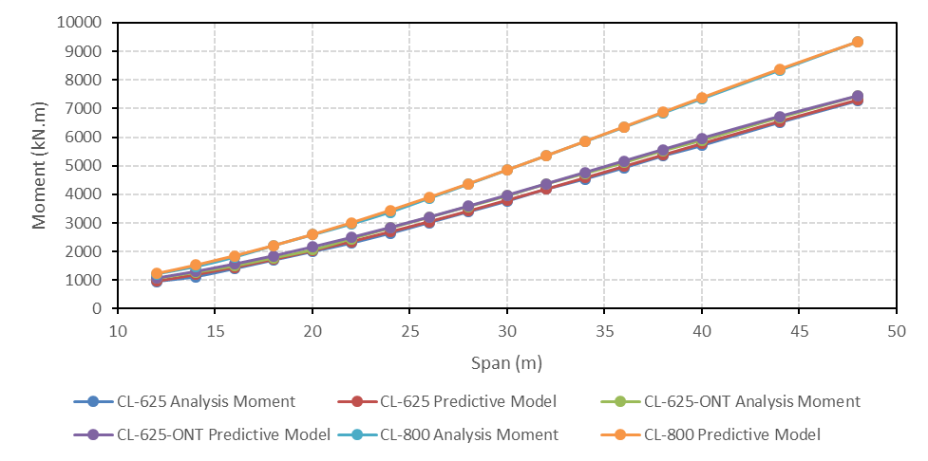

Figure 8: Comparison between the developed equations and the results obtained from SAP2000 model for longitudinal moment generated by one lane of CL-W loading in single span bridge girders

In the case of single span shear generated by one lane of CL-W loading as a function of the girder span for the three truck configurations considered in this study, the following developed equations showed accuracy of the results of 98.5% on the conservative side. Figure 9 shows a comparison between the developed equations and the results obtained from SAP2000 model for shear generated by one lane of CL-W loading in single span bridge girders.

[8 $] V_{T}=0.0097\left(L^{3}\right)- 1.1\left(L^{2}\right)+ 44.79\left(L\right)- 43 kN$ for CL-625 Truck

[9 $] V_{T}=0.0063\left(L^{3}\right)-0.755\left(L^{2}\right)+ 32.7\left(L\right)+116 kN$ for CL-625-ONT Truck

[10 $] V_{T}=0.0086\left(L^{3}\right)-1.02\left(L^{2}\right)+ 45\left(L\right)+70 kN$ for CL-800 Truck

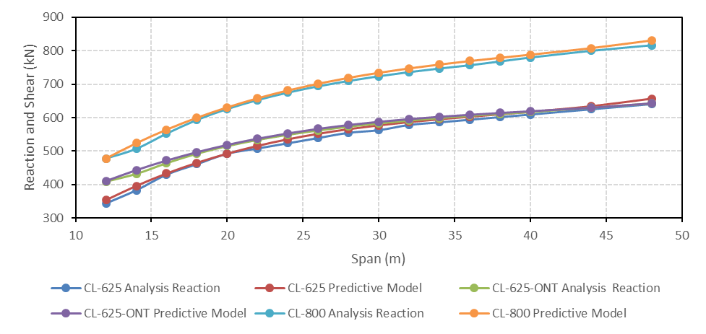

Figure 9: Comparison between the developed equations and the results obtained from SAP2000 model for shear generated by one lane of CL-W loading in single span bridge girders

## **Two-Equal-Span Bridge**

The following equations were developed for maximum positive moment, MT+, generated by one lane of CL-W loading in two-equal-span bridge girders. Figure 10 shows comparison between these developed equations and the data from analysis, showing excellent agreement.

[11] $M_{T+}= -0.0365\left(L^{3}\right)+ 4.1\left(L^{2}\right)+ 5.2\left(L\right)+ 180 kNm$ for CL-625 Truck

[12] $M_{+}= -0.035\left(L^{3}\right)+ 3.8\left(L^{2}\right)+ 19.4\left(L\right)+ 180 kNm$ for CL-625-ONT Truck

[13] $M_{T+}= -0.045\left(L^{3}\right)+ 5.1\left(L^{2}\right)+ 9.7\left(L\right)+ 230 kNm$ for CL-800 Truck

Figure 10: Comparison between the developed equations and the results obtained from SAP2000 model for longitudinal positive moment generated by one lane of CL-W loading in two span bridge girders

The following equations were developed for maximum negative moment, MT-, generated by one lane of CL-W loading in two-equal-span bridge girders. Figure 11 shows comparison between these developed equations and the data from analysis, showing excellent agreement.

[14] $M_{T- }= -0.0256\left(L^{3}\right)+ 4.03\left(L^{2}\right)– 54.28\left(L\right)+ 920 kNm$ for CL-625 Truck

[15] $M_{T-}= -0.0286(L^{3})+ 4.09(L^{2}) - 53.71(L)+ 885 kNm$ for CL-625-ONT Truck

[16] $M_{T-}= -0.023(L^{3})+ 4(L^{2}) - 51.2(L)+ 1175 kNm$ for CL-800 Truck

The following equations were developed for maximum interior shear generated by one lane of CL-W loading in two-equal-span bridge girders.

[17] $V_{Tint}=0.0094(L^{3}) - 1.027(L^{2}) + 41.75(L) + 33 kN$ for CL-625 Truck

[18] $V_{Tint}=0.0132\left(L^{3}\right)- 1.381\left(L^{2}\right)+ 51.43\left(L\right)-25 kN$ for CL-625-ONT Truck

[19] $V_{Tint}=0.0088\left(L^{3}\right)- 1.06\left(L^{2}\right)+47.47(L) + 84 kN$ for CL-800 Truck

Finally, the following equations were developed for maximum exterior shear generated by one lane of CL-W loading in two-equal-span bridge girders. Figure 12 shows comparison between these developed equations and the data from analysis, showing excellent agreement.

[20] $V_{Text}=R_{Text}= 0.004(L^{3}) - 0.54(L^{2}) + 27.5(L) + 90 kN$ for CL-625 Truck

[21] $V_{Text}=R_{Text}= 0.0036(L^{3}) - 0.5(L^{2}) + 25.447(L) + 147 kN$ for CL-625-ONT Truck

[22] $V_{Text}=R_{Text}= 0.005(L^{3}) - 0.69(L^{2}) + 35.3(L) + 117 kN$ for CL-800 Truck

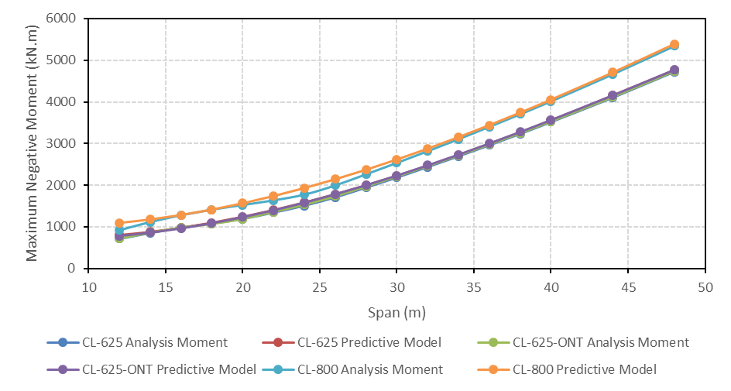

Figure 11: Comparison between the developed equations and the results obtained from SAP2000 model for longitudinal negative moment generated by one lane of CL-W loading in two span bridge girders

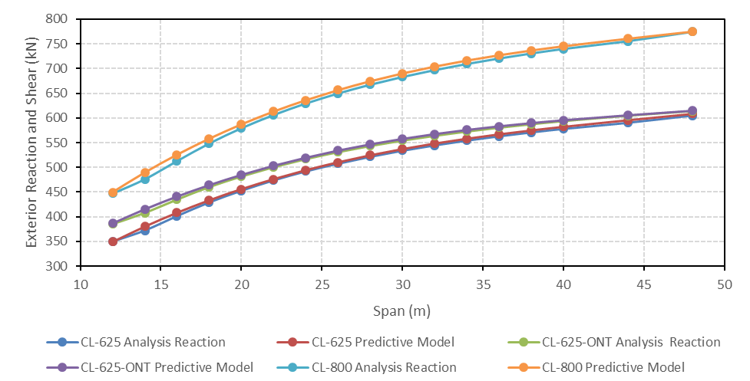

Figure 12: Comparison between the developed equations and the results obtained from SAP2000 model for longitudinal exterior shear generated by one lane of CL-W loading in two span bridge girders

# **CONCLUSIONS**

Using CHBDC 2014 provisions and the finite element SAP2000 software for girder analysis under truck loading conditions, empirical equations for the longitudinal moment, MT, and shear, VT, generated by one lane of CL-W loading were developed. The developed equations are valid for single and two-span bridges of span lengths ranging from 12 to 48 m. Also, the equations are applicable for the three truck types specified for bridge design in Canada, namely: CL-625, CL-625-ONT and CL-800. The developed equations are of high accuracy and can be used to assist in quick bridge design at the project bidding stage.

# **Acknowledgements**

The authors would like to acknowledge the support of the Natural Sciences and Engineering Research Council of Canada (NSERC).

# **References**

Alberta Transportation. 2015. *Bridge Load Evaluation Manual*. Technical Standard Branch, Alberta Transportation, Alberta, Canada.

CSA. 2014. *Canadian Highway Bridge Design Code CAN/CSA-S6-14*. Canadian Standards Association, Ontario, Canada.

*Diab, A. 2018. Development of Quick Design Method for Steel Girder Bridges for Project Bidding. M.A.SC. Thesis, Civil Engineering Department, Ryerson University, Toronto, Canada.*

*SAP2000. 2017. Integrated Finite Element Analysis and Design of Structures, SAP2000 Software*. Computer and Structure Inc. Berkely, CA, USA.