|  |  |  |
| --- | --- | --- |
|  | **10th International Conference on Short and Medium Span Bridges**  **Quebec City, Quebec, Canada,**  **July 31 – August 3, 2018** |  |

**The First Moving Load Simulator for Testing Bridges in Canada**

Fam, Amir1,3 and Brennan, Dustin2

1 Donald and Sarah Munro Chair Professor and Associate Dean (Research and Graduate Studies), Department of Civil Engineering, Faculty of Engineering and Applied Science, Queen’s University, Kingston ON, Canada

2 Master’s Student, Department of Civil Engineering, Faculty of Engineering and Applied Science, Queen’s University, Kingston, ON, Canada

3 [fam@civil.queensu.ca](mailto:fam@civil.queensu.ca)

**Abstract:** A new large scale Moving Load Simulator (MLS) with a 250 kN moving load capacity has recently been built for testing bridges in a controlled laboratory environment in the Department of Civil Engineering at Queen’s University, Kingston, Ontario, Canada. This apparatus is the first of its kind in Canada and likely among very few in the world. The MLS is supported by four portal steel frames spaced 5.08 m apart in the longitudinal (travel) direction. Each frame has a span of 4.42 m and a height of 4.27 m. This enables a total rolling distance of almost 15 m on bridge superstructures of up to 4 m wide. The moving load vehicle consists of a primary ’cart’ supporting dual wheel of a full size truck, and a secondary ‘trailer’ that also supports a similar dual wheel. The spacing between each of the dual wheel sets can be set either to 1.2 m or 2.4 m. Each of the dual wheel sets represent a half axle of a truck and can exert a downward force of up to 125 kN, using hydraulic actuators. This load represents the maximum half axle load of the CL-625 design truck of the CHBDC, including dynamic allowance. An electric belt drive system provides the ‘movement’ component of the MLS to the ‘cart’ at a speed ranging from zero, at either end of the travel, to 6 m/sec at mid-span. This paper introduces this unique apparatus along with a demonstration of its various features, through testing of a full scale precast prestressed concrete box girder topped with a deck slab. The girder is simply supported on neoprene pads and subjected to several cycles of moving loads. Deflections and longitudinal surface strains are measured while the load is moving and are presented.

1. **INTRODUCTION**

Bridges are the ultimate expression of art and science in structural engineering. A key component of transportation networks, bridges are essential to the Canadian way of life. Each day, thousands of vehicles cross a typical bridge. Repetitive vehicle loading results in significant wear and tare on these structures. A report published by the Association of Municipalities of Ontario (AMO) states that in 2013, at least 26% of bridges found, in those 93 municipalities investigated, were in poor condition (AMO, 2015). After the collapse of the de la Concorde overpass in Laval stated that at least 32% of Ontario’s 15,000 bridges need rehabilitation or replacement (Government of Québec, 2007). In order to improve these structures, researchers and scientists have been studying bridges for many years. Aging infrastructure and the increase in traffic loads combined with aggressive environmental effects has resulted in degradation of bridges. For this reason, bridges are constantly monitored and tested. For example, the Ministry of Transportation of Ontario (MTO) has been conducting bridge tests for decades (Bakht and Jaeger, 1990). In-situ field tests of bridges have been conducted for decades. In these tests, many vehicles pass over a bridge at various speeds and the response of the bridge is measured. Data has been used to assess the serviceability of these bridges. This provides engineers with an insight into the long term performance of bridges and the information they need to improve design of future bridges. While field tests account for the moving load effect, only a few loading cycles can be performed.

In order to observe the long term effects of vehicle loads on bridges, including the repeated cycles of loading and fatigue effects, laboratory tests have been conducted. Currently, the common practice is to apply a stationary pulsating loading (i.e. loading and unloading at the same spot) using hydraulic actuators (Richardson et. al., 2014). The problem is that this type of experiment does not have the same effect as a rolling truck tire, due to the unrealistic distribution of loads and stresses in the structure and the lack of principal stress reversals that occur under moving loads. Small scale moving load tests have been compared to pulsating fatigue tests using 1/6.6 scale bridge deck specimens (Perdikaris et. al., 1988). The study showed that pulsating stationary loading is significantly unconservative, compared to the moving loads and could lead to overestimation of bridge strength and service life. Perhaps, for this reason, some of the design methodologies are over conservative. This paper introduces a new, and first in Canada, large scale Moving Load Simulator (MLS) that is capable of testing full scale bridge superstructures.

1. **DESCREPTION OF THE APPARATUS**

The new Moving Load Simulator (MLS) at Queen’s University has three main components, namely the supporting steel frame structure, the moving load vehicle (MLV) and the high power electric drive motor:

* 1. **Steel Structure**

Four steel portal frames spaced at 5.08 m were constructed to support the steel girders and guide rails. Each portal frame is 4.27 m tall and 4.42 m wide, with bolted connections. The column bases were anchored to the foundation of the laboratory using rock anchors. Guide rails and reaction beams run along the length of the MLS travel path. Lateral diagonal bracing is provided on both sides of one of the two end bays to resist the lateral forces arising from acceleration and deceleration of the MLS. All of the steel members were designed in accordance with CAN/CSA-S16. All bolted connections were designed in accordance with ASTM A325. The steel structure layout and the constructed steel frames are shown in Figures 1 and 2, respectively. In addition to the moving load of 250 kN maximum vertical force, the frame was also designed to resist up 1500 kN static vertical force, in order to be able to test specimens to failure after being exposed to the cyclic and fatigue loadings.

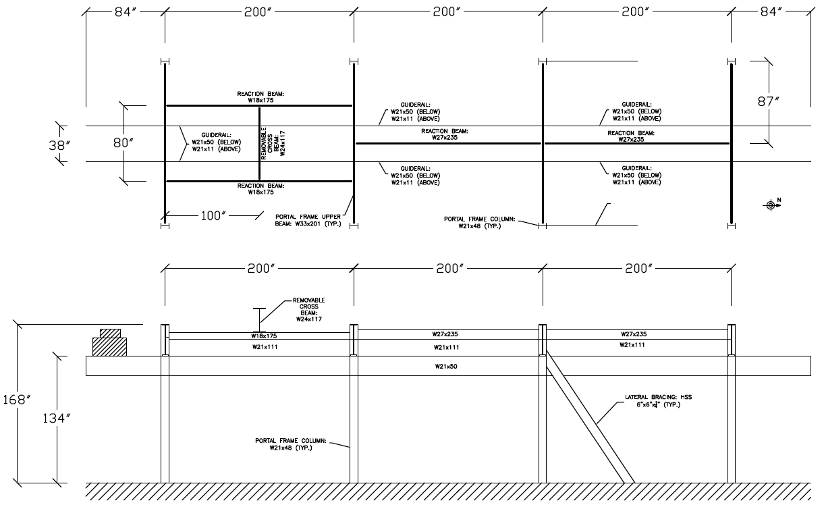

Figure 1: Steel Structure Layout

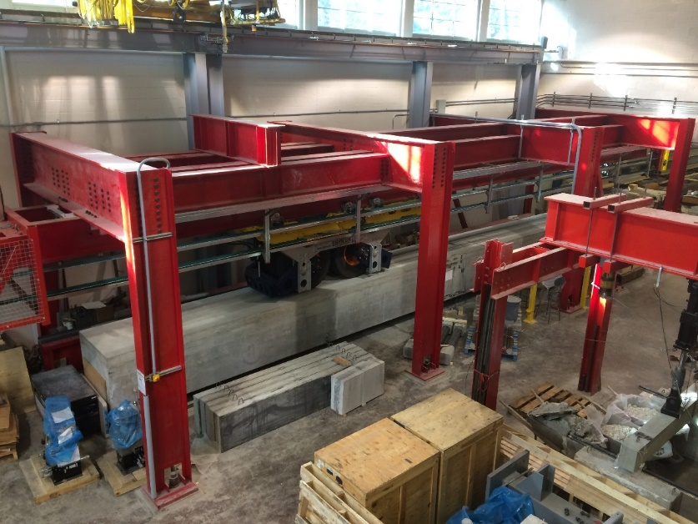 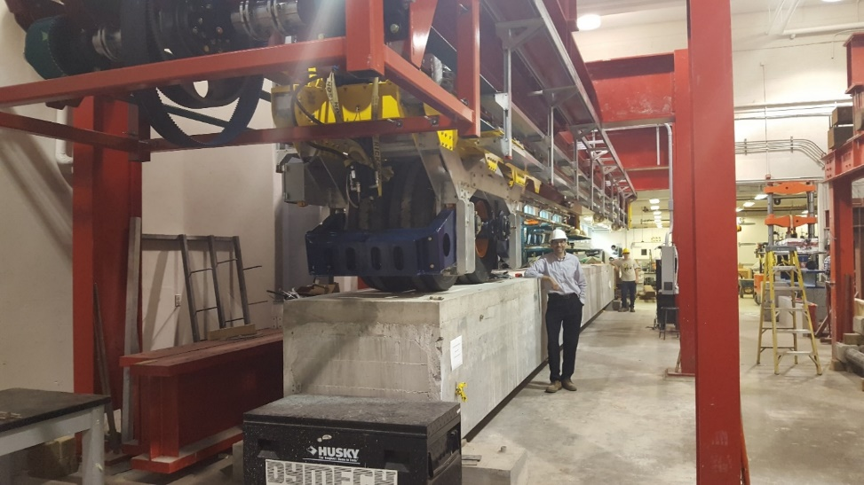

Figure 2: Overall View of the MLS Apparatus Showing the Supporting Steel Structure

**2.2 Moving Load Vehicle (MLV)**

The Moving Load Vehicle (MLV) is suspended from the steel structure and is composed of a primary ‘cart’ and secondary ‘trailer’ which are separable, as shown in Figures 3 and 4. Each component of the MLV is equipped with a large tandem axle tire, simulating a real heavy half-axle of a truck. The tire diameter and width (of a single tire) are 1140 mm and 311 mm, respectively, while the clear spacing between the dual tires is 41 mm. The tire pressure is 142 psi (and 150 psi maximum). Each component of the MLV is also equipped with its own hydraulic actuator. These actuators are able to operate independently or in synchronous, simulating different loading patterns. Load patterns include sinusoid, square and triangular waves as shown in Figure 5 and the user can choose single or multiple period loading profiles. Custom load profiles can also be used to simulate the effect of bumps in the road on bridges. Each hydraulic actuator is able to apply up to 125 kN at the dual wheel of its respective vehicle through the use of a two-to-one lever arm (shown in in blue in Figure 3). A maximum load of 125 kN represents the largest half axle load of the CL-625 design truck of the CHBDC, including maximum dynamic allowance. The user can convert from a two wheeled configuration to a single wheeled configuration by removing the trailer. The cart can also be rotated to change the wheel spacing from 1.2 m to 2.4 m, to reflect different axle spacing. The total travel range of the MLS is 14.8 m in the single wheel configuration, and 12.7 m in the two wheeled configuration.

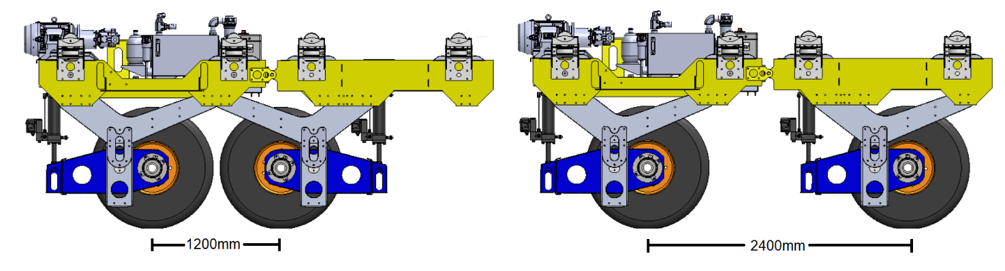

Figure 3: Schematic of Different Configurations of the Moving Load Vehicle (MLV)

* 1. **Drive System**

A 450 HP electric motor powers the MLS (Figure 6 (A)). The motor sits at one end of the MLS. Belts, fastened to the sides of MLV (Figure 6(B)), run the full length of the MLS on special rails. The motor turns a shaft (Figure 6(C)) which drives the belts, accelerating and decelerating the MLV. A maximum speed of 6 m/s (21.6 km/h) is achievable at the midway point of the MLS travel path.

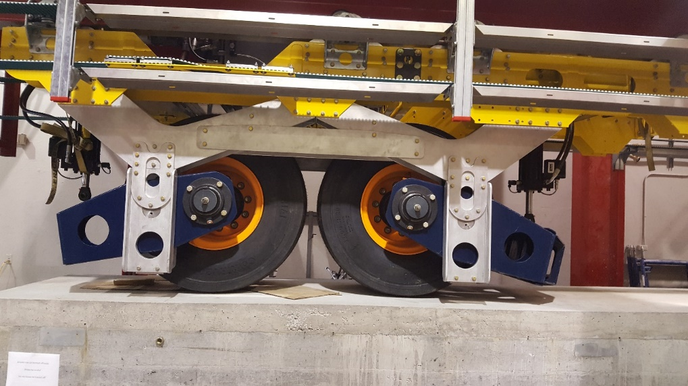 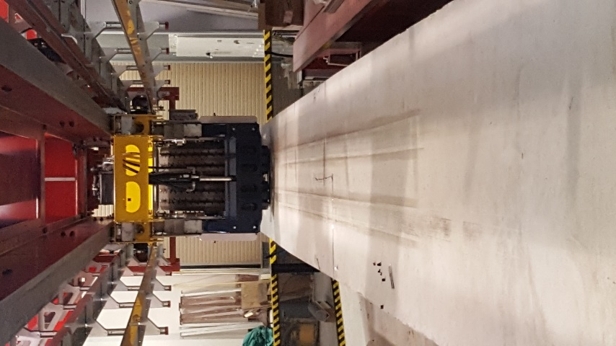

Figure 4: Moving Load Vehicle (MLV)

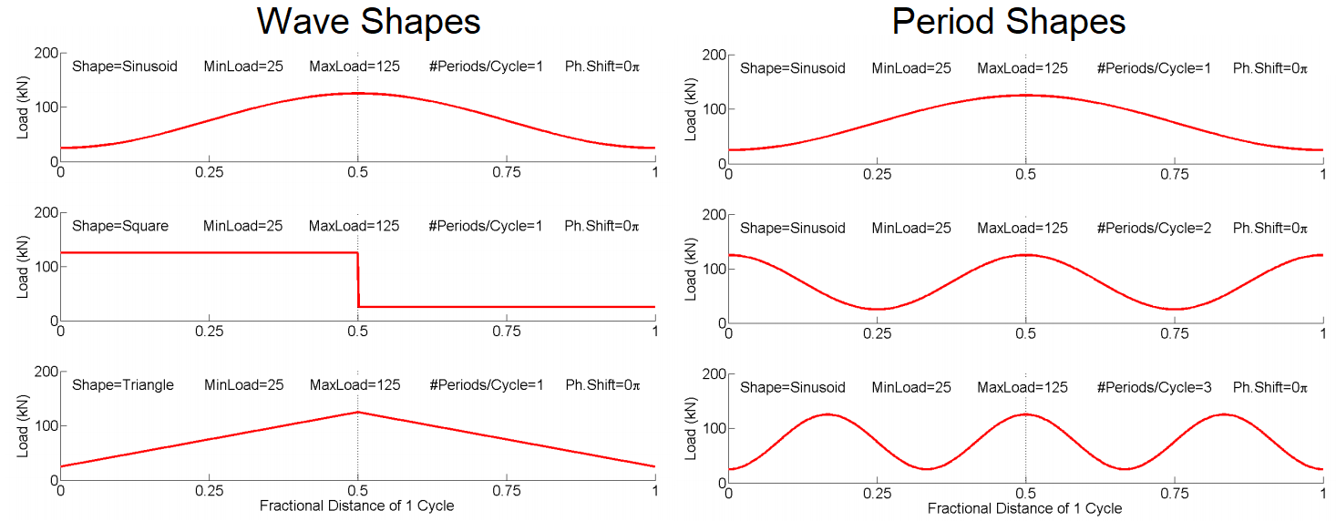

Figure 5: MLS Load Profiles

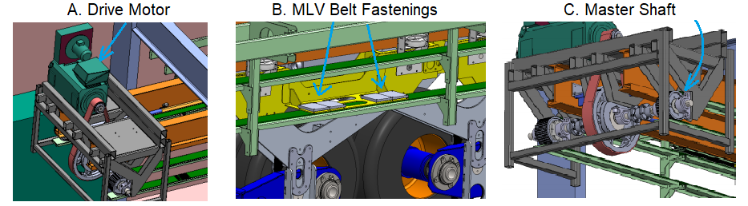

Figure 6: Drive System and Belts

1. **EXPERIMENTAL PROGRAM**
   1. **Test Specimen Overview and Setup**

A B900 concrete box girder was used for the first test and commissioning purposes of the new MLS. The girder is designed for an eight girder bridge with a 27 m span (Figure 7). The specified concrete strength (*fc’*) of the girder is 55 MPa. The B900 girder is prestressed with 36 Size 13, Grade 1860 seven-wire strands, and the details of the bridge are described below.

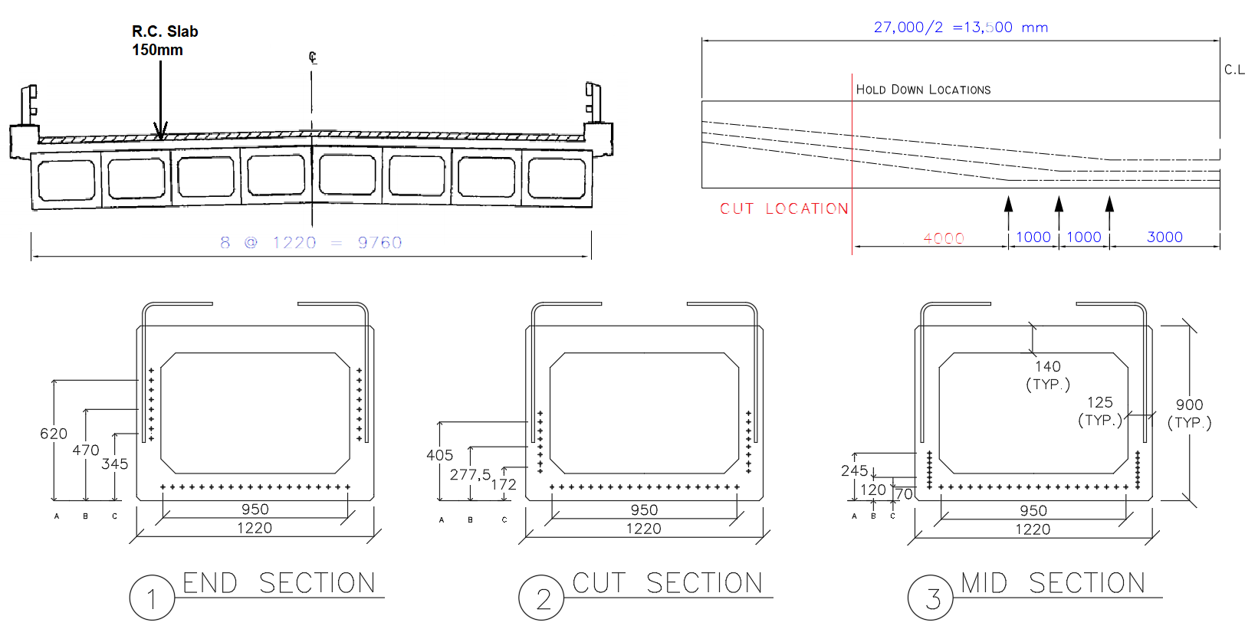

Figure 7: B900 Box Girder Test Specimen and Bridge Layout

In order to fit the girder into the MLS, it was shortened to a length of 16 m using a wire concrete cutting saw. A 5.5 m long section was cut from either end to maintain a 16 m long symmetric middle section. Prior to cutting analysis of the shortened section showed that the stresses at the top and bottom fibers at various locations along the length remain within the permissible limits due to self-weight and prestressing effects. The 16 m long girder was then placed onto 300x300 mm neoprene pads, as in the field, resting on simulated concrete abutments. These abutments were cast in the laboratory and anchored to the floor at each end of the MLS travel path. The clear span of the girder was 15.3 meters for this test. A 150 mm thick reinforced concrete deck slab was cast onto the girder across its full width as per the bridge design in which all girders were adjacent to each other (Figure 8). The specified concrete strength (*fc’*) of the deck slab is 25 MPa. Longitudinal and transverse deck slab reinforcement were 15M spaced at 300 mm. Shear connection was provided through the 15M hooked stirrups protruding from the girder into the deck and spaced at 300 mm. Also, concrete was cast inside the girder at both ends to create solid end blocks over the supports.

The aim of this experiment is to demonstrate the behaviour of box girders under moving loads representing CHBDC design service loads. To the authors’ knowledge, this is the first study ever on full scale box girders under heavy moving loads in a laboratory environment. Using the CHBDC simplified live load distribution method, the maximum share of the CL-625 design truck (with a dynamic load allowance of 1.25) to a single girder in the actual 27 m span bridge configuration, was first established. Then, the load necessary to induce the same stresses in the shortened (16 m long) girder using the two-wheeled configuration with axle spacing of 1.2 m was determined and was 115 kN per dual wheel (i.e. 230 kN total). Presented in this paper is the measured response of this B900 girder to the first 5 cycles of MLS loading at a 1 m/s rolling speed.

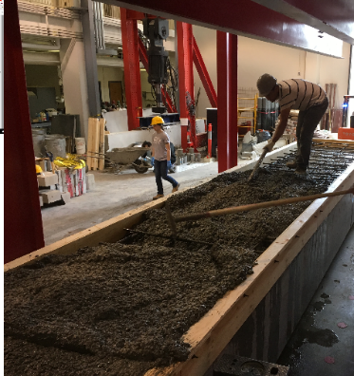

Figure 8: Casting the Deck Slab on Top of the B900 Box Girder in the Lab

* 1. **Instrumentation and Data Acquisition**

Instrumentation of the specimen consisted of surface mounted strain gauges, linear potentiometers (LPs), string potentiometers (SPs) and PI gauges. LPs and SPs were used to monitor deflections at either end of the girder (over the neoprene pads), at quarter points and at the mid-span on both sides of the girder. Strain gauges and PI gauges were used to monitor surface strains. Strain gauges and PI gauges were placed along the centerline of the girder as well as at the critical location of maximum moment under the rolling load to capture maximum strains (See Figure 9). A total of 11 strain gauges and 10 PI gauges were used in this test, but only the centreline strains are presented for discussion in this paper. The other instruments will be used in future tests. Relevant instrumentation for the centerline strain profile are SG3, which is located 75 mm below the slab surface; SG4, which is located 220 mm below the slab surface; and PI3, which is located 100 mm above the soffit of the girder.

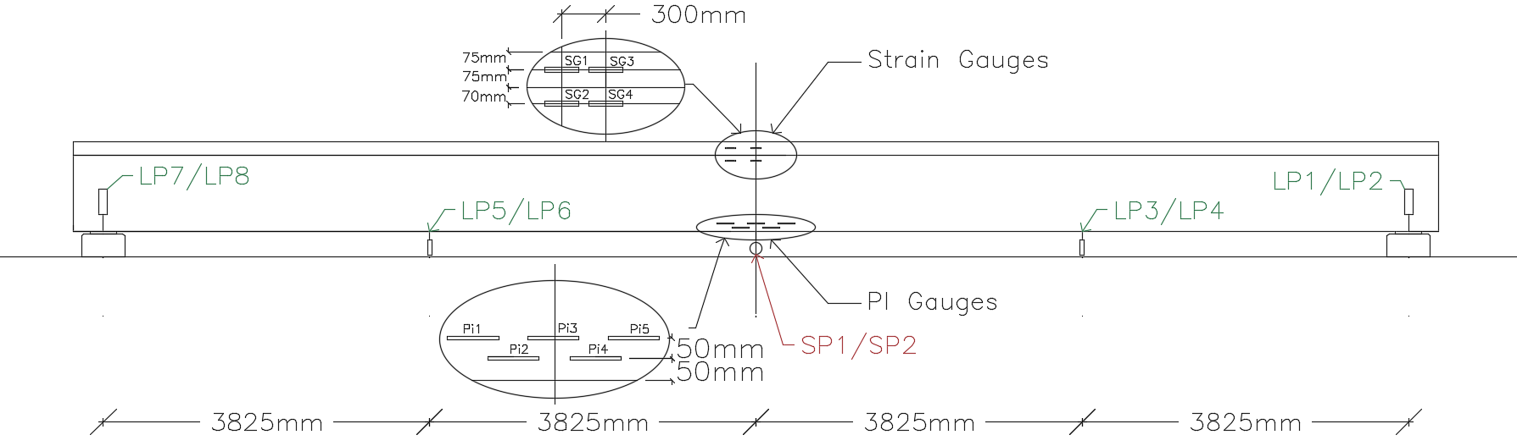

Figure 9: Instrumentation Layout of the B900 Girder

1. **TEST RESULTS AND DISCUSSION**

The MLS was successfully launched. The behaviour of the B900 girder in response to the applied service load is illustrated in this section. A 115 kN load was applied at each dual wheel as they rolled from one end of the travel path to the other end. During this test, the MLV travelled at a maximum speed of 1 m/s. Each cycle (from end to end and back) took 27 seconds at this speed. In cycling, as the MLV approached the centre of the girder, strains increased due to the applied loads at this location. An uneven strain distribution was observed across the width of the girder at the top surface of the slab (Figure 10). This is likely due to the relatively concentrated tire load at mid-width (Figure 4 (right)), which induces two-way bending in the slab. The maximum average strain at the slab surface is roughly 76 micro strain.

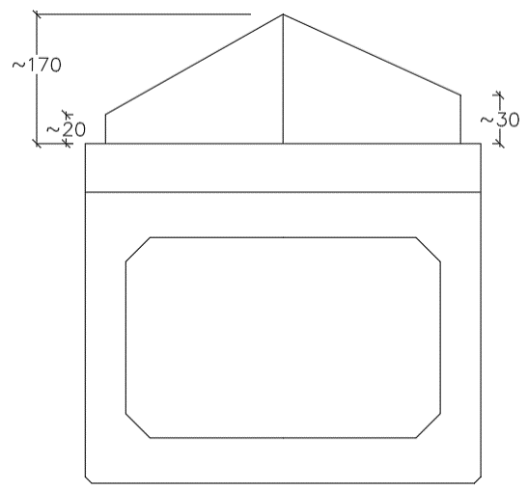

Figure 10: Top Strain at Three Locations Across Width (Plot Shows One Path to the End and Return)

Figure 11 shows the centerline strains at various locations along the depth of the girder, namely the average slab surface strains and strains from SG3, SG4 and Pi3 gauges, over five full cycles of moving loads. As the MLV travelled from one end of the MLS to the other, strain increased until the MLV was situated at the mid-span, then strains decreased as the MLV travelled away from the mid-span. The results obtained from SG3 were found to be unreliable. This strain gauge malfunctioned and was therefore omitted.

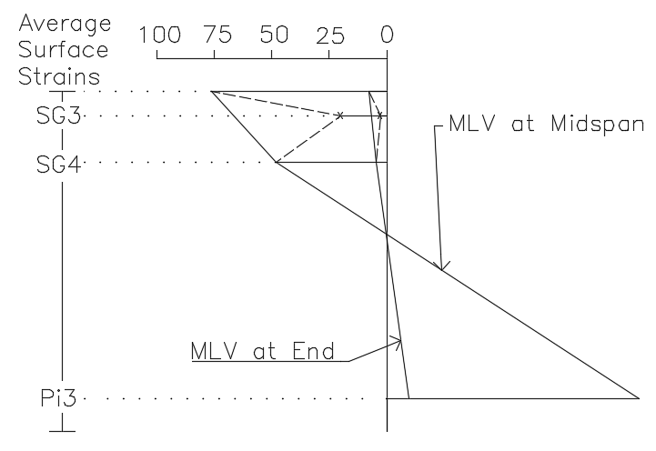

Figure 11: Centerline Strains

Figure 12 shows the deflections at various locations along the span of the girder, including mid-span (SP1 and SP2) over the five loading cycles. As the MLV moved from one end of the MLS to the other, mid-span deflections also increased to a maximum point at mid-span. It is noticed that small deflections occur over the supports due to the neoprene pads, and as the deflections on one end of the girder are high, the deflections at the other end are low, leading to the weaving patterns back and forth for LP1 and LP2 versus LP7 and LP8. The maximum deflection at mid-span under the service vehicle load is 4.9 mm. This is well within the acceptable service deflection limit of L/800.

Figure 11: Deflections along Span (SP1&2 at Mid-span and LP1, 2, 7 &8 at Supports)

1. **SUMMARY AND CONLCUSION**

A new Moving Load Simulator (MLS) was developed at Queen’s University, Kingston, ON, Canada and is considered the first in Canada and likely among very few in the world. The apparatus is characterized by its large scale where it covers a foot print of about 4.5 x 15 m. It has a maximum loading capacity of 250 kN, while moving. It includes two dual wheel sets of 1100 mm diameter, each representing a half axle of full scale truck. The two sets may be either 1.2 m or 2.4 m apart. The MLS is capable of reaching a maximum speed of 6 m/s at mid-length of the travel with an initial acceleration and final deceleration profiles with zero speed at either end. Each half axle load is 125 KN, which satisfies the highest load of the CL-625 of the CHBDC with maximum dynamic allowance. The MLS was successfully launched late 2017. This paper provides a summary description of the apparatus along with preliminary data from its first experiment conducted on a 900x1220x16000 mm full scale B900 prestressed concrete box girder topped with a cast-in-place 150 mm thick deck slab. Preliminary results show excellent performance of the MLS and logical test results of the girder, in terms of deflections at various locations along the span and strains along the depth and width at mid-span. To date, only a few dozens of cycles have been performed on the girder. The MLS is capable of conducting millions of loading cycles under realistic moving load conditions which is expected to be more critical to bridges compared to conventional stationary pulsating loading.

**Acknowledgements**

Funding for this apparatus was provided by Canada Foundation for Innovation (CFI) and Ontario Research Fund-Infrastructure (ORF). The authors are grateful to Queen’s University, particularly the Department of Civil Engineering and its faculty, staff and graduate students.

**References**

Association of Municipalities of Ontario (2015) “State of Ontario’s Roads and Bridges”, Public Sector Digest, March, pp. 11.

Government of Québec (2007) *Report of the Commission of inquiry into the collapse of a portion of the de la Concorde overpass*, October, pp. 198.

Bakht, B. and Jaeger, L. G. 1990. Bridge Testing – A Surprise Every Time. ASCE Journal of Structural Engineering, **Vol. 116** (Issue 5).

Richardson, P., Nelson, M. and Fam, A. 2014. Fatigue Behavior of Concrete Bridge Decks Cast

on GFRP Stay-in-Place Structural Forms. ASCE Journal of Composite Construction, **Vol. 18** (Issue 3).

Perdikaris, P. C. and Beim, S. 1988. RC Bridge Decks Under Pulsating and Moving Load. ASCE Journal of Structural Engineering, **Vol. 114** (Issue 3).