 | 10th International Conference on Short and Medium Span Bridges  Quebec City, Quebec, Canada,  July 31 – August 3, 2018 | 
A Novel Indirect Damage Assessment Method for Short and Medium Span Bridges
Mei, Qipei¹, Gül, Mustafa^{1,2}
¹ Department of Civil and Environmental Engineering, University of Alberta, Edmonton, Alberta, T6G 2W2, Canada
² mustafa.gul@ualberta.ca
Abstract: Bridge health monitoring is an important component for infrastructure maintenance. Traditional bridge health monitoring techniques require sensors to be installed on bridges, which is costly and time consuming. In order to resolve this issue, new damage detection techniques by installing sensors on passing-by vehicles on bridge and considering vehicle bridge interaction (VBI) have gained much attention from researchers in the last decade. In this paper, a novel statistical based damage detection technique utilizing data collected from sensors mounted on a large number of passing-by vehicles is introduced. In this approach, the acceleration data is first collected from all the vehicles within a certain period. Then, the features that are related to bridge damage are extracted using Mel-frequency cepstral coefficients. At last, the damage can be identified by comparing the distributions of these features using Kullback-Leibler divergence. The logic behind this method is that if we assume the distributions of vehicle configurations are similar within different periods, the distribution of the features should be similar if there is no damage in the bridge. In contrast, if the distributions of the features vary a lot, this could be a sign that damage has occurred. The results from the numerical analysis show that the approach not only can identify the existence of the damage, but also provide useful information about severity.

Introduction
With the aging of transportation infrastructure across Canada, there is an increasing demand for approaches to efficiently assess the current condition of bridge structures. Effective assessment of structures could not only improve the quality of transportation network but also aid the decision-making process regarding structural rehabilitation or replacement. In this context, vibration based structural health monitoring (SHM) has drawn much attention as an alternative to visual inspection methods, which avoids the subjectivity and has promising for automation. In last decades, a number of researchers developed various methods for SHM and verified them numerically and experimentally (Mei and Gül 2016, Gul and Catbas 2011, Zhu et al. 2012, Soh et al. 2000, Catbas et al. 2008).
However, the commonly used SHM techniques require sensors to be installed on bridges, which is costly and time consuming. At current stage, most of the decision makers or infrastructure owners do not consider to instrument all short and medium span bridges due to its significant cost. As an alternative to traditional SHM technique, an approach to detect damage on bridges based on data collected from passing-by vehicles is proposed (Yang et al. 2004, Li 2014, Keenahan et al. 2014, Kim et al. 2011). Although the research in this area has gained very promising results, there are still some challenges that are unresolved (Malekjafarian et al. 2015). First, according several numerical and lab experiments, the road profile would usually dominate the vibration response of vehicle, which makes the identification of bridge properties difficult. Second, the duration of vehicle bridge interaction (VBI) is usually limited, and thus the resolution of frequency spectrum is limited. Third, environmental and operational effects cannot be avoided.
In this paper, we propose a novel approach utilizing data from a large number of vehicles termed mobile sensor network and considering the VBI to overcome the issues about limited VBI time and reduce the operational effect. The concept of mobile sensor network has gained gradually increasing attention these years (Matarazzo et al. 2017, Harris et al. 2017, Ozer et al. 2015). Although the VBI time for a single vehicle is limited, the accuracy of damage detection can be improved by utilizing a large number of vehicles. Data from a large number of tests are also more robust to operational effect or measurement error.

Methodology
In this paper, Mel-frequency cepstral cepstrum (MFC) is first used to extract features, and then the distributions of the features are compared using Kullback–Leibler divergence. The logic behind our method is that when we compare the features extracted from a large number of vehicles, the distribution of features should be similar if there is no damage on bridge. In contrast, if damage occurs on a bridge, the difference of distributions should be larger.
  - Mel-frequency cepstral coefficients (MFCCs)
MFCCs are commonly used features in speech recognition and natural language processing. The major advantage of MFC compared to other frequency domain method is that it scans a wide range of frequencies and give higher weights to lower frequency. In SHM, there are only a few studies about utilizing MFC for damage detection (Dackermann et al. 2014, Zhang et al. 2011).
The procedure of calculating MFCCs is summarized as below:
- Calculate Fourier transform of acceleration data collected from a single vehicle.
- Apply Mel filter bank in Mel scale.
- Take the logarithm of the spectrum.
- Take discrete cosine transform of logarithmic spectrum.
Traditional Mel-frequency cestrum is designed to mimic human auditory system, which has a frequency range different than bridges. This phenomenon is also discussed in (Balsamo et al. 2014). Therefore, in this paper, a new Hertz-scale to Mel-scale mapping is designed to better represent the characteristics of bridges.
[]
[]
where f is the Hertz-scale frequency and m is the Mel-scale frequency. The relationship between points on Hertz-scale and Mel-scale are presented in Figure 1. The step is to map evenly spaced frequencies in Mel-scale to frequencies in Hertz-scale. As shown in the figure, we can see that lower hertz frequencies have smaller intervals while higher hertz frequencies have larger intervals. The width of intervals grows exponentially with frequency.
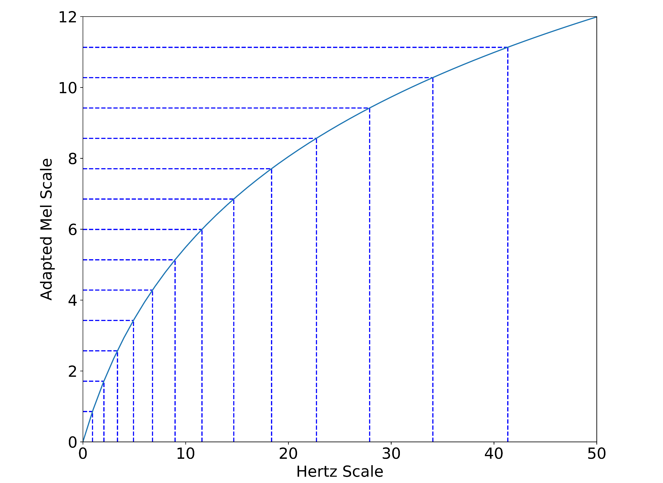
Figure 1: Transformation between Hertz Scale and Adapted Mel Scale
Then, we apply a series of triangular filters termed as filter bank to the spectrum of acceleration. The key points of the triangles in the filter bank are Hertz frequencies corresponding to evenly spaced Mel frequencies. An equation to define a key point is presented in Eq. 3.
[]
Then, the triangular filter bank is defined using the following equations:
[]
where H_{i}(k) is the i^{th} filter bank that is applied to the power spectrum. The plot of the above equations is shown in Figure 2. As shown in Eq. 5, it is simple to apply the filter bank calculated in Eq. 4 to the spectrum of acceleration signal since both of them are in frequency domain. Each triangle in the filter bank is applied to spectrum separately.
[]
where F(k) is the Discrete Fourier Transform (DFT) of the original acceleration signal. Then, the logarithms of the powers are taken at each of the Mel frequencies:
[]
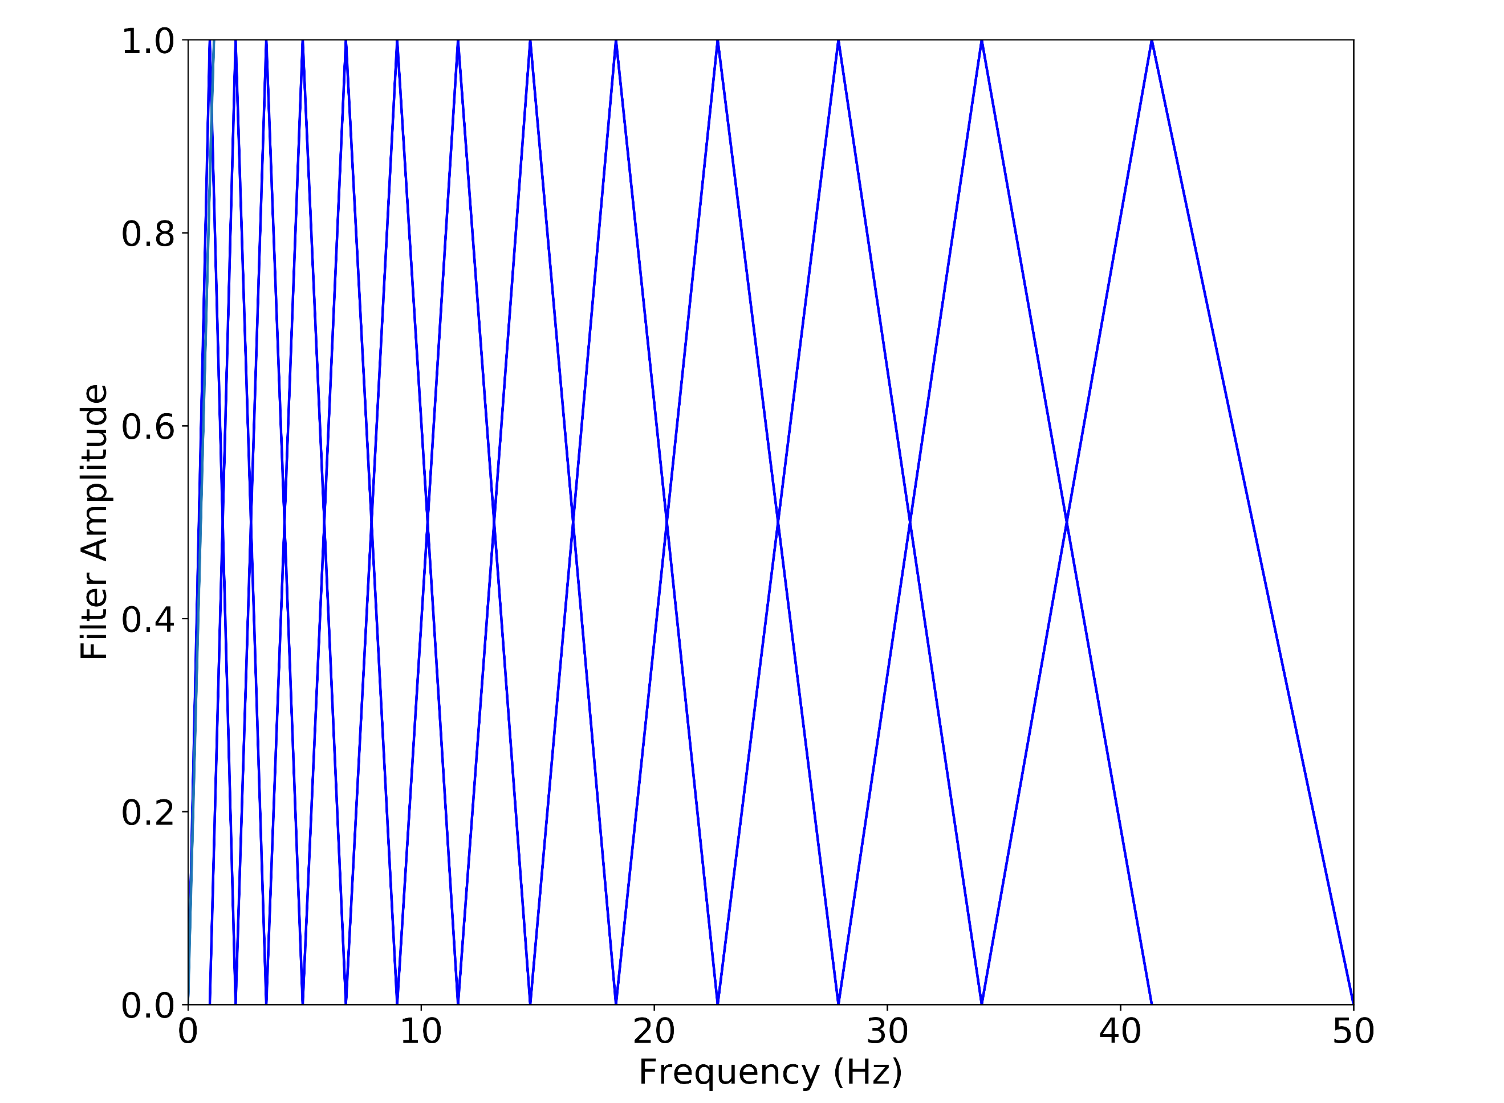
Figure 2: Filter bank for frequency ranging from 0 to 50 Hz
The last step of the MFC is to take the Discrete Cosine Transform (DCT) of the logged powers just like they are signals.
[]
where X_{j} is denoted as Mel-frequency cepstral coefficients or MFCCs. Practically, some of the coefficients are selected as features for further analysis.
  - Kullback–Leibler divergence
Kullback-Leibeler (KL) divergence is the technique that can be used to compare two probability distributions (Kullback and Leibler 1951). The general form of KL divergence is as below,
[]
where P and Q are the probability over set X. Derived from information theory, the KL divergence gives a measure of information loss when Q is approximated by P.
Regarding the proposed damage detection method, for baseline case, if there are m₁ vehicles and n features are extracted using MFCCs from each vehicle, the features can form a m₁×n matrix. The n features must follow a multi-variate distribution. For an unknown case, assuming that there are m₂ vehicle passing through the bridge, another m₂×n matrix based on MFC can be formed, which follows another multi-variate distribution. The damage can be identified by comparing these two distributions. Assuming both distributions are Gaussian, the KL divergence can be written as (Duchi 2007),
[]
Where μ₀ and μ₁ are the mean matrix and Σ₀ and Σ₁ are the covariance for baseline and unknown cases. k is the number of features.

Numerical Verification
  - Numerical Model
A numerical simply supported bridge with the same properties as described in (Yang et al. 2004) is introduced for numerical verification. The bridge is made of concrete, and is 25 m long, 2.357 m wide and 0.8485 m thick. As shown in Figure 3, a spring mass model is used to simulate the vehicle bridge interaction. In numerical model, the bridge is divided into 16 elements as presented in Figure 4.
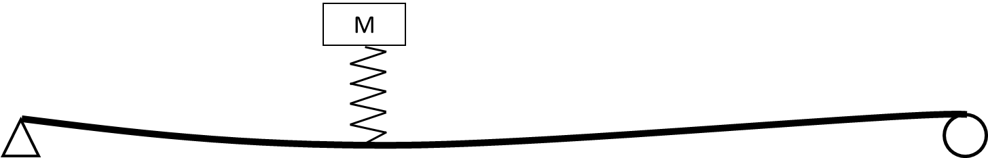
Figure 3: Spring mass vehicle bridge interaction model (adapted from (Yang et al. 2004))
Figure 4: Mesh grid of the bridge
As shown in Table 1, in order to simulate a large number of vehicles, the spring constant, weight and speed of the vehicles are varied. Therefore, there are 7×7×7=374 tests for each damage case. In real world, the number and the configuration of vehicles are different within different periods. To avoid using the same sets of vehicles for different damage cases, we sample 80% of the tests (80% * 374 = ~300) for each case. In this way, the vehicles would be different for different damage cases. The process is repeated 10 times to verify the robustness of the method. Besides, in order to simulate the measurement error and operational effect, all data are corrupted with 5% artificial noise.
Table 1: Variation of vehicle configurations
 | 1 | 2 | 3 | 4 | 5 | 6 | 7
Weight (kg) | 480 | 720 | 960 | 1200 | 1440 | 1680 | 1920
Speed (m/s) | 4 | 6 | 8 | 10 | 12 | 14 | 16
Spring Constant (kN/m) | 200 | 300 | 400 | 500 | 600 | 700 | 800
As described below, to verify the approach, 3 damage cases as well as a validation case is introduced. DC1, DC2 and DC3 are related to stiffness reduction of elements 7 and 8 at mid-span. DC3 is from boundary condition changes at both ends.
- DC0: No damage (validation case)
- DC1: 10% reduction of stiffness at mid-span
- DC2: 20% reduction of stiffness at mid-span
- DC3: 30% reduction of stiffness at mid-span
- DC3: Both ends are changed to fixed supports.
  - Results and interpretations
The results for DC1 to DC3 are presented in Figure 5. In these three damage cases, stiffness reduction is artificially applied at mid-span of the bridge. It is seen that all 3 damages are identified successfully. The validation case has the lowest damage features (DFs), DC1, DC2 and DC3 have DFs of about 0.07, 0.15 and 0.35. It is noted that the damage features increase exponentially as damage become more severe. Since we need to sample the vehicles from our vehicle configurations to make sure not exactly the same vehicles are used for different damages, we repeat the process 10 times to investigate the robustness of our method. From Figure 5, we can see that different the results from different sampling process are very close to each other compared to different damage cases. It is proven that the damage detection method is robust to the slight difference in distribution of vehicle configurations.
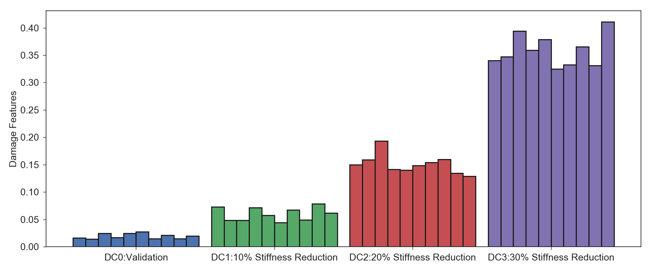
Figure 5: KL divergence for DC1 – DC3
Unlike previous damage cases, boundary condition changes at both ends are very severe damage. In Figure 6, we can see that the DFs have increased to 6. It should be noted that such big difference is caused by the fact that DFs increase exponentially with severity. The DFs for DC4 is also robust to the sampling process.
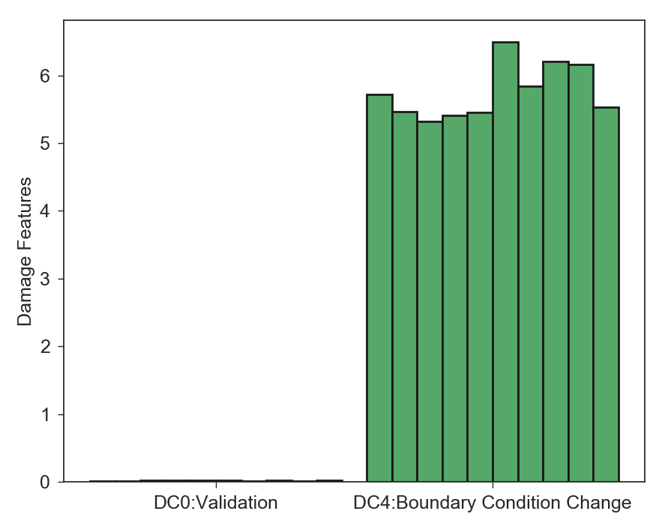
Figure 6: KL divergence for DC4

Conclusions
In this paper, a novel damage detection method taking advantage of a large number of vehicles is proposed. The method that is derived from MFCCs and KL divergence is presented. From the numerical analysis, it is concluded that the method is very sensitive to the damage and robust to noise. As the damage become more severe, the DFs increase accordingly. The method has the potential to monitor a population of bridges simultaneously thanks to the large number of vehicles. However, it should be acknowledged that this study is still very preliminary. More detailed investigation including more complex numerical models and more realistic lab experiments will be introduced in the future. In addition, the capability of the method to localize damage will be investigated as well.

References
Balsamo, L., Betti, R., and Beigi, H. 2014. A Structural Health Monitoring Strategy Using Cepstral Features. Journal of Sound and Vibration 333 (19):4526-4542.
Catbas, F.N., Gul, M., and Burkett, J.L. 2008. Conceptual Damage-Sensitive Features for Structural Health Monitoring: Laboratory and Field Demonstrations. Mechanical Systems and Signal Processing 22 (7):1650-1669.
Dackermann, U., Smith, W.A., and Randall, R.B. 2014. Damage Identification Based on Response-Only Measurements Using Cepstrum Analysis and Artificial Neural Networks. Structural Health Monitoring 13 (4):430-444.
Duchi, J. 2007. Derivations for Linear Algebra and Optimization. Berkeley, California.
Gul, M., and Catbas, F.N. 2011. Damage Assessment with Ambient Vibration Data Using a Novel Time Series Analysis Methodology. Journal of Structural Engineering 137 (12):1518-1526.
Harris, D.K., Alipour, M., Acton, S.T., Messeri, L.R., Vaccari, A., and Barnes, L.E. 2017. The Citizen Engineer: Urban Infrastructure Monitoring Via Crowd-Sourced Data Analytics. Structures Congress 2017.
Keenahan, J., OBrien, E.J., McGetrick, P.J., and Gonzalez, A. 2014. The Use of a Dynamic Truck–Trailer Drive-by System to Monitor Bridge Damping. Structural Health Monitoring 13 (2):143-157.
Kim, C.-W., Isemoto, R., Toshinami, T., Kawatani, M., McGetrick, P., and O'Brien, E.J. 2011. Experimental Investigation of Drive-by Bridge Inspection. 5th International Conference on Structural Health Monitoring of Intelligent Infrastructure (SHMII-5), Cancun, Mexico, 11-15 December, 2011.
Kullback, S., and Leibler, R.A. 1951. On Information and Sufficiency. The annals of mathematical statistics 22 (1):79-86.
Li, Z. 2014. "Damage Identification of Bridges from Signals Measured with a Moving Vehicle." HKU Theses Online (HKUTO), The University of Hong Kong (Pokfulam, Hong Kong).
Malekjafarian, A., McGetrick, P.J., and OBrien, E.J. 2015. A Review of Indirect Bridge Monitoring Using Passing Vehicles. Shock and Vibration 2015.
Matarazzo, T., Vazifeh, M., Pakzad, S., Santi, P., and Ratti, C. 2017. Smartphone Data Streams for Bridge Health Monitoring. Procedia Engineering 199 (Supplement C):966-971.
Mei, Q., and Gül, M. 2016. A Fixed-Order Time Series Model for Damage Detection and Localization. Journal of Civil Structural Health Monitoring 6 (5):763-777.
Ozer, E., Feng, M.Q., and Feng, D. 2015. Citizen Sensors for Shm: Towards a Crowdsourcing Platform. Sensors 15 (6):14591-14614.
Soh, C., Tseng, K.K., Bhalla, S., and Gupta, A. 2000. Performance of Smart Piezoceramic Patches in Health Monitoring of a Rc Bridge. Smart materials and Structures 9 (4):533.
Yang, Y.B., Lin, C.W., and Yau, J.D. 2004. Extracting Bridge Frequencies from the Dynamic Response of a Passing Vehicle. Journal of Sound and Vibration 272 (3–5):471-493.
Zhang, G., Harichandran, R.S., and Ramuhalli, P. 2011. Application of Noise Cancelling and Damage Detection Algorithms in Nde of Concrete Bridge Decks Using Impact Signals. Journal of Nondestructive Evaluation 30 (4):259-272.
Zhu, D., Guo, J., Cho, C., Wang, Y., and Lee, K.-M. 2012. Wireless Mobile Sensor Network for the System Identification of a Space Frame Bridge. Mechatronics, IEEE/ASME Transactions on 17 (3):499-507.

