 | 10th International Conference on Short and Medium Span Bridges  Quebec City, Quebec, Canada,  July 31 – August 3, 2018 | 

DETERMINATION OF THE DYMANIC COMPONENT OF VEHICLE LOADS FOR THE BLUCHER BRIDGE
Doan, Kien T.¹, Sparling, Bruce F.² and Feldman, Lisa R.^{3,4}
¹ Ph.D. Candidate, University of Saskatchewan, Canada
² Professor & Associate Dean Academic, University of Saskatchewan, Canada
³ Associate Professor, University of Saskatchewan, Canada
⁴lisa.feldman@usask.ca
Abstract: The dynamic response of vehicle loads is difficult to isolate using theoretical methods given the number of influencing parameters. Field testing has therefore been recommended as a more effective method and is implemented for a short span precast and prestressed concrete box girder bridge located in Blucher, Saskatchewan that was originally constructed in 1984. The bridge was instrumented with strain gauges and subject to 108 test truck runs. A subsequent analysis of the test data was made assuming that the dynamic component of the measured bridge response was independent of the static component and occurred randomly for each vehicle run. Filtering techniques were used to separate the static and dynamic components of bridge response to truck loads and a Monte Carlo simulation was then used to estimate the dynamic truck load component based upon the measured traffic volume for this bridge. The dynamic component of the vehicle load for the Blucher Bridge was determined to be approximately 15% and therefore markedly lower than the dynamic load allowance prescribed by the Canadian Highway Bridge Design Code. This difference may be attributed, in part, to the bridge’s short span and relatively stiff cross-sectional geometry.
- INTRODUCTION
In rural municipalities in Saskatchewan, there are a total of 1720 bridges in place to service the transportation network of the province. Many of these bridges are nearing the end of their nominal service lives and, as a result, require careful monitoring and evaluation. For example, more than 45% of those bridges are older than 50 years old (SARM 2013). As part of any evaluation, it is necessary to estimate the peak load effects likely to occur in critical bridge elements over a specified reference period, based on regional traffic conditions.
One of the factors contributing to design load effects is the dynamic component of the bridge response to vehicular traffic. Although dynamic bridge load effects have been investigated extensively both analytically and experimentally by a number of researchers, it is generally acknowledged that this issue has not been fully resolved due to the large number of uncertainties involved (Paultre et al. 1992, Deng et al. 2014). However, field testing has been identified as the most dependable method for evaluating the dynamic impact factor for highway bridges (Billing 1984, Paultre et al. 1995, Cantieni 1992, Nassif et al. 1995, Kim et al. 1997, Ashebo et al. 2007) and has been used as the basis for calibration of dynamic loading provisions in current bridge design codes, including the Canadian Highway Bridge Design Code (CSA 2014).
In the current study, full-scale field testing was undertaken to investigate the dynamic response characteristics of a prestressed concrete girder bridge located on a gravel road in the rural municipality (RM) of Blucher, Saskatchewan. This work formed part of a broader research program aimed at developing a new truck loading model designed specifically for short-span bridges in rural Saskatchewan.
Ideally, bridge testing should consider responses to the range of real vehicles likely to pass over the bridge during its service lifetime, addressing such factors as vehicle speeds, axle weights and configurations, and potential driving paths. Due to the very low traffic volumes on these rural roadways, however, the time required to collect statistically reliable traffic data of this type would have been prohibitive. For example, in one study carried out at a total of 3743 traffic counting stations in rural Saskatchewan, 1990 locations (53% of the total) were observed to experience average daily truck traffic (ADTT) of less than 10 (SMHI 2012), with many seeing only 1 or 2 large trucks per day. Consequently, controlled load tests were adopted in the current investigation as a more feasible alternative to the use of ambient traffic. In this way, measured responses to a known test truck were obtained for well-defined trials featuring different vehicle speeds, driving paths and directions of travel.
- DESCRIPTION OF THE TEST BRIDGE AND TEST TRUCK RUNS
    - Geometry and Instrumentation of the Blucher Bridge
The Blucher Bridge was constructed in 1984 and is located in south-central Saskatchewan at a latitude of 51°52’54” and a longitude of 106°16’7”. The single-span bridge crosses a small, unnamed stream and has a length of 6 m and a width of 7.2 m. Figure 1 shows that the superstructure is composed of a gravel wearing surface on 6 shear-connected precast and prestressed concrete box girders that are each 1200 mm wide by 500 mm deep. Figure 1 shows that the girders are numbered from the south to north end of the bridge with girder G1 being the exterior girder on the south end and girder G6 the exterior girder on the north end. The girders are supported on each end by 300 mm wide by 250 mm deep timber pile caps each supported by seven 250 mm diameter timber piles spaced at approximately 1.3 m on centre.
Figures 1 and 2 show the location of the five accelerometers (labelled as A1 to A5), six linear variable displacement transducers (LVDTs) (labelled as L1 to L6 in the figures), and 36 strain gauges (identified as S#### in Figures 1 and 2) used to instrument the Blucher Bridge. Thirty of the total 36 strain gauges were affixed to the underside of the girders, with 18 located at midspan and 12 located at the quarter points of the span. The remaining 6 strain gauges were affixed to the exposed side of the two exterior girders (i.e. Girders G1 and G6) at the girder midspan, with one strain gauge fastened near the bottom, mid-height, and top of these two girders. All sensors were connected to the high-speed data acquisition system that was used to collect data at a rate of 500 Hz. The analysis included in this paper is based exclusively on data collected by the strain gauges.
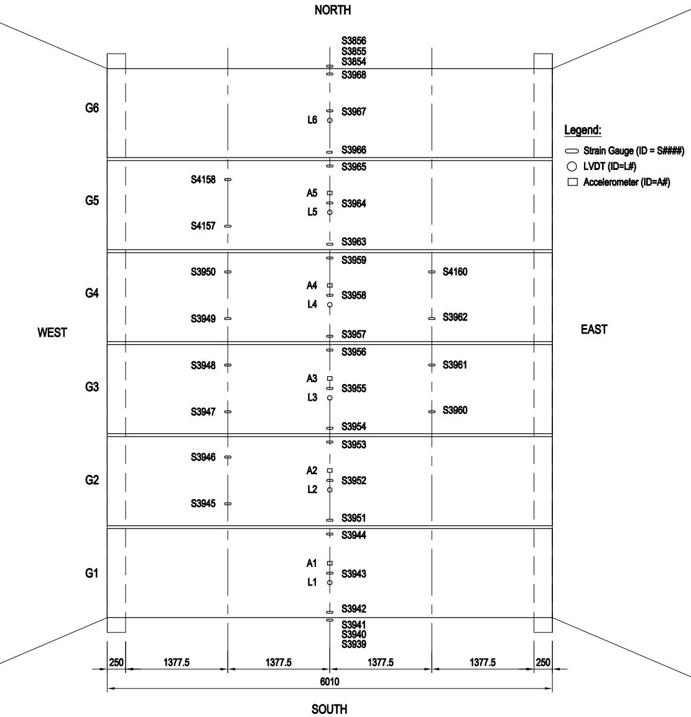
Figure 1: Plan of the instrumented bridge in RM of Blucher

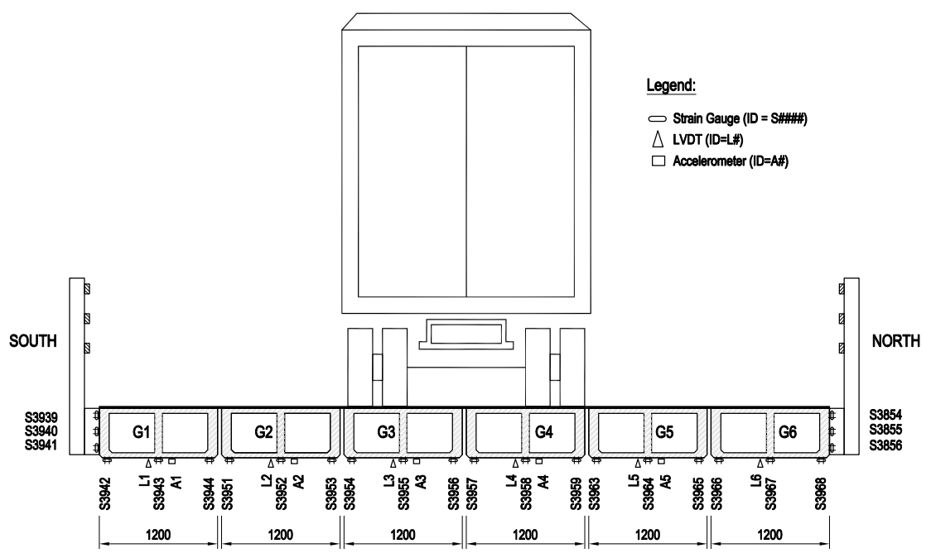
Figure 2: Cross-section of the instrumented bridge at mid-span (view from the east)
- Test Truck Runs
Figure 3 shows the truck used for the test runs. Axle weights, as shown in Figure 3(b) were determined on-site using a portable scale. A total of 108 test runs were conducted with an equal number of runs having the test truck located: in the north lane (designated as within 1.4 m of the outer edge of girder G1), the middle 1.4 m of the bridge, and the south lane (designated as within 1.4 m of the outer edge of girder G6). Lines were painted on the wearing surface to assist the driver in positioning the truck for all test runs. Target vehicle speeds for the runs ranged from 5 km/hr, representing the static condition, to 90 km/hr. This maximum speed was selected based on the recommendation of the experienced test truck driver, taking into consideration the very low traffic volume condition of the bridge site at the time of the test. A traffic counter located adjacent to the west end of the bridge was used to record the actual vehicle speed for each test run.
  a) | 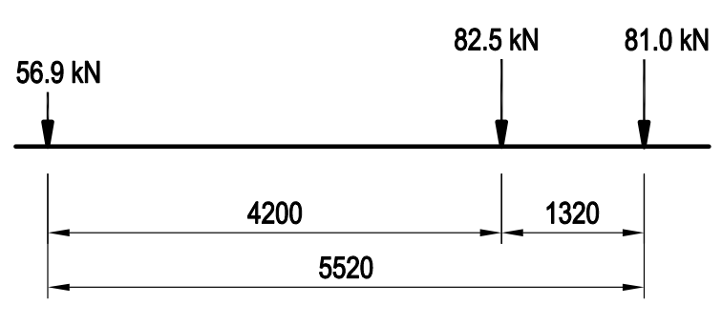  b)
Figure 3: The test truck: a) photo of the test truck, and b) test truck loading configuration

- ESTIMATION OF THE DYNAMIC COMPONENT OF LIVE LOAD
The relationship between the static and dynamic components of vehicle loads has a decided effect on the development of an appropriate truck load model and the calibration of its corresponding live load factor. While some disagreement was found in the literature regarding whether or not the static and dynamic components of vehicle loads are interdependent or not, most researchers concluded that they generally do not show a strong correlation (e.g. Billing 1984, Kim et al. 1997, Hwang & Nowak 1991). The assumption of independence of the static and dynamic components of vehicle loads ultimately formed the basis for the calibration of load factors included in the Canadian Highway Bridge Design Code (Kennedy et al. 1992). This assumption is therefore used in this work when evaluating the results of load testing for the Blucher Bridge.
The dynamic amplification, DA, is calculated as follows when based on the results of field testing:
[1] $\text{DA}=\frac{R_{\text{dyn}}−R_{\text{sta}}}{R_{\text{sta}}}$
where R_{dyn} and R_{sta} are the dynamic or total response and static responses, respectively, based upon the effect of vehicle loads for any test truck run. Bahkt et al. (1989) have acknowledged that different values of DA may result depending on whether the absolute maximum values of both R_{dyn} and R_{sta} are incorporated in Eq. 1, or are assumed to occur simultaneously.
Subsequently, the dynamic amplification may be calculated using Equation 2 if the intent is to calibrate measured values for use in the Canadian Highway Bridge Design Code:
[2] $\text{DA}=\overline{\text{DA}}\frac{\left(1+\text{SVβ}\right)}{α_{L}}$
where $\overline{\text{DA}}$ is the mean value resulting from measured values of the dynamic amplification as obtained from results of test truck runs, S is a sensitivity or separation factor, V is the coefficient of variation, $β$is the target reliability index, and $α_{L}$ is the live load factor which was taken as 1.4 in the work of Billing (1984). Billing incorporated a target reliability index of 3.5 in his work to estimate the load factor for the dynamic component of live load from a sample of a variable. It can be induced that it was not intended to represent any specific reference period such as 1, 50, or 75 years. In the other words, the dynamic amplification calculated by Billing did not include a specific period that relates to the number of vehicle events. As a result, this approach was not consistent with that used for $β$ values that were meant to be representative of specific reference periods, and thus may be more appropriate for structural evaluation (Kennedy et al. 1992).
The total factored traffic load effect (including static and dynamic load effects) for new design or structural evaluation, L, is then calculated in accordance with Clauses 3.8.3, 3.8.4.5, and 14.9.3 of the Canadian Highway Bridge Design Code (CSA 2014) as:
[3] $L=α_{L}R_{\text{CL}−W}\left(1+\text{DLA}\right)$
where R_{CL-W} is the static truck load effect resulting from the CL-W truck load model, and DLA is the dynamic load allowance. Generally, the dynamic amplification value, DA, and the dynamic load allowance, DLA, are considered to be synonymous; however, DAs are determined for a particular truck located at a specific position on a certain bridge, while DLAs are values calibrated for inclusion in design codes based upon reported DA resulting from numerous bridge testing programs.
  - Processing of Data Obtained from the Blucher Bridge
Following the recommendations made by others (Paultre et al. 1992, Bakht et al. 1989), only data from the 12 strain gauges affixed to the soffits of girders G2 to G5 at their midspan locations were included in the analyses as these gauge locations were within the influence zone for the middle traffic lane. Low pass filters included in Matlab were used to eliminate signal noise with frequencies in excess of 50 Hz from the collected test data. Figures 4(a) and (b) show examples of measured and filtered responses, respectively, for a select strain gauge and test truck run. In total, 108 values of the dynamic and corresponding static response for each of the 12 strain gauges were collected, corresponding to the number of test truck runs conducted. As a result, 108 values of the dynamic and corresponding static response for each of the 12 strain gauges were calculated.
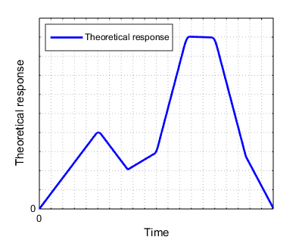  a) | 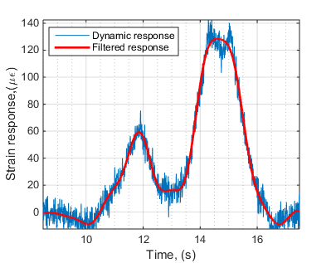  Strain response (με)  b)
Figure 4: Bridge response at midspan under the test truck loading configuration: a) form of theoretical static response, and b) measured responses - sensor S3955
The difference between the dynamic or total vehicle response, R_{dyn}, and the static response, R_{sta}, as included in the numerator of Equation 1 was calculated for the Blucher Bridge using the maximum values of these two terms (Paultre et al 1995, Billing 1984, Wang et al. 2016); therefore, those two values do not necessarily coincide with the test truck being located at the same position on the bridge for test truck runs at various speeds. Figure 5 shows a plot of the dynamic versus static components of bridge response for all 12 strain gauges. This figure, supplemented with information provided in Table 1, shows that the correlation between the dynamic and static components of response is weak, with an average value of the correlation coefficient of -0.14. These results validate the assumption that these two components are independent of each other.
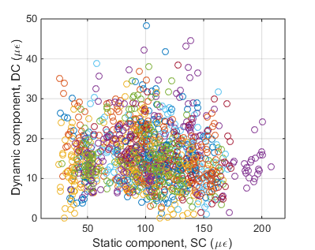
Dynamic component, DC (με)
Figure 5: Correlation between DC and SC for the Blucher Bridge

Table 1: Correlation coefficients between DC and the other factors (SP and SC) in sensors at mid-span

 | G2 |  |  | G3 |  |  | G4 |  |  | G5
 | S3951 | S3952 | S3953 | S3954 | S3955 | S3956 | S3957 | S3958 | S3959 | S3963 | S3964 | S3965
SP | -0.08 | -0.25 | -0.21 | 0.00 | -0.24 | -0.06 | 0.13 | 0.02 | -0.08 | 0.11 | 0.01 | 0.25
SC | 0.05 | -0.07 | -0.10 | -0.43 | -0.21 | -0.33 | -0.34 | -0.11 | -0.05 | -0.12 | 0.08 | -0.03
Figure 6 shows the calculated dynamic component of bridge response versus the speed of the test truck for all 12 strain gauges and all test truck runs. Table 1 additionally shows the correlation coefficients as calculated for each strain gauge. Figure 6 shows that calculated values of the dynamic component of bridge response vary considerably at each truck speed level; furthermore, it was noted that the dynamic component was independent of the lane in which the truck travelled. Table 1 shows that the resulting mean value of the correlation coefficient is equal to -0.033 which suggests that the dynamic component of bridge response is independent of vehicle speed. This conclusion is consistent with that reported by others (Ashebo et al. 2007).
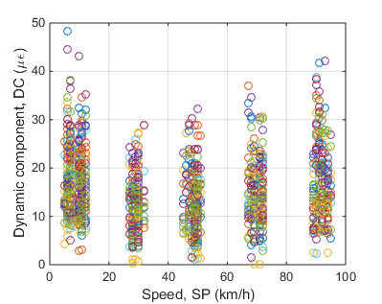
Dynamic component, DC (με)
Figure 6: Correlation between DC and SP for the Blucher Bridge
A Monte Carlo simulation, as described elsewhere (Doan et al. 2016), was then conducted to determine the extreme values of the dynamic component of bridge response for reference periods of 1, 5, and 75 years. Figure 7 shows an example of the probability distribution of the dynamic component of bridge response for a sample strain gauge. Values calculated from the strain gauge data are compared to the fitted values of the same parameter assuming a normal distribution and a good fit was obtained. For this reason, the distribution of the dynamic component of bridge response was assumed to follow a normal distribution as required for input to the Monte Carlo simulation. For this simulation, total numbers of loading events within selected reference periods for one of the heaviest truck classes, truck class 10, were obtained from traffic count data as provided by the Saskatchewan Ministry of Highways and Infrastructure (SMHI 2012).
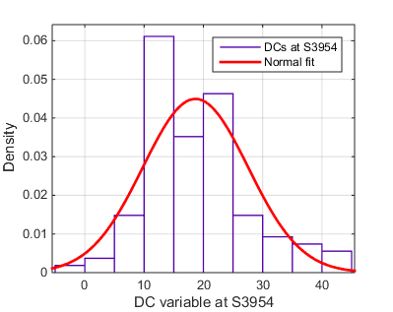  Density  a) | 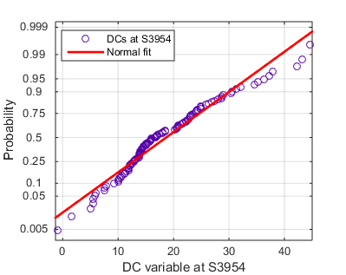  Probability  b)
Figure 7: DC variable for S3954: a) histogram; b) probability plot
  - Resulting Values of the Dynamic Component of Bridge Response
Figures 8(a) and (b) show the resulting absolute values and those calculated as a fraction of the maximum static component of bridge response, respectively, for the mean values of samples and mean extreme values for the 1, 5, and 75 year reference periods as a function of the position across the bridge width at the midspan of the girders. Figure 8(b) shows that the resulting average values of the mean extreme dynamic component of the bridge response are 21.8, 23.0, and 24.8% of the maximum static component of bridge response for the 1, 5, and 75 year reference periods, respectively.
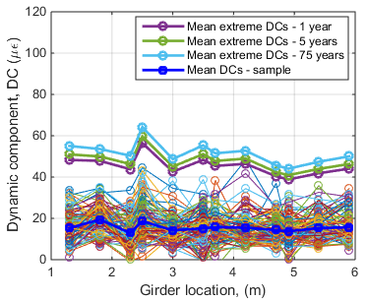  Dynamic component, DC (με)  a) | b)  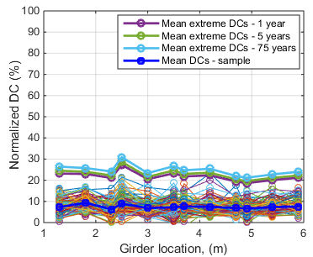  Normalized DC (%)
Figure 8: Dynamic components of bridge response for the Blucher Bridge: a) absolute values; b) values normalized by maximum static test truck load effect
The value of the maximum static component of bridge response was then normalized with respect to the CL-625 model truck as included in the Canadian Highway Bridge Design Code. The resulting ratio between the maximum static total bending moment effect at the girder midspan due to the test truck to that of the CL-625 model truck is 0.6. The resulting normalized dynamic component of the bridge response to the test truck, as shown in Figure 8(b), was therefore multiplied by 0.6. Figure 9 shows the dynamic component of bridge response, normalized by the CL-625 model truck, as a function of the position across the bridge width. These normalized values of the dynamic component of bridge response are equivalent to the dynamic amplification. Mean extreme values of the dynamic amplification are approximately equal to 13.0, 13.8, and 14.8% for the 1, 5, and 75 year reference periods, respectively.
It is widely recognized (e.g. Paultre et al. 1992, Deng et al. 2014, Kim et al. 2007) that road surface roughness strongly influences the dynamic load allowance and results in relatively high values for gravel wearing surfaces, as is the case for the Blucher Bridge. The bridge’s short span length and relatively stiff cross-sectional geometry appear to be overriding factors that result in calculated values of the dynamic load allowance that are substantially less that the 30% value specified in Clause 3.8.4.5.3 of the Canadian Highway Bridge Design Code.
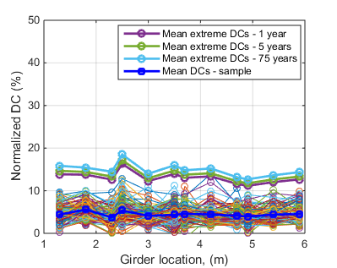
Normalized DC (%)
Figure 9: Dynamic components of truck response for the Blucher Bridge normalized by the CL-625 model truck
- SUMMARY AND CONCLUSIONS
The Blucher Bridge, located in south-central Saskatchewan, is a 6 meter long single span bridge with a superstructure consisting of shear-connected precast and prestressed concrete box girders and a gravel wearing surface. The bridge was instrumented and subjected to test truck runs at speeds ranging from 5 to 90 km/hr. The focus of this paper was to establish, based upon the results of strain gauge data and a subsequent Monte Carlo simulation of extrapolation of extreme values, a representative value of the dynamic amplification for this bridge.
The following significant conclusions are noted:
- The mean value of the correlation coefficient between the dynamic and static components of bridge response obtained from the field test data is weak. This result is consistent with that reported by others, and confirms that the dynamic and static components may be considered statistically independent of each other.
- The dynamic component of bridge response was determined to be independent of vehicle speed and so is consistent with the findings reported in other works.
- Mean extreme values of the dynamic amplification were found to be approximately equal to 13.0, 13.8, and 14.8% for the 1, 5, and 75 year reference periods, respectively. These values are relatively constant for all reference periods, and are considerably less than the value of 30% prescribed by the Canadian Highway Bridge Design Code. This result is likely attributed to the bridge’s short span and relatively stiff cross-sectional geometry.
Acknowledgements
This research project is being funded by the Saskatchewan Association of Rural Municipalities and the Saskatchewan Ministry of Highways and Infrastructure. Scholarship support for the first author from the VIED Fellowship of the Ministry of Education of Vietnam and the University of Saskatchewan is also gratefully acknowledged.

References
Ashebo, D.B., Chan, T.H.T., Yu, L. 2007. Evaluation of Dynamic Load on a Skew Box Girder Continuous Bridge. Part II: Parametric Study and Dynamic Load Factor. Engineering Structures, 29: 1064-1073.

Bakht, B., Pinjarkar, S.G. 1989. Dynamic Testing of Highway Bridges – A Review. Transportation Research Record 1223, Transportation Research Board, Washington, DC: 93 – 100.

Billing, J.R. 1984. Dynamic Loading and Testing of Bridges in Ontario. Canadian Journal of Civil Engineering, 11: 833 – 843.

Canadian Standards Association. 2014. CAN/CSA-S6-14: Canadian Highway Bridge Design Code. Canadian Standards Association, Mississauga, ON, Canada.

Cantieni, R. 1992. Dynamic Behavior of Highway Bridges Under the Passage of Heavy Vehicles. Report No. 220, Dr. Sc. Techn., Section Concrete Structures, Swiss Federal Laboratories for Materials Testing and Research (EMPA), CH-8600, Dubendorf, Switzerland.

Deng, L, Yu, Y., Zou, Q., Cai, C.S. 2014. State-of-Art-Review of Dynamic Impact Factors of Highway Bridges. Journal of Bridge Engineering, 20(5): 04014080(14).

Doan, K., Sparling, B.F., Feldman, L.R. 2016. Methods of Comparing Extreme Load Effects Based on Weigh-in-Motion Data. In Proceedings of the 5th International Structural Specialty Conference of the 2016 Annual Conference of the Canadian Society for Civil Engineering, 1- 6 June, London, ON, Canada: STR-846.

Hwang, E.S., Nowak, A.S. 1991. Simulation of Dynamic Load for Bridges. Journal of Structural Engineering, 117: 1413 – 1434.

Kennedy, D.J.L., Gagnon, D.P., Allen, D.E., MacGregor, J.G. 1992. Canadian Highway Bridge Evaluation: Load and Resistance Factors. Canadian Journal of Civil Engineering, 19: 992 – 1006.

Kim, S., Nowak, A.S. 1997. Load Distribution and Impact Factors for I-Girder Bridges. Journal of Bridge Engineering, 2(3): 97 – 104.
Kim, C.W., Kawatani, M. and Kwon, Y.R. 2007. Impact Coefficient of Reinforced Concrete Slab on a Steel Girder Bridge. Engineering Structures 29: 576-590.
Nassif, H.H., and Nowak, A.S. 1995. Dynamic Effect of Truck Load on Girder Bridges. Road Transportation Technology 4, University of Michigan, Transportation Research Institute, Ann Arbor, 1995.

Paultre, P., Chaallal, O., Proulx, J. 1992. Bridge Dynamics and Dynamic Amplification Factors – Review of Analytical and Experimental Findings. Canadian Journal of Civil Engineering, 19: 260 – 278.

Paultre, P., Proulx, J., Talbot, M. 1995. Dynamic Testing Procedures for Highway Bridges Using Traffic. Journal of Structural Engineering, 121(2): 362 – 376.

SARM. 2013. Rural Bridge Inventory in Saskatchewan. Saskatchewan Association of Rural Municipalities, Regina, SK, Canada.

SMHI. 2012. Traffic Count Program. Saskatchewan Ministry of Highways and Infrastructure. Regina, SK, Canada.

Wang, W., Deng, L. 2016. Impact Factor for Fatigue Design of Steel I-Girder Bridges Considering the Deterioration of Road Surface. Journal of Bridge Engineering, 21(5): 04016011-1:04016011-10.

