|  |  |  |
| --- | --- | --- |
|  | 10**th** International Conference on Short and Medium Span Bridges  Quebec City, Quebec, Canada,  July 31 – August 3, 2018 |  |

Widening and Strengthening of Crowchild Trail Bridge Over Bow Trail

Afhami, Shahab1,2, Gow, Matthew1

1 COWI North America Ltd., Canada

2 [shaf@](mailto:shaf@)cowi.com

**Abstract:** Constructed in 1968, Northbound Crowchild Trail Bridge over Bow Trail is located west of downtown Calgary on a horizontal curve. This three-cell concrete box girder bridge consists of eight continuous spans varying from 18 to 31 metres. The bridge requires rehabilitation and widening from 11.9 m to 14.1 m to accommodate three traffic lanes. The widening work includes removing the existing deck overhangs, constructing new pier caps, widening the existing abutment seats, installing new bearings, casting and post-tensioning new concrete webs composite with the existing exterior webs, and casting new deck overhang. The substructure and foundations were carefully analyzed for the increased dead and live loads, and the articulation of the bearings is permanently revised as an alternative to costly strengthening of piles, pile caps and piers. With an average annual weekday traffic of 107,000 on Crowchild Trail, traffic accommodation during construction is one of the major considerations. The mandate is to maintain two lanes of vehicular traffic on the bridge during the construction; two construction seasons are allocated to complete the bridge widening economically. The first construction season will see widening and longitudinal post-tensioning on a single side of the bridge prior to winter shut down. The asymmetric cross section and post-tensioning at this stage would generate excessive lateral deformations if adequate lateral restraints were not provided during construction. To address this, the construction sequence and other practical considerations were integrated into the design of strengthening and post-tensioning. Short-term lateral supports are introduced to maintain bridge geometry until the widening and post-tensioning are complete on both sides of the deck. This paper presents the design of the rehabilitation and widening measures, the perceived construction sequence, and how the sequence and other practical considerations are integrated into the strengthening and post-tensioning design.

# Introduction

In 2017, City of Calgary awarded the construction of the Crowchild Trail over Bow River Corridor Improvement. The project includes widening and rehabilitation of four major bridge structures. The team of COWI and WSP were responsible for the assessment, design, and construction supervision of the widening and strengthening of the North Bound Crowchild Trail Bridge over Bow Trail (Figure 1). The City required widening and rehabilitation of this bridge to accommodate 3 traffic lanes and provide additional 35 years of life. With an average annual weekday traffic of 107,000 on Crowchild Trail, it was mandated to provide a design that permits two traffic lanes during the construction of the bridge widening (Calgary 2016).

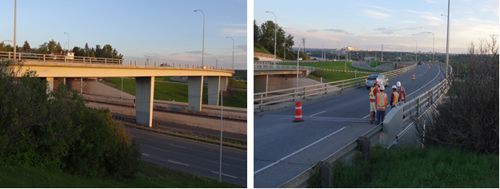

Figure 1: Pre-construction bridge condition

The bridge is an eight span cast in place reinforced concrete structure without any post-tensioning and on a horizontal radius of about 340 m. The girders are 3 cell conventionally reinforced concrete box girders with an overall depth of 1.5m (Figure 2). The girders were designed integral with Piers 4, 5, and 6 while seating on non-sliding elastomeric bearings at the abutments and over Piers 1, 2, 6, and 7. The foundations included driven steel pipe piles supporting concrete pile caps. The detail of the foundation is different at Pier 2 where a different pile arrangement and a deeper pile cap were used to bridge over an existing culvert.

|  |  |
| --- | --- |
|  |  |

Figure 2: Existing bridge deck at pier diaphragms

The expansion joints were modified in 1982, and the bridge deck received a new polymer modified asphalt wearing surface in conjunction with deck concrete repair in 1994. Deck condition assessments were conducted in 2007 and 2014. The consultant team assessed the bridge in 2016 and concluded that with the 2017-2018 intervention the bridge can be in service for another 35 years with maintenance.

Several symmetric and asymmetric alternatives were considered for the widened structure. The existing foundation, substructure, and superstructure were assessed to determine the feasibility and estimated cost of the alternatives. At this site, symmetric widening would be the natural choice as any asymmetric widening would introduce a shift in the roadway alignment and pose a significant challenge to transition to the next bridge shortly after. However, symmetric widening could be very costly if it requires additional pile or substructure strengthening.

The recommended alternative was to widen the bridge symmetrically using cast-in-place girders composite with the existing deck as shown in Figure 3. Post-tensioning of the new girders was proposed to minimize the additional dead loads needed to widen the bridge, thereby preventing overload of the substructure. In addition to new sliding bearings under the new girders, lateral restraints were proposed over the piers to take the full lateral loads, thereby avoiding replacement of the existing bearings.

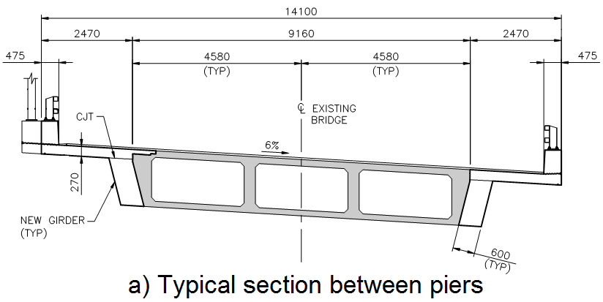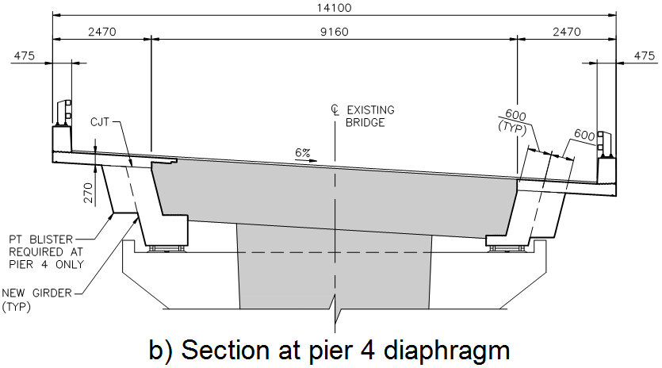

Figure 3: Widened cross sections

The bridge was built in 1968 with higher grade of steel than typically used in bridges back then with the grade mentioned in a general note on the record drawings. Samples were collected and tested which confirmed the high grade of steel shown on the original drawings. New pier caps were required to support the new girders because the existing diaphragms did not have the required capacity to support the additional loads. However, strengthening of the pier columns was avoided by accurate modeling and analysis using the verified material properties of the reinforcement.

Strut and tie analysis, with consideration of the required development of reinforcement, was conducted to demonstrate that the pile caps have adequate capacity for the increased live and dead loads. However, elastic distribution of the force effects showed that the factored pile axial load would exceed the geotechnical vertical pile capacity. Plastic analysis was conducted, as permitted by CHBDC S6-14 (CSA 2014), to improve the load sharing among piles. It was determined that with the exception of the Pier 2 piles, the foundation had adequate capacity. Rather than costly strengthening of the foundation, the designers opted not to introduce lateral restraint at Pier 2 as had been done at Piers 1, 6, and 7; without lateral restraint at pier 2, lateral loads transfer to adjacent piers, reducing the pile axial load demands at Pier 2 thereby avoiding any foundation work.

COWI achieved an economical solution to the widening of the bridge by using accurate analysis and capacity calculations as well as innovative solutions such as introduction of post-tensioned cast in place girders and changing the articulation of the bridge supports. By eliminating the need for any foundation work or pile cap strengthening, it became possible to complete the project within two construction seasons. This allowed for widening of the first side prior to winter shut down which then facilitated the presence of two traffic lanes at all times, particularly during the winter months as mandated by the City.

While the completed bridge widening will be symmetrically post-tensioned, during the construction the bridge deck experiences asymmetric post-tensioning on an asymmetric section. In addition, the structural capacity of the bridge elements are negatively affected by the demolition sequence of the deck and additional construction loads. This introduced a new challenge to the project. It was necessary to check the load carrying capacity of the bridge for all construction stages. Hence, it was necessary to devise the most efficient construction sequence and present the sequence to the bidders as part of the tender documents.

Figure 5 shows the summary of the construction tasks for Stage 1 as presented in the design drawings. The project was tendered and the construction started in November 2017. The contractor's proposed construction sequence was in close agreement with the summary of the tasks created by the consultant. The staging of the construction had a significant impact on the modelling and analysis of the structure which will be discussed in sections 3 and 4 of this paper.

# The Widened Structure

## Abutment widening

Widening of the abutment seats included demolishing select abutment elements, widening and lengthening the abutment seat, building new wingwalls, and widening of the existing approach slabs. There was no need for new piles and the new wingwalls were anchored into the existing footings and wingwalls. The backwall was partially removed to the elevation of the abutment seat to provide room for the post-tensioning of the deck. Existing deck joints were also removed and replaced. To create a strong bond, the interface between the new and existing concrete was roughened and reinforced with dowels.

## Pier Modifications

The 3D modeling of the bridge together with material verification tests and plastic analysis of pier piles demonstrated that there was no need for additional piles, footing strengthening, or pier column strengthening. However, the existing concrete diaphragms over the piers lacked adequate capacity to transfer the loads of the widened superstructure. As shown in Figure 2, the existing piers do not have a distinct pier cap, thus new pier caps were introduced to support the new widened superstructure. The caps are thicker than the existing pier columns to allow continuity of top reinforcement. The interface between the new and the existing concrete was roughened and reinforced with dowels. Self-consolidating concrete was specified for the pier caps since there is not enough room below the existing deck soffit to use traditional vibrators.

## Bearings and Lateral Supports

There are only three existing abutment bearings and they are showing excessive lateral deformations. The abutment bearings were replaced with four new sliding elastomeric bearings using jacks. New lateral restraints are also provided at the abutments. The west lateral restraint is substantially larger than the east lateral restraint in order to maintain the deck geometry at the abutments after the first stage post-tensioning.

New rocker bearings are provided over the integral piers (Piers 3, 4, and 5). These bearings do not deform vertically or longitudinally, but will allow the new girders to rotate under live loads. The existing bearings over Piers 1, 2, 6, and 7 are in good condition and it was decided they should remain. However, provisions are provided for future jacking to facilitate the replacement of these bearings if needed. New sliding elastomeric bearings are provided under the new girder seats. To avoid overloading existing bearings, temporary supports were specified during construction. The temporary supports are to be removed without jacking, hence eliminating expensive jacking operations (4 piers at two stages). Lateral restraints are provided over Piers 1, 6, and 7. As explained earlier, no lateral restraint was provided at Pier 2, thereby minimizing the moment at the base of the footing and avoiding pile driving.

## New girders and deck overhang

As shown in Figure 3, the existing deck overhangs are removed and new girders are cast against the existing deck. The new girders are 600 mm wide and will accommodate 6 post-tensioning ducts. The new deck overhang is 270 mm thick and supports the new bridge barriers. The surface between the new and existing concrete was roughened and reinforced with dowels to increase the interface shear capacity. These dowels together with the deck overhang dowels and dowels at the pier and abutment diaphragms facilitate transfer of a portion of the post-tensioning force from the new girders into the existing structure and hence improve the durability of the existing deck.

## Post-tensioning Details

Each girder is post-tensioned with 6 tendons of 12-15.2 mm DIA 7 wire low relaxation strands (Figure 4). The tendons are sized so that the new girders can resist the design loads at the ultimate limit state while the tensile stresses in concrete are limited to the cracking stress of new concrete. While the post-tensioning forces will be shared with the existing concrete, the intent was not to fully close the cracks already formed in the existing deck.

An efficient profile was achieved by optimizing the tendon profiles and jacking from both ends of the tendons. Parabolic tendon profiles are typically used to add efficient post-tensioning. However, in this bridge friction losses were substantial due to the high span to depth ratios of the girders and the lateral curve. These effects resulted in more than usual curvature losses when parabolic profiles were used for all spans. For the top tendons, it was more efficient to maintain a straight profile within the shorter spans (Spans 1, 2, 7, and 8) to reduce losses and then a parabolic profile in the middle four spans. The web tendons have parabolic profile at all spans. To counteract losses and create an efficient system, it was decided to provide post-tensioning blisters at Pier 4 for jacking of the web tendons. The top and bottom tendons run continuously from one abutment to the other.

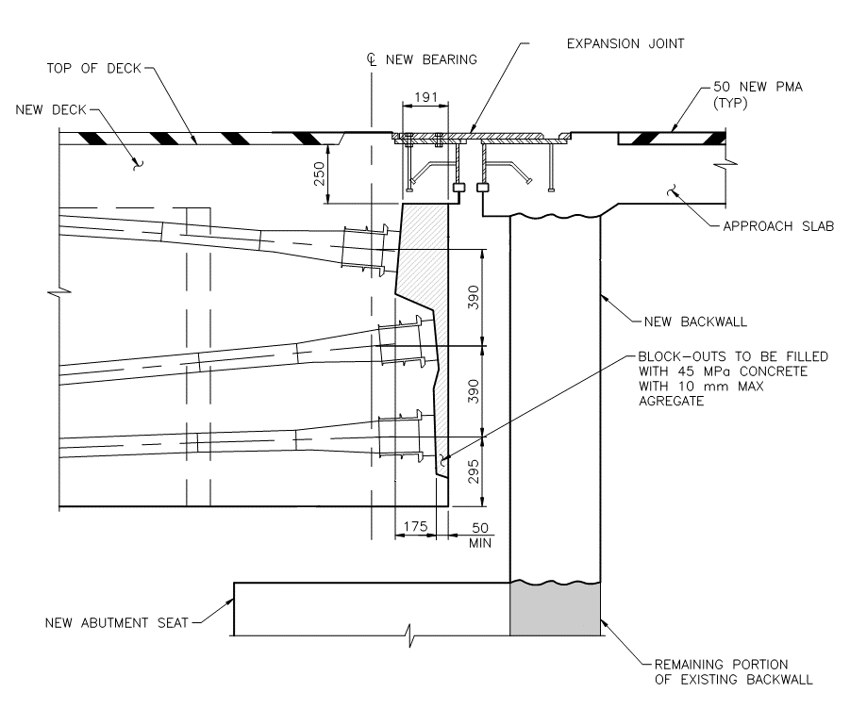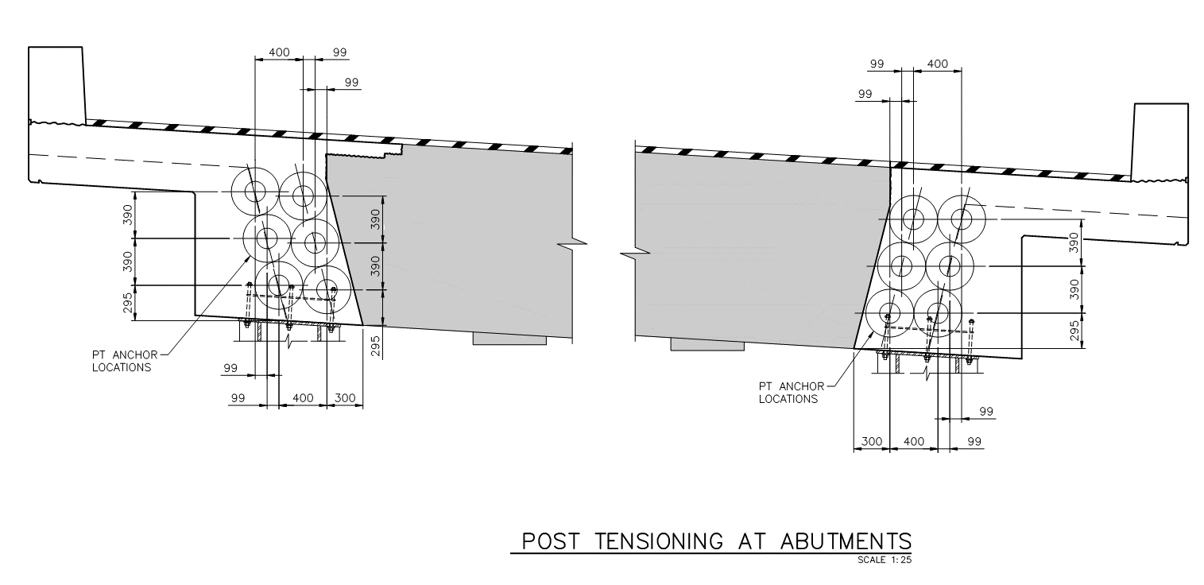

|  |  |
| --- | --- |
| a) Section | b) Elevation |

Figure 4: Girder post tensioning at abutments

# Construction Stages

With an average annual weekday traffic of 107,000 on Crowchild Trail, this segment of road has been called “one of the most notoriously gridlocked corridors in Calgary” (Kaufmann 2017).The City of Calgary set a clear requirement that the bridge must maintain 2 viable traffic lanes at all times during construction. Due to the requirement that the bridge support two full lanes at all times during construction and that the project duration exceeds one construction season, the staging of the construction became a relevant design consideration. Construction staging dictated many of the critical load cases for the structure. Consequently, the sequence of construction steps were prescriptive and required careful thought by the designer in an arena typically determined by the contractor and only reviewed by the consultant.

With an existing driveable width of 10.4 m, there is a minimal laydown width once the deck cantilever has been removed. Due to this space constraint and the fact that the bridge is to be symmetrical in its finished condition, the work must take place on one side and then the other. Normally this requirement would not cause significant difficulties, but the inclusion of longitudinal post-tensioning in the new girders caused a unique situation that required careful design consideration during each stage. In addition, demolition work would temporarily reduce the capacity of the bridge elements, in particular the deck, requiring step-by-step capacity checks.

|  |  |
| --- | --- |
| Summary of stage 1 construction tasks |  |

Figure 5: Summary of construction tasks (left) and final bridge cross section (right)

## Staged Post-tensioning

Traditionally, post-tensioning loads are applied in a balanced manner with tendons equilibrating one another on either side of the bridge centreline. However, the scheduling of the construction meant that the new west girder would need to be fully post-tensioned at a significant eccentricity without the benefit of an equilibrating force in the opposite side. Piers three, four, and five, are integral with the deck and restrict the deck lateral movements. The permanent lateral restraints over the other piers and at the abutments wouldn't be installed at this stage, which meant the first and last three spans were effectively 70 m long cantilevers in the lateral direction for the unbalanced post-tensioning. The eccentric post-tensioning could be expected to cause 180 mm of lateral translation of the deck at the abutments, which was untenable because neither the deck joints nor the abutment bearings could accommodate these movements. Thus it was necessary to restrain this movement through the use of substantially larger lateral restraints than needed to resist the lateral loads during the bridge service life (as indicated by the size discrepancy between east and west lateral restraints in Figure 5). This restraint introduced secondary lateral moments that were accounted for in the analyses. The west lateral restraints will persist for the remainder of the bridge service life, but will see their design load for a period of only one year between the first post-tensioning operation and the subsequent operation that balances out the eccentric post-tensioning loads.

## Demolition

Demolition of the existing deck overhang weakens the existing structure temporarily, and the construction load cases could be critical in comparison to the final state loads. Anticipated live load deflections during construction precluded the use of ground-supported scaffolding as was used for the original construction. This meant all concrete dead load for the new girder and deck cantilever along with two lanes of traffic had to be carried by the existing structure itself in a weakened state. Demolition of the cantilevered segments of the existing bridge deck reduced the negative moment capacity to such a degree that the existing girder could become capacity deficient at the piers under construction loads. To prevent overload, the placement of the new girder and deck overhang needed to be separated into two operations. Negative moment steel was placed in the new girder just below the deck overhang to support the additional negative moments in the girder caused by the placement of the deck overhangs.

To model the changes in superstructure elements and to capture the critical loads applied during construction, modelling of the bridge was broken into two main stages. Stage one is the demolition and construction of the west side, and stage two is the demolition and construction of the east side. Each stage was broken down into three sub-stages. The first primary analysis was once the structure had been weakened by the demolition of the deck cantilever and new construction and fresh concrete loads had been added. This was followed by an analysis with the new girder hardened and the new deck cantilever placed as fresh concrete. For the west side, a third analysis was conducted with the post-tensioning tendons installed and stressed, causing an unbalanced loading condition across the asymmetrically widened section.

# Analysis

## Objectives

When selecting an analysis tool, a set of objectives were compiled and compared against the capabilities of available software programs. Of primary concern, the analysts sought a tool that would accurately capture torsion, thermal effects, and longitudinal post-tensioning effects associated with a curved structure. Additionally, parametric modelling was desired to enable rapid prototyping of design concepts as work progressed. Finally, the analysts needed the ability to conduct stage-by-stage analyses to ensure the semi-demolished structure would have adequate capacity during construction. While creating a shell element model manually was considered, ultimately the Bridge Modeller tool of CSI Bridge was selected because its robust functionalities allowed us to meet our analysis objectives. This tool allows for bridge geometry to be defined parametrically through the definition of a layout line along which the superstructure cross-section is swept to automatically generate the model as shown in Figure 6.

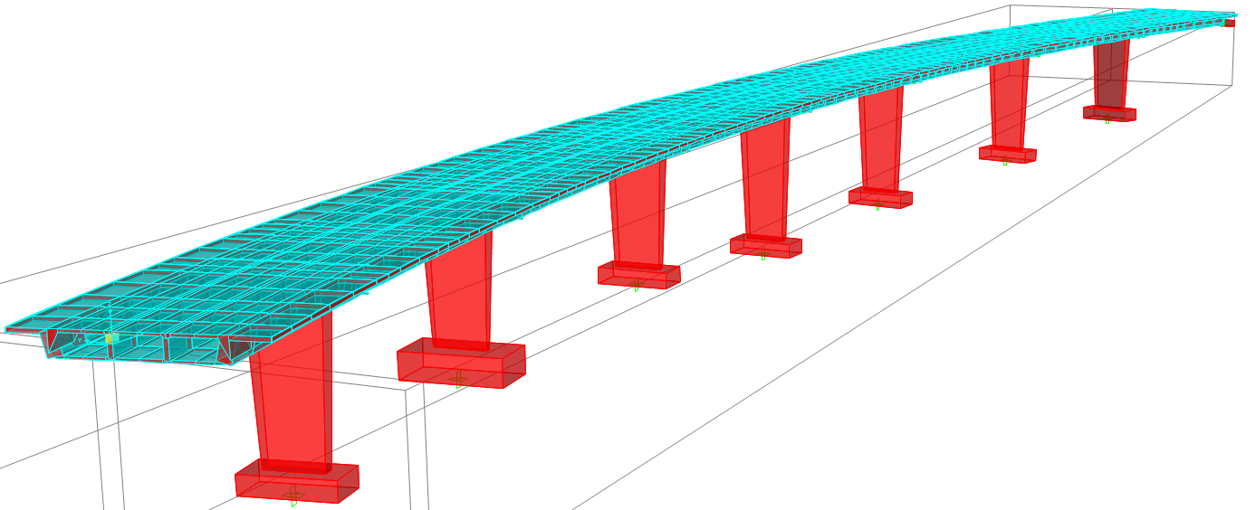

Figure 6: 3D Shell and frame analysis model

## Effects of Post-tensioning

Accurate modelling of the prestressing force effects was required to capture and understand the secondary prestress forces applied to the bridge. Because the bridge has eight continuous spans, the secondary effects brought about by the restraint at each of the piers were significant. To model the effects of the prestressing tendons, two methods were used in tandem which allowed for comparison and verification of the analysis. Externally applied distributed loads (CPCI 1996) was the first method and tendon modeller built into the analysis tool was the second method. Due to the nature of the software inputs, the external distributed loads were cumbersome to manipulate and prone to input error due to the large quantity of values to be manually entered. However, this method had the benefit of being self-checking in the sense that all externally applied loads must result in vertical equilibrium. Tendon modeller input instead relied on the geometry of the tendon profiles to calculate the force effects. Both methods were verifiable by considering the fact that primary plus secondary force effects must equal the total force effects (PTI 2006). The back calculation of primary force effects allowed for the back calculation of the tendon profile which could then be compared with the original profile geometry to confirm a match. Successful use of this check methodology led to confidence in the analysis tool for modelling the effects of prestress tendons.

## Analysis Tool Limitations

To facilitate the parametric variation of the bridge model, the analysis tool effectively removes and rebuilds the model each time it updates. This recreation allows analysts to follow rapidly shifting designs and geometry thereby making it an incredibly powerful tool. However, despite its apparent advantages, the Bridge Modeller caused some unexpected challenges during the analysis process.

The continuous model regeneration prevented the effective use of selection groups; these groups allow for efficient selection of multiple elements for load extraction and manipulation of model properties. Each time the model updated, the selection groups needed to be manually repopulated – a somewhat repetitive process that adds little value. Secondly, there was a bug in the previous version of the analysis tool where the bearing locations would translate laterally in a seemingly random manner with each model update. This behaviour was brought to the attention of the software developer and has been addressed in the latest version where the bearings now function as intended.. Finally, a substantial excess of dead load was observed which required a slight adjustment in material densities. This will be discussed in detail later in this section. Each of these problems were surmountable, but there was one modelling challenge with Bridge Modeller that required a creative manual workaround – how to model an asymmetric cross section?

### Modelling of an Asymmetric Cross Section

The input parameters for a multi-cell concrete box girder in the analysis tool are quite robust and allow for a highly customizable section. However, the limitation encountered was the use of a single parameter to define the thickness of the exterior webs. It’s entirely reasonable to assume that a completed cross-section would be symmetrical with a uniform web thickness, but the bridge was being analyzed not only in its final state, but also all significant states during construction. Staged demolition and post-tensioning necessitated the analysis of asymmetric cross-sections, the geometry of which was not supported by the tool. To address this, the web widening was modelled through the use of local thickening of web area elements. These thickened elements manually added to one web captured the additional dead load caused by the widened girder as well as the increase in girder stiffness, thereby effectively mimicking the behaviour of the desired asymmetric section. However, any changes to the model applied manually outside the confines of the Bridge Modeller input were removed any time the model was updated. The perpetual removal of loads and element modifications through the update process required diligent replacement of these loads and modifications each time an update was required, which began to undermine the value of the rapid parametric adjustments facilitated by the Bridge Modeller. Because Bridge Modeller input doesn’t support the full range of inputs permitted by the software, it may not be suitable for non-standard geometry, loading conditions, or staged analyses as many of these require manual inputs that would then need to be repeated after each update.

### Excessive Dead Load

During equilibrium checks for the model, it became clear that the dead loads for the bridge were up to 15% in excess of their anticipated values. Discussions with software support led to the conclusion that the automatically generated area elements were exhibiting overlap – effectively double-counting – in some areas of the section. The overlap of area elements is a known issue to the software developer and is mentioned in one of their online support articles, but this was not common knowledge to the analysts. The developer recommended the use of solid elements instead of area elements, which did eliminate the overlap and bring dead loads in line with expectations; however this had implications in the run-time required to analyze a model. In the author’s experience, the time required to analyze the model using solid elements was an order of magnitude longer than that required using area elements. The use of solid elements stripped the software of its ability to adapt to change and provide force effects in a timely manner. Ultimately, area elements with an appropriately reduced material density were used to model the bridge; this allowed for sufficient accuracy while still maintaining reasonable analysis times.

# Conclusions

An efficient design was achieved for the widening of the Northbound Crowchild Trail Bridge using cast in place girders composite with the existing deck and widening to both sides. Post-tensioning of the new girders allowed for efficient use of material and kept additional dead loads on the substructure to a minimum. Accurate analysis of the structure, changing the articulation of bridge supports, and plastic analysis of the foundations allowed for the elimination of any foundation works, despite a wider deck and an extra lane of traffic.

Post-tensioning was provided to obtain capacity at ULS and to limit tensile stresses in the new girders to the cracking stress of concrete at SLS. Limited room was available for post-tensioning anchors and it was not intended to close the existing cracks in the deck. Due to the curved geometry and substantial number of spans, friction losses on the tendons were high. These losses were counteracted by jacking on both ends, the creation of a jacking blister at the centre of the bridge, and through the use of straight tendon profiles in the shorter spans followed by full-depth parabolic profiles in the long spans where the post-tensioning was needed most.

The bridge had to be open to two lanes of traffic and the volume of the construction activities required two staging the construction for two seasons. Stage 1 was widening of the west side including post-tensioning of the structure with significant bi-axial bending. Temporary lateral supports were used to prevent excessive lateral deformation of the deck at the abutments. In addition, demolition of existing components, two full lanes of service loads, and construction loads created critical loading cases for the structure prior to its final widened state. These conditions meant the designers needed to prescribe a construction sequence necessary to ensure the safe construction of the widened bridge without directing the contractors or limiting their techniques.

Modeling a continuous multi-cell cast in place concrete bridge is challenging and time consuming, particularly when considering asymmetric geometry during demolition of existing deck elements and biaxial bending caused by staged post-tensioning. The software selected met analysis objectives, however, some time-consuming limitations such as overestimation of dead loads were encountered throughout the course of the analyses. Additional time and budget are required to check the structure during all stages of the construction in addition to the service condition and to obtain accuracy required to prevent unnecessary strengthening.

Acknowledgements

The authors would like to acknowledge the contribution of WSP and City of Calgary in providing resources, background information, and invaluable input on the project and Dr Scott Alexander for providing guidance for this paper.

References

CPCI. 1996. Equivalent Load Method of Analysis. *Design Manual – Precast and Prestressed Concrete, Third Edition: 3-120 to 3-121.*

Calgary. 2016. 2016 Average Daily (24hr) Weekday Traffic Volume. *Calgary.ca* URL:http://www.calgary.ca/Transportation/TP/Pages/Planning/Transportation-Data/Traffic-volume-flow-maps.aspx (accessed 21 January, 2018).

CSA. 2014. Canadian Highway Bridge Design Code, CAN/CSA S6-14. Canadian Standard Association, Toronto, Canada.

PTI. 2006. Analysis and Design Fundamentals. *Post-Tensioning Manual, Sixth Edition*: 95-103.

Kaufmann. 2017. City Vows to Keep Traffic Disruption to Minimum as Crowchild Trail Upgrade Looms. *Calgaryherald.com*: <URL:http://calgaryherald.com/news/local-news/city-vows-to-keep-traffic-disruption-to-minimum-as-crowchild-tr-upgrade-looms> (accessed 21 January, 2018).