|  |  |  |
| --- | --- | --- |
|  | **10th International Conference on Short and Medium Span Bridges**  **Quebec City, Quebec, Canada,**  **July 31 – August 3, 2018** |  |

Replacement of deteriorated RC slab with precast PC slab using lightweight concrete

Kobayashi, Shu1,4, Nakamura, Sadaaki1, Higashiyama, Hiroshi2 and Matsui, Shigeyuki3

1 IHI Construction Service Co., Ltd, Japan

2 Kindai University, Professor, Japan

3 Osaka University, Emeritus Professor, Japan

4 shu_kobayashi@iik.ihi.co.jp

**Abstract:** Precast prestressed concrete slabs manufactured at plants are frequently used for replacement of deteriorated reinforced concrete slabs on steel bridges in Japan. This on-site replacement technique can shorten the work period and reduce nuisance to road users. Since replacement slabs tend to be thicker and heavier in weight compared to existing reinforced concrete slabs due to the high requirement for durability, it is often necessary to strengthen the existing steel main girders and substructures for the additional stress. The new slabs need to be as lightweight as possible, with the additional stress and strengthening needs kept to the minimum. Use of concrete with artificial lightweight aggregate is one way to obtain lightweight prestressed concrete slabs. However, compared to normal concrete, the lightweight concrete is lower in tensile and shear strengths in relation to compressive strength, which results in lower performance as concrete and, when used in slabs, lower punching shear capacity or fatigue durability under wheel load. This study is a part of research for developing precast prestressed concrete slabs using the lightweight concrete, in which the authors investigated performance of two types of lightweight concrete for the use in slabs as well as wheel load carrying capacity and fatigue durability of the slabs using them under repeated traffic load. The precast prestressed concrete slabs using the proposed lightweight concretes were found to achieve the performance required for highway bridge slabs. Methods for assessment of punching shear and fatigue durability performance were also examined in this study.

# **Introduction**

The number of bridges in service for over 50 years is rapidly increasing in Japan. Significant damage with age is found in such old bridges, and many large-scale strengthening or replacement projects are under way by road administration organizations, especially on existing reinforced concrete (hereinafter referred to as "RC") slabs. Precast prestressed concrete (hereinafter referred to as "PC") slabs manufactured at plants are frequently used to replace the existing damaged RC slabs at site. This on-site replacement technique is needed to shorten the work period and reduce nuisance to road users.

The replacement slabs tend to be thicker and heavier in weight than existing slabs due to the recent increases in traffic volumes and vehicle weights. This requires strengthening of the existing steel main girders and substructures to resist the additional stress. The new slabs need to be as lightweight as possible, with the additional stress and strengthening needs kept to the minimum. Use of concrete which uses artificial lightweight aggregate is one way to obtain lightweight PC slabs. However, when compared to normal concrete, lightweight concrete is lower in tensile and shear strengths in relation to compressive strength, thus being lower in performance as well as punching shear capacity and fatigue durability under wheel load.

Given the background described above, the authors used lightweight concrete of Class 1 with a unit weight of 19.0 kN/m3 or less that contained lightweight aggregate with a specific gravity of about 1.26 g/cm3 and a maximum particle size of 15 mm as coarse aggregate (hereinafter referred to as "lightweight Class-1") and developed a new precast PC slab using the concrete (hereinafter referred to as "lightweight Class-1 PC slab") with punching shear capacity improved by applying prestressing force. The slab is already in practical use in replacement work. The authors also used lightweight concrete of Class 2 with a unit weight of 16.5 kN/m3 or less that contained lightweight aggregate with a specific gravity of about 1.67 g/cm3 and a maximum particle size of 5 mm as fine aggregate in addition to the lightweight coarse aggregate described above (hereinafter referred to as "lightweight Class-2") and developed another new precast PC slab using the concrete (hereinafter referred to as "lightweight Class-2 PC slab") to achieve further reduction in slab weight. This paper reports the experiments conducted for the development of the lightweight precast PC slabs, focusing on the performance of the proposed lightweight concretes and the performance of the precast PC slabs using them.

# **Outline of the Proposed Lightweight Concretes**

## **Targeted Performance**

The targeted unit weight of the lightweight concretes for the precast PC slabs was 19.0 kN/m3 or less for lightweight Class-1, and 16.5 kN/m3 or less for the lightweight Class-2, corresponding to a reduction of about 20% or 30%, respectively, from the weight of normal concrete. Compressive strength equivalent to that of normal concrete generally used in precast PC slabs was required for the lightweight concretes: 35 N/mm2 or more at the application of prestressing force at the plant at 1 day (steam cured); and 50 N/mm2 or more at 28 days under the design load. Table 1 shows the targeted performance of the proposed lightweight concretes, Table 2 shows the materials used, and Table 3 shows the mix proportions.

Table 1: Targeted performance of the proposed lightweight concretes

|  |  |  |
| --- | --- | --- |
| Age | Compressive strength  (N/mm2) | Unit weight  (kN/m3) |
| At the application of prestressing force  (1 day, steam cured) | 35 | Class-1: 19.0 or less  Class-2: 16.5 or less |
| Under the design load (28 days) | 50 |

Table 2: Materials used

|  |  |  |  |
| --- | --- | --- | --- |
| Materials | Descriptions | Symbols | Remarks |
| Cement | High early strength Portland cement | C | Density: 3.14 g/cm3 |
| Fine aggregate | Normal weight fine aggregate | SN | Limestone crushed sand  Saturated surface-dry density: 2.67 g/cm3 |
| Lightweight fine aggregate | SL | Oven-dried density: 1.67 g/cm3; low water product (water content 0.3%) |
| Coarse aggregate | Lightweight coarse aggregate | GL | Oven-dried density: 1.26 g/cm3; low water product (water content 0.2%) |
| Admixture | Superplasticizer | Fd | Ether-based polycarbonate  solid content 18% (water content 82%) |
| Air entraining agent | AE | Modified alkyl carboxylate |

Table 3: Mix proportions of the proposed lightweight concretes

|  |  |  |  |  |  |  |  |  |
| --- | --- | --- | --- | --- | --- | --- | --- | --- |
| Types | W/C  (%) | S/a  (%) | Air  (%) | Unit weight (kg/m3) | | | | |
| W | C | SN | SL | GL |
| Class-1 | 35.0 | 42.7 | 5.0 | 150 | 429 | 759 | -- | 476 |
| Class-2 | 32.0 | 41.0 | 5.0 | 150 | 469 | 71 | 402 | 481 |
| W/C: water content, S/a: fine aggregate ratio, W: water, C: cement, SN: normal weight fine aggregate, SL: lightweight fine aggregate, GL: lightweight coarse aggregate | | | | | | | | |

## **Strength Properties**

Table 4 shows material test results on the hardened lightweight concretes: compressive and tensile strength tests and static elastic modulus test using cylindrical specimens (diameter 100 mm, height 200 mm); and shear strength test using beam specimens (width 100 mm, height 100 mm, length 400 mm). The test results of normal concrete with a similar compressive strength are also shown for comparison. Water cement ratio was adjusted to 35% in the lightweight Class-1 or to 32% in the lightweight Class-2 to satisfy the compressive strength requirements.

Compared to normal concrete, lightweight concrete is generally lower in tensile and shear strengths in relation to compressive strength. Tensile strength of the proposed lightweight concretes was found to be 2.54 N/mm2 (lightweight Class-1) or 2.47 N/mm2 (lightweight Class-2), about 20% lower than that of normal concrete, 3.10 N/mm2. Similarly, shear strength was 6.15 N/mm2 (lightweight Class-1) or 5.93 N/mm2 (lightweight Class-2), about 20% lower than that of normal concrete, 7.69 N/mm2. Static modulus of elasticity which should decrease with the reduction in weight of concrete was 23.1 kN/mm2 (lightweight Class-1) or 19.6 N/mm2 (lightweight Class-2), which was about 60% or 50%, respectively, of that of normal concrete, 38.7 kN/mm2.

Table 4: Test results of hardened concrete characteristics

|  |  |  |  |  |  |  |  |  |
| --- | --- | --- | --- | --- | --- | --- | --- | --- |
| Types | At 1 day (steam cured) | | | At 28 days | | | | |
| Unit weight  (kN/m3) | Compressive strength  (N/mm2) | Elastic modulus  (kN/mm2) | Unit weight  (kN/m3) | Compressive strength  (N/mm2) | Tensile strength  (N/mm2) | Shear strength  (N/mm2) | Elastic modulus  (kN/mm2) |
| Class-1 | 18.3 | 43.4 | 20.8 | 18.1 | 58.6 | 2.54 | 6.15 | 23.1 |
| Class-2 | 16.0 | 46.1 | 17.8 | 15.8 | 58.5 | 2.47 | 5.93 | 19.6 |
| Normal | 23.4 | 39.0 | 33.8 | 23.7 | 56.6 | 3.10 | 7.69 | 38.7 |

## **Durability**

* + 1. **Freeze-thaw Resistance**

Lightweight concrete is known in general to be poor in freeze-thaw resistance due to the use of high water absorption lightweight aggregate in the saturated condition. The lightweight aggregates in the proposed lightweight concretes for the precast slabs are used at a low water content of 2.0% or below to ensure good freeze-thaw resistance. The authors carried out a freeze-thaw test, using 3% sodium chloride (NaCl) aqueous solution which is known to make the structure of concrete brittle or fragile and cause significant reduction in tensile strength and relative dynamic modulus of elasticity. As shown in Figure 1, relative dynamic modulus of elasticity of the proposed lightweight concretes remained above 90% after 300 cycles of three to four hours of freezing and thawing in a temperature range of −18°C to 5°C.

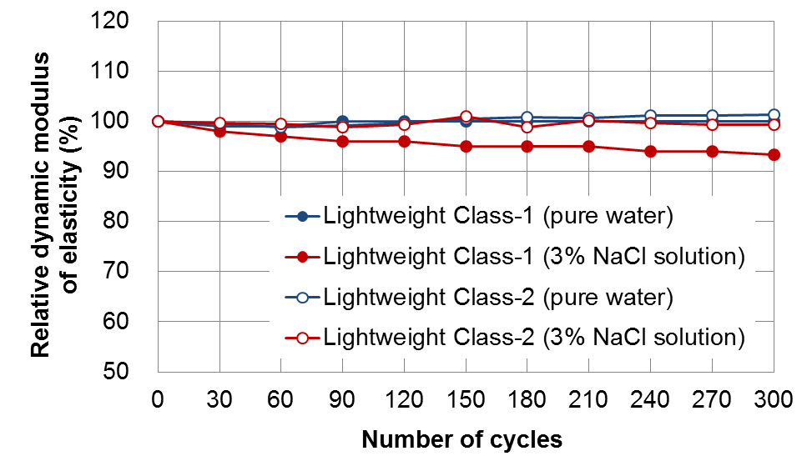

Figure 1: Freeze-thaw test results (relative dynamic modulus of elasticity)

* + 1. **Chloride Penetration Resistance**

Chloride penetration in the lightweight concretes was investigated after one year of immersion in 10% NaCl solution. Figure 2 shows the results of plane analysis using an electron probe micro-analyzer (EPMA). Normal concrete with the same compressive strength is also shown for reference. Chloride penetration depth in the lightweight concretes was found to be smaller than that in normal concrete.

Conventional lightweight concrete uses lightweight aggregate in the saturated condition, which allows free movement of chloride ions through the aggregate and results in lower chloride penetration resistance compared to normal concrete. In contrast, the proposed lightweight concretes contain the lightweight aggregate at a low water content. This prevents chloride penetration through the aggregate and makes chloride ions move through the cement paste in the similar manner to those in normal aggregate concrete. The proposed lightweight concretes are designed to have a smaller water cement ratio to achieve an equivalent compressive strength to that of normal concrete by forming a dense structure of cement paste with smaller diameter pores. This is thought to be the reason for good chloride penetration resistance of the lightweight concretes which was equivalent to that of normal concrete.

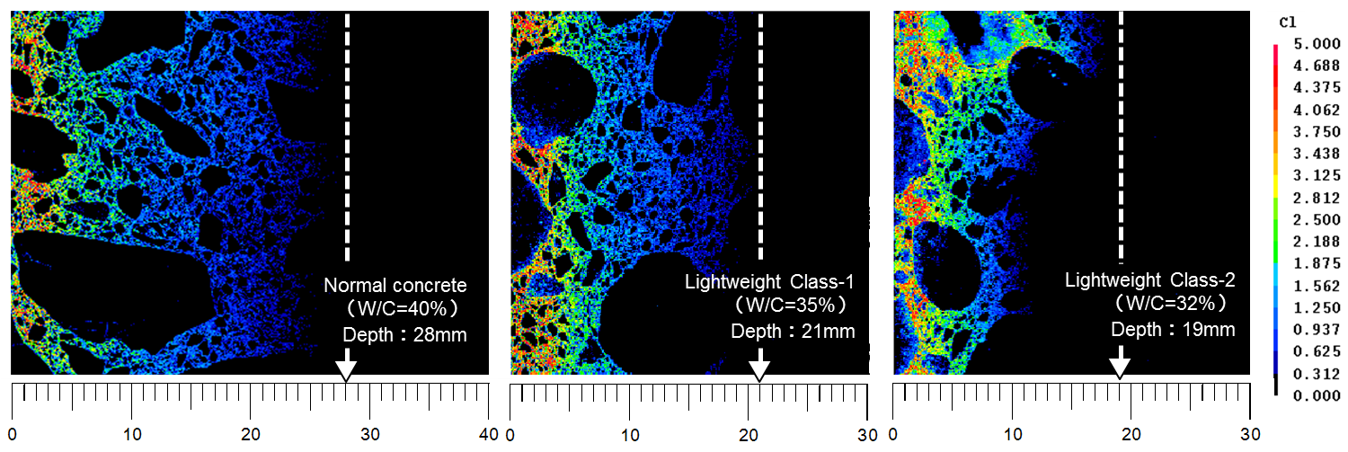

Figure 2: Chloride penetration depth of concrete after one-year immersion in 10% NaCl solution

# **Performance of the Lightweight Precast PC Slabs**

## **Static Punching Shear Performance**

Highway bridge slabs must have excellent punching shear capacity against wheel load. Higashiyama *et al.* (1997) proposed calculating the punching shear capacity *P0* of a PC slab with Equation [1] to take into account change in the angle of failure shear plane caused by the application of prestressing force as shown in Figure 3. The angle of failure shear plane used here is calculated by using Equations [2] and [3] based on the tensile strength of concrete and the amount of prestress.

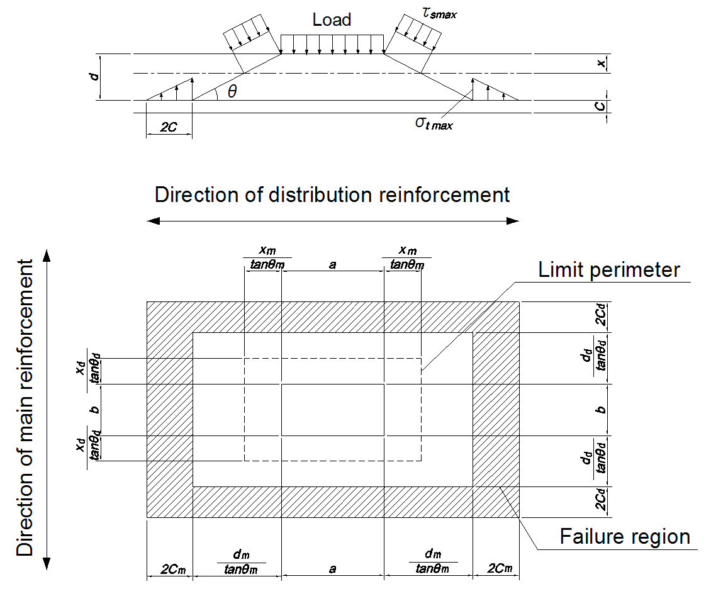

Figure 3: Punching shear failure model

[1] Punching shear capacity of a PC slab

$${\text{P}}_{\text{0}}\text{ = }{\text{τ}}_{\text{smax}}\left\{\text{2}\left(\text{a}\text{+}{{\text{2}\text{x}}_{\text{m}}}/{\text{tan}{\text{θ}}_{\text{m}}}\right){{\text{x}}_{\text{d}}}/{\text{tan}{\text{θ}}_{\text{d}}}\right.\text{+2}\left(\text{b}\text{+}{{\text{2}\text{x}}_{\text{d}}}/{\text{tan}{\text{θ}}_{\text{d}}}\right)\left.{{\text{x}}_{\text{m}}}/{\text{tan}{\text{θ}}_{\text{m}}}\right\}$$

$${\text{+ }\text{σ}}_{\text{tmax}}\left\{\text{2}\left(\text{a}\text{+}{{\text{2}\text{d}}_{\text{m}}}/{\text{tan}{\text{θ}}_{\text{m}}}\right){\text{C}}_{\text{d}}\right.\text{+2}\left(\text{b}\text{+}{{\text{2}\text{d}}_{\text{d}}}/{\text{tan}{\text{θ}}_{\text{d}}\text{+4}{\text{C}}_{\text{d}}}\right)\left.{\text{C}}_{\text{m}}\right\}$$

[2] Shear cracking strength of concrete ${\text{τ}}_{\text{cr}}\text{＝}\text{1.005}\sqrt{{{\text{σ}}_{\text{tmax}}}^{\text{2}}\text{+}{\text{σ}}_{\text{tmax}}\text{∙}{\text{σ}}_{\text{p}}}$

[3] Angle of the failure shear plane $\text{θ} \text{=}{\text{1}}/{\text{2}}{\text{tan}}^{\text{-1}}\left({\text{2}{\text{τ}}_{\text{cr}}}/{{\text{σ}}_{\text{p}}}\right)$

where, *a*, *b*: lengths of the edges of the loading plate in the main or distribution directions (mm); *xm*, *xd*: neutral axis depths of the sections perpendicular to the main and distribution directions, with the concrete on the tension side disregarded (mm), *θm*, *θd*: angles of failure shear planes in the main and distribution directions (rad); *dm*, *dd*: effective depths of the tensile reinforcements in the main and distribution directions (mm); *Cm*, *Cd*: cover thicknesses of the tensile reinforcements in the main and distribution directions (mm); *τsmax*: shear strength of the concrete (N/mm2); *σtmax*: tensile strength of the concrete (N/mm2); and *σp*: amount of prestress (N/mm2).

The wheel footprint usually used in Japan is 200 × 500 mm. In addition, the proposed lightweight precast PC slabs are intended for a two-way PC structure, with transverse prestress applied by the pretensioning system at the manufacturing plant and longitudinal prestress by the post-tensioning system after installation at site. However, fully simulating these conditions should result in excessively large specimens and excessively large failure load. Furthermore, brittle failure will make it impossible to determine the angle of failure shear plane. Therefore, the authors prepared three one-way prestressed slab specimens with a prestressing force of 6.29 N/mm2 introduced by the pretensioning system, and carried out static punching shear tests by applying a load to a 100 × 100 mm area which was supported at four sides with a span of 1 m. The static punching shear capacity under the wheel footprint of 200 × 500 mm was calculated by putting the test results into the equation for punching shear capacity. Figure 4 shows a schematic of the specimens used, and Figure 5 shows the test procedure. The prestressing bars were steel strands with a yield strength of 1580 N/mm2 and a tensile strength of 1850 N/mm2, and the reinforcement was deformed bars with a yield strength of 345 N/mm2 and a tensile strength of 490 N/mm2.

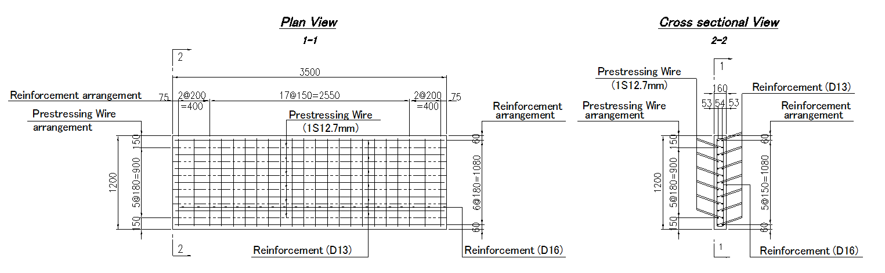

Figure 4: Schematic view of the specimens

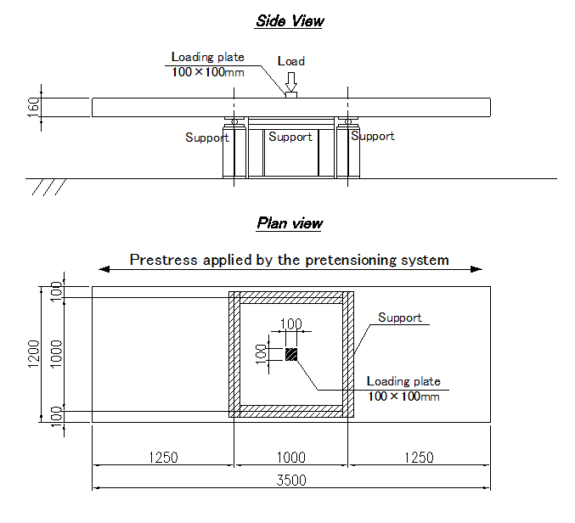

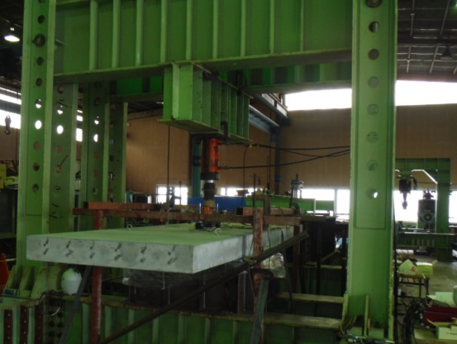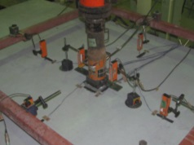

Figure 5: Static punching shear test

Table 5: Values used for static punching shear capacity calculation under the 100 × 100 wheel footprint

|  |  |  |  |  |  |  |  |  |  |  |  |  |
| --- | --- | --- | --- | --- | --- | --- | --- | --- | --- | --- | --- | --- |
| *a*  (mm) | *b*  (mm) | *xm*  (mm) | *xd*  (mm) | *θm*  (rad) | *θd*  (rad) | *dm*  (mm) | *dd*  (mm) | *Cm*  (mm) | *Cd*  (mm) | *τsmax*  (N/mm2) | *σtmax*  (N/mm2) | *σp*  (N/mm2) |
| 100 | 100 | 44.0 | 46.0 | 0.475 | 0.785 | 107.5 | 122.0 | 46.0 | 30.0 | 6.14 | 2.24 | 6.29 |

As shown in Figure 6, shear cracks found in the failure shear planes had angles of about 30° which was larger than 27° by calculation. The angle of failure shear plane calculated for the proposed lightweight concretes using Equations [2] and [3] was small due to the low tensile strength. In addition, the failure load was 433 kN on average which was lower than 519 kN given by Equation [1] using the values shown in Table 5. The tensile strength value of concrete *σtmax* in Table 5 was the experimental value of the cylindrical specimens (100 mm diameter × 200 mm high), and the shear strength value *τsmax* was the experimental value of the beam specimens (100 × 100 × 400 mm). Deflection at the failure of the specimens was about 2.7 mm, with no yielding of the reinforcement or prestressing steel bars. In the following sections, possible reasons for the lower experimental results than those by calculation are discussed.

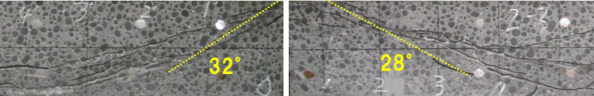

Figure 6: Failure shear planes in the prestressed direction

* + 1. **Investigation of the Angle of Failure Shear Plane**

The cracks in the failure shear planes of the specimens had angles of about 30° which was larger than 27° by calculation as mentioned above. In general, due to the lower tensile strength of lightweight concrete than that of normal concrete, calculation tends to give larger values for the change in the angle of failure shear plane caused by the application of prestressing force. However, the authors considered that there might be a lower limit for the angle of failure shear plane. Then, the angle of 30° suggested as the limit value for the specimens was used in this study.

* + 1. **Effects of the Failure of Lightweight Aggregate**

On the assumption that splitting of coarse aggregate particles would accompany punching failure of RC slabs using lightweight concrete, Higashiyama *et al.* (2005) proposed using reduced values for shear capacity and dowel resistance in calculation to take into account the low mechanical properties of lightweight concrete. Similar splitting of coarse aggregate particles could occur in the PC slabs in this test, although shear capacity of the specimens was improved by the application of prestressing force. Therefore, with reference to the study by Higashiyama *et al.* (2005), a reduction factor of *αt*=0.703 was applied to the value of dowel resistance determined by the second term of Equation [1].

* + 1. **Estimation of Punching Shear Capacity**

Calculation by Equation [4] using the values shown in Table 5 and an angle of failure shear plane in the cross section perpendicular to the prestressing direction *θd* of 30° (= 0.524 rad) and applying a reduction factor *αt* of 0.703 to dowel resistance resulted in a value of 432 kN. This was almost equal to 433 kN obtained by the experiment. The results suggest that punching shear capacity of PC slabs using lightweight concrete could be properly estimated with the existing equation for PC slabs, by taking the angle of failure shear plane and reduction in dowel resistance into account.

[4] ${\text{P}}_{\text{0}}\text{ = }{\text{τ}}_{\text{smax}}\left\{\text{2}\left(\text{a}\text{+}{{\text{2}\text{x}}_{\text{m}}}/{\text{tan}{\text{θ}}_{\text{m}}}\right){{\text{x}}_{\text{d}}}/{\text{tan}{\text{θ}}_{\text{d}}}\right.\text{+2}\left(\text{b}\text{+}{{\text{2}\text{x}}_{\text{d}}}/{\text{tan}{\text{θ}}_{\text{d}}}\right)\left.{{\text{x}}_{\text{m}}}/{\text{tan}{\text{θ}}_{\text{m}}}\right\}$

$${\text{+ }α_{t}\text{∙}\text{σ}}_{\text{tmax}}\left\{\text{2}\left(\text{a}\text{+}{{\text{2}\text{d}}_{\text{m}}}/{\text{tan}{\text{θ}}_{\text{m}}}\right){\text{C}}_{\text{d}}\right.\text{+2}\left(\text{b}\text{+}{{\text{2}\text{d}}_{\text{d}}}/{\text{tan}{\text{θ}}_{\text{d}}\text{+4}{\text{C}}_{\text{d}}}\right)\left.{\text{C}}_{\text{m}}\right\}$$

The lightweight precast PC slabs in this study are intended for a two-way PC structure in actual construction, with prestress applied in the transverse and longitudinal directions as mentioned above. In the fatigue test described in the following section, 180 mm thick lightweight precast PC slab specimens prestressed to 6.07 N/mm2 longitudinally and to 8.15 N/mm2 transversely were used. The authors calculated punching shear capacity of the two-way PC slab specimens by Equation [4], using the values shown in Table 6. The calculation result was 1110 kN, suggesting that the two-way prestressed precast slabs would have an adequate punching shear capacity against the legal wheel load of 50 kN (equivalent to a load of a single wheel of the legal axle load).

Table 6: Values used for static punching shear capacity calculation under the 200 × 500 wheel footprint

|  |  |  |  |  |  |  |  |  |  |  |  |  |  |
| --- | --- | --- | --- | --- | --- | --- | --- | --- | --- | --- | --- | --- | --- |
| *a*  (mm) | *b*  (mm) | *xm*  (mm) | xd  (mm) | *θm*  (rad) | *θd*  (rad) | *dm*  (mm) | *dd*  (mm) | *Cm*  (mm) | *Cd*  (mm) | *τsmax*  (N/mm2) | *σtmax*  (N/mm2) | *σpm*  (N/mm2) | *σpd*  (N/mm2) |
| 500 | 200 | 45.0 | 43.0 | 0.524 | 0.524 | 130.5 | 143.5 | 43.0 | 30.0 | 5.91 | 2.09 | 6.07 | 8.15 |

## **Fatigue Durability Performance**

Highway bridge slabs must be adequately durable under cyclic wheel loading. This section describes the moving wheel load test which has been carried out to evaluate fatigue durability of the precast PC slabs using the proposed lightweight concretes. The slab specimens were two-way PC structures each consisting of four lightweight precast PC slabs which were transversely prestressed to 8.15 N/mm2 by the pretensioning system and then integrated via longitudinal prestress of 6.07 N/mm2 introduced by the post-tensioning system. Figure 7 shows a schematic of the slab specimens used, Figure 8 shows manufacturing of the slab specimens, and Table 7 shows the material test results of the concrete used in the slab specimens. The transverse prestressing bars were steel strands with a yield strength of 1580 N/mm2 and a tensile strength of 1850 N/mm2, the longitudinal prestressing bars were steel bars with a yield strength of 930 N/mm2 and a tensile strength of 1180 N/mm2, and the reinforcement was deformed bars with a yield strength of 345 N/mm2 and a tensile strength of 490 N/mm2.

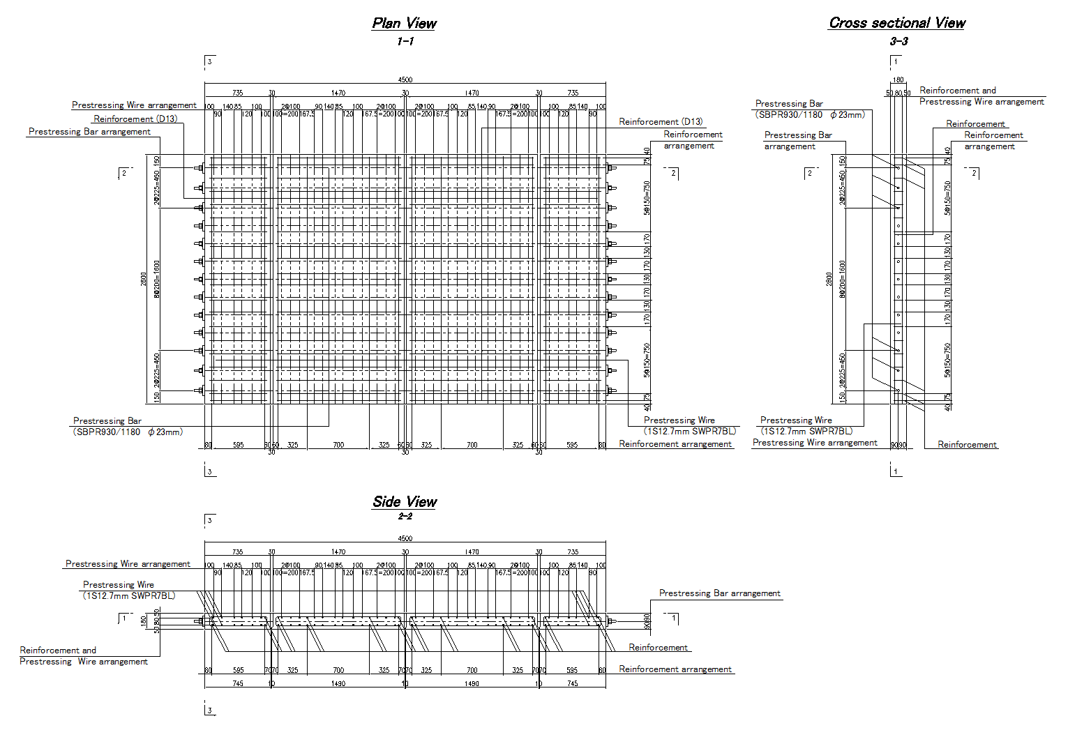

Longitudinal prestress applied by the post-tensioning system

Transverse prestress applied

by the pretensioning system

Figure 7: Schematic view of the slab specimens

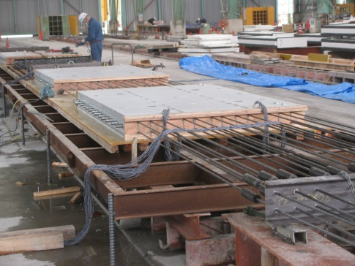 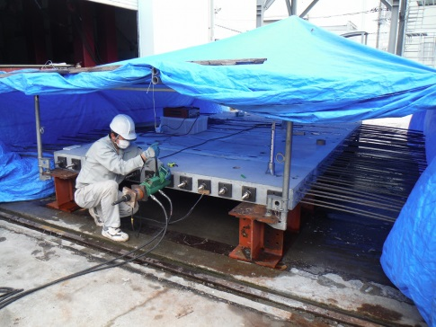

(a) Transverse prestress applied by pretensioning (b) Longitudinal prestress applied by post-tensioning

Figure 8: Manufacturing of the slab specimens

Table 7: Test results of hardened concrete characteristics

|  |  |  |  |  |  |
| --- | --- | --- | --- | --- | --- |
| Types | At the start of the experiment | | | | |
| Unit weight  (kN/m3) | Compressive strength  (N/mm2) | Tensile strength  (N/mm2) | Shear strength  (N/mm2) | Elastic modulus  (kN/mm2) |
| Class-1 | 18.1 | 55.6 | 2.67 | 6.15 | 26.3 |
| Class-2 | 16.0 | 53.8 | 2.09 | 5.91 | 18.7 |

The wheel load was applied by moving a 320 mm wide steel wheel back and forth for ±1.5 m from the center of the specimen (total distance: 3 m) on a running path made by placing 500 mm-wide steel blocks on the specimen. Figure 9 shows the outline of the fatigue test. Stepped incremental load (variable amplitude fatigue (VAF) loading) was applied until failure in accordance with the method by the Public Works Research Institute of Japan (Nakatani *et al.*, 2002). Initial load was set to 157 kN based on the failure load of reinforced concrete slabs from the previous research. Load was increased to the maximum load of 491 kN in steps by 19.6 kN at every 40,000 wheel passes in order to avoid a rapid acceleration.

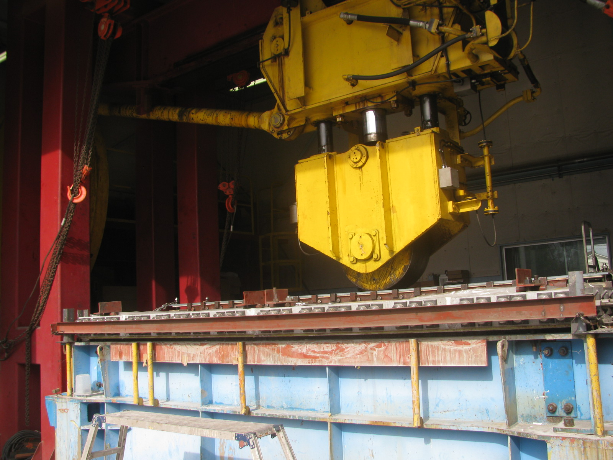 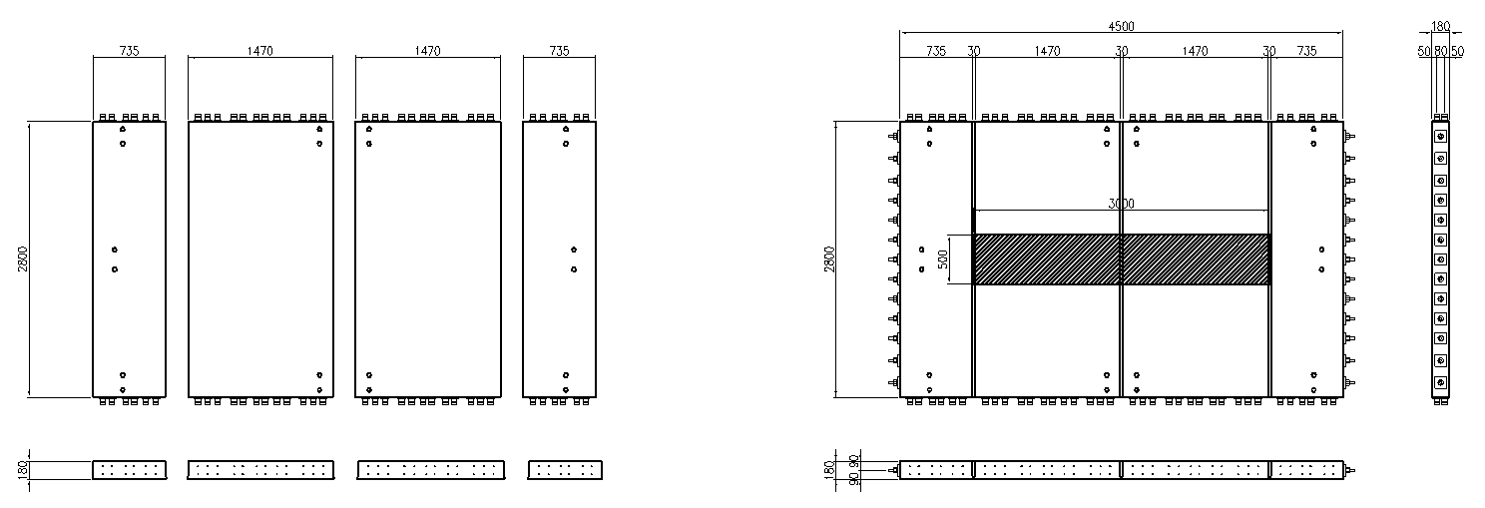 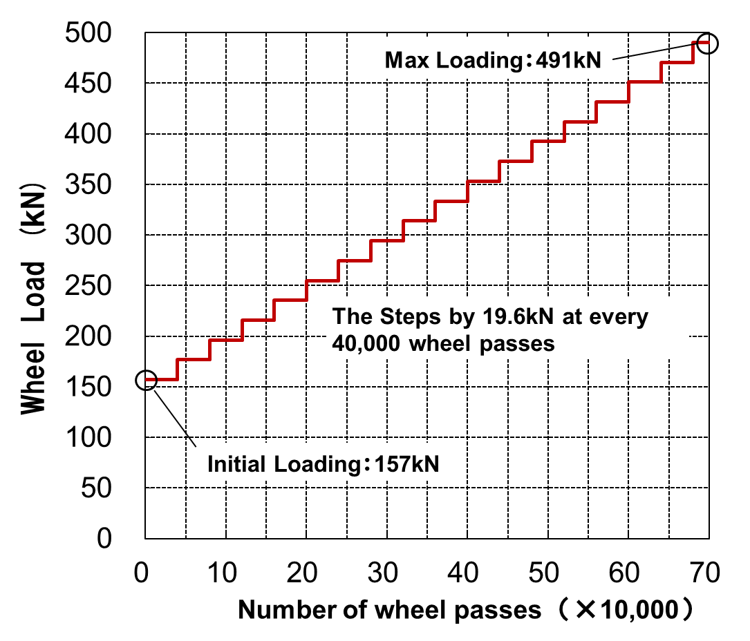

(a) Applying the wheel load (b) Travel range of wheel load (c) Loading pattern

Figure 9: Wheel loading test

Figure 10 shows the wheel loading test results. The lightweight Class-1 PC slab specimen failed at a maximum load of 471 kN at 593,000 wheel passes, and the lightweight Class-2 PC slab specimen failed at a maximum load of 431 kN at 565,000 wheel passes. Although no thresholds are specified for maximum load or deflection in this test method, these results show that the lightweight precast PC slabs in this test satisfy the required fatigue durability, i.e., the maximum load of 392 kN and the total 520,000 wheel passes under the same loading system, specified as a desirable durability target for highway bridge slabs in Japan (Nakatani *et al.*, 2002).

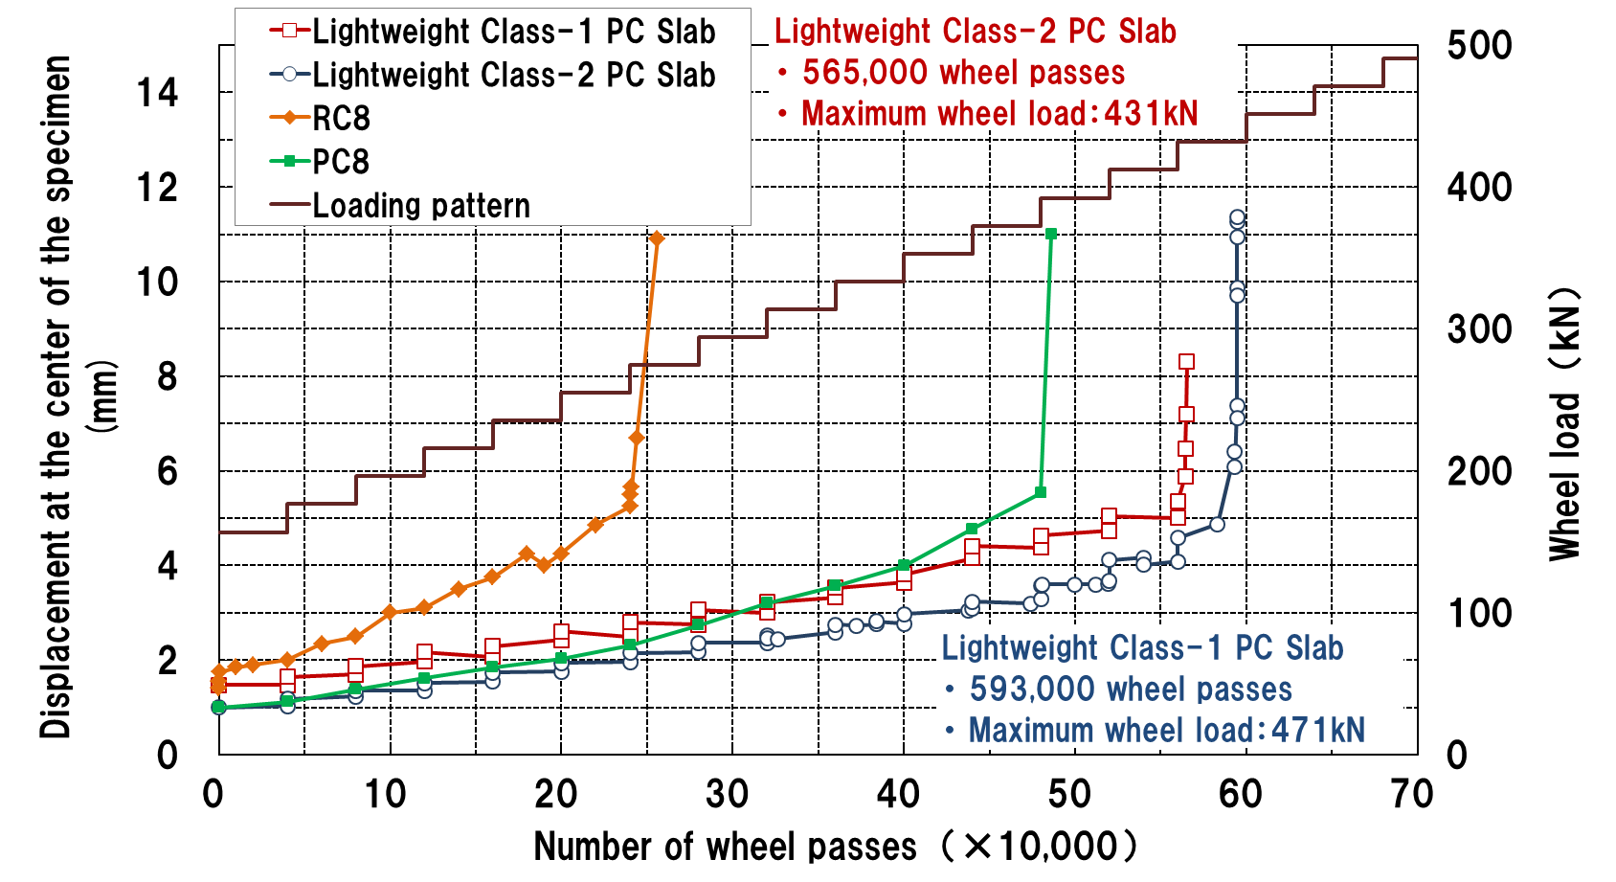

RC8: Test results by the Public Works Research Institute of Japan on reinforced concrete slabs designed in accordance with the Japanese Specifications for Highway Bridges (1996)

PC8: Test results by the Public Works Research Institute of Japan on prestressed concrete slabs designed in accordance with the Japanese Specifications for Highway Bridges (1996)

Figure 10: Relationship between the number of wheel passes and deflection in the slab

# **Conclusions**

Replacement slabs need to be as lightweight as possible. The authors have been working on developing the precast PC slabs using lightweight concrete. The performance of the lightweight concretes as well as the load carrying capacity and the fatigue durability performance of the precast PC slabs using them were investigated in this research. The followings are the major findings of the study:

1. Using lightweight aggregate at low water contents contributes to ensuring the good freeze-thaw resistance and improving the chloride penetration resistance.
2. The precast PC slabs using the proposed lightweight concretes were estimated to have a punching shear capacity of 1110 kN under the moving wheel load, showing an adequate capacity under the legal wheel load of 50 kN. In addition, the moving wheel load applied in the test was greater than that specified for the fatigue durability of highway bridge slabs in Japan: the maximum load of 392 kN and the total 520,000 wheel passes. These suggest that the proposed lightweight slabs have adequate punching shear capacity and fatigue durability as replacement for existing highway bridge RC slabs.
3. Static punching load tests using one-way prestressed lightweight concrete slabs showed that proper estimation of punching shear capacity of the lightweight precast PC slabs would be possible by taking into account the lower limit of the angle of failure shear plane in the punching shear failure and the reduction in dowel resistance due to the failure of lightweight aggregate particles.

# **Acknowledgements**

Valuable comments and suggestions were received during the development of lightweight precast PC slabs from Professor Osamu Ohyama of Osaka Institute of Technology, Dr. Takashi Kosaka of Hanshin Expressway Company Limited, Dr. Hideki Manabe of CORE Institute of Technology Corp., Dr. Akira Koyama of Nihon Mesalite Industry Co., Ltd. and Dr. Hiroshi Sato of IHI Infrastructure Systems Co., Ltd. The authors gratefully acknowledge them. The authors also would like to express their gratitude to Nihon Mesalite Industry Co., Ltd. for supplying all lightweight aggregate samples required for the tests in this study.

# **References**

Higashiyama, H., Mizukoshi, M., Matsui, S. and Oda, K. 2005. Estimation of Punching Shear Capacity of Reinforced Concrete Slabs with Lightweight Concrete and its Practicality to Highway Bridge Slabs. *Concrete Research Technology*, Vol. 16, No. 1, 45-54. (in Japanese)

Higashiyama, H., Ohta, H., Park, J-J. and Matsui, S. 1997. Study on Punching Shear Capacity of PC Slabs. *Proceedings of the 7th Symposium on Development in Prestressed Concrete,* Japan Prestressed Concrete Engineering Association (currently Japan Prestressed Concrete Institute): 13-16. (in Japanese)

Nakatani, S., Uchida, K., Nishikawa, K., Kanda, M., Miyazaki, K., Kawama, S. and Matsuo, S. 2002. Experimental study on the Fatigue durability of Highway Bridge slabs. *Technical Note of National Institute for Land and Infrastructure Management*, MLIT, No. 28. 7-15, 24-50. (in Japanese)