|  |  |  |
| --- | --- | --- |
|  | **10th International Conference on Short and Medium Span Bridges**  **Quebec City, Quebec, Canada,**  **July 31 – August 3, 2018** |  |

**Climate Change Impact on Design Service Life of Concrete Bridge Decks Exposed to Chlorides**

Zhang, Jieying1,2, Shirkhani, Hamidreza1, and Lounis, Zoubir1

1 National Research Council Canada, Construction Research Center, Canada

2 Jieying.Zhang@nrc-cnrc.gc.ca

**Abstract:** A simplified diffusion-based model of onset of corrosion is used to illustrate the sensitivity of design service life of concrete bridge decks to the changes of concrete diffusivity and chloride threshold value of rebar due to climate change induced temperature rise. The temperature rise was predicted by using Canadian Regional Climate Models under the emission scenarios of RCP 8.5. Chloride diffusion coefficient of concrete was found to increase linearly with temperature rise within 6 °C, but increases much more significantly in high performance concrete (HPC) than in ordinary Portland cement concrete (OPC). This alone will reduce the time to corrosion initiation by 6- 14% for OPC decks and 10-21% for HPC decks, if designed on the basis of historical temperature data of the last 30 years. The chloride threshold value could decrease proportionally with temperature rise within 6 °C, and the linearity depends greatly on the value of activation energy. The annual average temperature rise of 1.3-3.1 °C predicted in the next 30 years across Canada may decrease a rebar’s expected chloride threshold value by 8-19%. The temperature-rise impacts on chloride diffusivity of concrete and chloride threshold value of rebar in turn could induce significant reduction in design service life unless adaptation measures are adopted.

# INTRODUCTION

Since 1950 the annual average surface air temperature over Canada’s landmass has warmed by 1.7°C, while average temperatures in Canada are expected to rise by an additional 1.5°C to 4.5°C by 2070, which is approximately twice the global average. At the same time, Canada has in general become wetter in recent decades with an increase in annual precipitation of about 16% between 1950 and 2009 (Mekis and Vincent 2011). Global warming and extreme weather events have resulted in observable effects on people, environment, and civil infrastructures (IPCC 2014). Climate change will further exacerbate the existing state of corrosion of concrete infrastructure in North America, which requires billions of dollars for maintenance and rehabilitation. Corrosion of reinforcing steel bars (rebars) embedded in concrete bridges is mainly due to the use of de-icing salts in winter time and is affected by three critical environmental factors: temperature; humidity; and CO2 concentration for concrete carbonation (Wang et al. 2010 a & b), with all of these factors time-dependent as a result of increasing greenhouse gas emissions and climate change

Compared to atmospheric CO2 concentration, temperature plays a more complex role in the corrosion of rebars embedded in concrete, because it affects both steel and concrete through different mechanisms. The corrosion rate of steel increases with temperature and may follow the Arrhenius law potentially resulting in a corrosion rate of a metal doubled for every 10°C increase in temperature. Temperature rise also facilitates the diffusion of chlorides in concrete significantly, more in high performance concrete (HPC) than ordinary Portland cement concrete (OPC) (Dhir et al. 1992). Furthermore, temperature rise was also found to increase the concentration of free chloride ions in the concrete pore solution and reduce the expected chloride resistance of rebars in terms of total chloride content in concrete as often used in service life design and service life predictions (Hussain et al. 1995).

How a change in ambient humidity affects corrosion of rebars would depend critically on the concrete cover depth and presence of cracking. Ryu et al. (2011) found that the moisture content did not change due to rainfall in concrete deeper than 50 mm from the surface if no cracks are present. This finding is consistent with the findings by Nilsson (2002). Andrade el al. (2002) showed that the internal relative humidity of concrete did not correlate with outside ambient relative humidity, but in contrast, the internal temperature at the rebar level was found to be very similar to the ambient temperature that affected greatly the corrosion rate of rebar.

Most existing studies of climate change impacts on corrosion of concrete structures are based on modeling. Peng and Stewart (2008 and 2009) used a time-dependent reliability analysis to calculate the probabilities of corrosion initiation and propagation to failure when the CO2 concentration increases with time over the next 100 years. It was found that probability of corrosion initiation in the worst scenario of greenhouse gases (GHGs) emissions can be up to 7.2 times higher than that corresponding to a scenario based on maximum mitigation of CO2 emissions in reinforced concrete structures, and 4.6 times higher for prestressed bridge girders. Bastidas-Arteaga et al. (2013) used a probabilistic approach to illustrate that global warming can reduce the time to failure of RC bridge girders by up to 31% in a chloride-contaminated environment with the combined effect of concrete carbonation, or shorten service life by up to 15 years for moderate levels of aggressiveness. The modelling results predicted that concrete carbonation-induced corrosion would be impacted by climate change more significantly than chloride-induced corrosion (Bastidas-Arteaga et al. 2013, Wang et al. 2010 a & b).

However, it should be noted that these predictions are not calibrated with observations or experimental results and are associated with great uncertainty from using simplified chloride ingress models, as well uncertainty with climate model projections. Hence, a fundamental understanding of deterioration processes that take into account the dependence of chloride threshold of rebar, concrete diffusivity, and corrosion rate of rebar on temperature are needed to obtain more accurate predictions. Due to the widespread of chloride-induced corrosion damage of concrete bridges, a better understanding of the climate change impact in terms of reduced service life designed on the basis historical climate data is critical to come up with effective adaptation strategies for service life design of new structures and rehabilitation/strengthening of existing structures that will yield long service life and lower life cycle costs.

To address the above issues, this study uses a diffusion-based deterministic model of corrosion initiation (Zhang and Lounis 2006) to illustrate the sensitivity of design service life to the changes of the governing parameters of concrete diffusivity and chloride resistance of rebar due to the effects of temperature in a changing climate. This is to gain a better understanding of necessary changes to current practice to achieve an acceptable target design service life considering the impacts of climate change.

# GOVERNING PARAMETERS FOR SERVICE LIFE DESIGN

## Four Governing Parameters

A simplified diffusion-based model (Eq.1) has been used to quantify the role of four parameters that govern the time to corrosion initiation (*Ti*) of rebars in concrete bridge decks (Zhang and Lounis 2006 and 2009), and these parameters are as follows: (i) concrete cover depth(*dc*, *mm);* (ii) type of concrete and corresponding chloride diffusivity (*D, m2/s*); (iii) type of reinforcing steel and corresponding resistance to chloride ions, chloride threshold concentration/level (*Cth,* kg/m3 of concrete); and (iv) surface chloride concentration (Cs, kg/m3 of concrete), which is a measure of the environmental corrosion load applied on the structure.

The corrosion of concrete structures is a two-stage process that includes corrosion initiation stage and corrosion propagation stage (Tuutti 1982), and the service life is the sum of the durations of the two stages. In in this study, the focus is on the service life defined as of the time to the onset of corrosion (*Ti*) of bridges decks exposed to chlorides, and Eq.1 presents the simplified deterministic model of the four governing parameters, where *erf* is the error function.

[1] $T_{i}=f\left(C_{s},C_{th},D,d_{c}\right)={{d_{c}}^{2}}/{4D[{erf}^{-1 }{(1-\frac{C_{th}}{C_{s}}) ]}^{2}}$

where $T_{i}$ is the time to corrosion initiation, $C_{s}$ is the chloride concentration at the surface, $C_{th}$ is the chloride threshold level, $D$ is the diffusion coefficient, $d_{c}$ is the depth of concrete cover over the reinforcing steel, and $erf$ is the error function. Despite the extensive use of this diffusion-based model, considerable uncertainties are associated with its governing parameters, which include physical uncertainty, statistical uncertainty, and model uncertainty. The physical or inherent uncertainty is identified with the inherent random nature of the main parameters of the model. For example, *D* is not a constant but rather depend on time, temperature, and depth. There exist a considerable scatter of this threshold value of a rebar as found in the literature, and *dc* is variable and the level of variability depends primarily on the quality of construction and to a lesser extent on the size of the structure. The top surface of bridge decks is subjected to a continually changing chloride exposure. As a result, the chloride concentration at the surface varies with time, however at some shallow depth, it can be assumed as a quasi-constant (Weyers et al. 1993).

Through a differential analysis, this model has been used to identify the sensitivity of the service life design to the variation of each of the parameters and rank their importance in terms of their impact on service life (Zhang and Lounis 2006). It was also used to understand the nonlinear relationships between the parameters that guide the selection of materials and corrosion-resistance properties towards a performance-based service life design (Zhang and Lounis 2009). For example, it was found that a relative decrease in the concrete cover has to be compensated by a much greater increase in the corrosion resistance of steel to achieve a design service life.

Similarly, this model can be used to estimate the impact of temperature rise due to climate change on the design service life of concrete bridges decks. The time to corrosion initiation (Eq. 1) can represent the design service life of a concrete bridge deck in a region, e.g. *Ti* targeted to be 30 years, and it is determined by the four governing parameters with time-invariant average or design values that are expected under the annual average temperature based on historical data in that region in the past 30 years, e.g. 1987 to 2016. For example, the annual average temperatures of Canadian cities of Vancouver, Toronto and Québec City was 10.1 °C, 9.7°C and 6.3 °C, respectively, over a 30 years of period from 1987-2016 (Table 1). It is expected that the governing parameters in the model for each city are expected to have average or design values under their respective annual average temperature to meet a design service life. A rise in the annual average temperature in the next 30 years however, would lead to deviations of the governing parameters from their design values and will accordingly change the design service life.

Among the four parameters, concrete diffusivity (*D*) and rebar’s chloride threshold values (*Cth*) are affected by temperature. The surface chloride concentration (*Cs*) and concrete cover depth (*dc*) will be assumed invariant under climate change in this study, although in the long run *Cs* could be also affected by the possible adjustment of the amount of de-icing salts used on bridge decks due to the increase in temperature and precipitation. The precipitation patterns may also change the moisture content in concrete if the concrete cover is less than 50 mm, and its effect will be studied in the future with the availability of more climatic information and improved understanding of moisture transport in concrete. The annual average temperature rise is modeled through climate models as described in the next sections.

## Temperature Rise under Global Warming Scenarios

Climate models, referred to as Global Climate Models (GCMs) are capable of simulating the future response of the earth climate system to the emissions imposed to the system. Future GHGs and aerosols emissions however, depend strongly on the social and economic factors and four future scenarios by the change in radiative forcing, called “Representative Concentration Pathways” (RCPs). As a result, four Representative Concentration Pathways (RCPs) were adopted by the Intergovernmental Panel on Climate Change for its fifth assessment report (IPCC 2014) based on different levels of predicted GHGs concentrations dependent on the amount of emissions between 2014 and 2100. The highest emission scenario (RCP 8.5) yields an expected 2.6°C to 4.8°C global warming over that time, and the latest global GHG emissions trend has been found to follow the high end of this emission scenario (Peters et al. 2012).

The Canadian regional climate model, CanRCM4, was developed by the Canadian Centre for Climate Modelling and Analysis (Scinocca et al. 2016) and is used in this study to project temperature rise across Canada forced by RCP8.5 emission scenario. This is to reveal the potential risks in reducing service life design. The mean daily temperatures of CanRCM4 simulations are used to estimate the annual average temperature across Canada over three 30-year time periods: historical period (1987-2016) and future short term period (2017-2046), and a third long-term future period (2047-2076). The predictions are shown in Figure 1 that the annual average temperature rise can be 1.3 to 3.1 °C in the next 30-year period of 2017-2046 across Canada, and 2.5 to 6.8 °C in the following 30-year period of 2046-2076. Based on these predictions, a temperature rise range is identified to be 0 - 6 °C in this study within which the changes of concrete material properties and corrosion behavior of rebars are modelled.

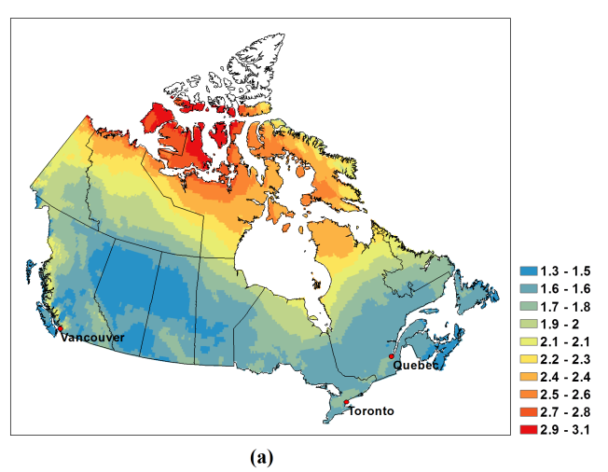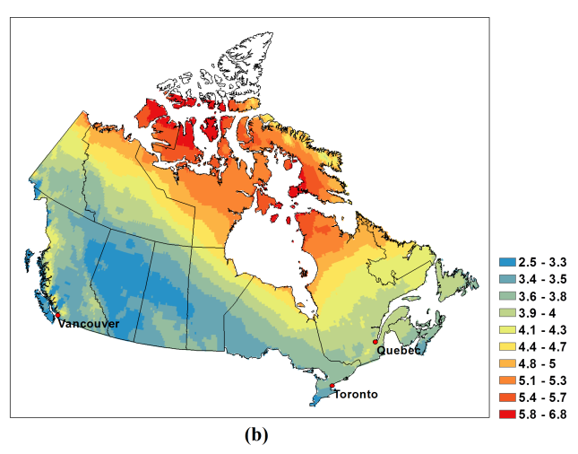

Figure 1: CanRCM4 results of annual average temperature anomalies $\left(C^{o}\right)$ across Canada under (a) RCP8.5 for 2017-2046 and (b) 2047-2076 relative to the period of 1987-2016

The fine spatial resolution of this model ($\sim 25 km$) can also help in gaining a better understanding of the local temperature changes in various locations across Canada. Three locations are selected to illustrate the impact on service life across Canada: Vancouver, Toronto, and Québec City. For these three locations, the annual average temperatures, estimated from the CanRCM4 output, are presented in Table 1. The annual average temperatures are predicted to rise in the next 30 years by 1.3, 1.7, and 1.7 °C, respectively, for the three cities. An average temperature rise of 1.5 °C will be used to illustrate the impact of climate change on design service life in these locations with their respective reference historical average annual temperatures in the period of 1987-2016.

Table 1: CanRCM4 results under RCP8.5 for annual average temperature over two 30-year periods

|  |  |  |  |
| --- | --- | --- | --- |
|  | (1987-2016) | (2017-2046) | Increased by |
| Vancouver | 10.1 °C | 11.4 °C | 1.3 °C |
| Toronto | 9.7°C | 11.4°C | 1.7 °C |
| Québec City | 6.3°C | 8.0°C | 1.7 °C |

## Temperature Effect on Chloride Diffusion Coefficient

The ingress of chloride ions from the external environment is greatly influenced by a range of concrete characteristics, particularly water/cementitious materials (w/c) ratio, the type of cement and the concrete microstructure, and has been the subject of many studies. Dhir et al. (1992) conducted a thorough experimental investigation on various strength grades of concrete under five exposure temperatures from 5 °C to 45 °C. The temperature was shown to have a significant impact on the chloride diffusion in concrete, and the data extracted from their work are re-analyzed in this paper and presented in Table 2.

Table 2: Chloride diffusion coefficient with temperature (10-9cm2/s, raw data from Dhir et al. 1992)

|  |  |  |  |
| --- | --- | --- | --- |
|  | Concrete of three grades | | |
| Temperature (°C) | 20 MPa | 40 MPa | 60 MPa |
| 5 | 36.2 | 10.6 | 3.6 |
| 10 | 52.4 | 15.1 | 5.0 |
| 20 | 82.7 | 27.9 | 10.8 |
| 35 | 140.0 | 52.5 | 23.7 |
| 45 | 224.0 | 96.8 | 45.6 |
| Ea-D regressed | 30.5 KJ/mol | 38.8 KJ/mol | 46.9 KJ/mol |
| R-squared | 0.9887 | 0.995 | 0.9971 |

Assuming that the chloride diffusion coefficient (*D*) changes with temperature following the Arrhenius law (Saetta et al. 1993), the activation energy of each concrete grade is obtained through regression (Table 2). The activation energy (Ea-D) are 30.5, 38.8, and 46.9 kJ/mol for concretes with 28-day compressive strengths of 20, 40, 60 MPa, respectively. It thus can be expected that the temperature change affects HPC (e.g. 60 MPa concrete with lower concrete diffusivity) more than OPC. Eq. 2 shows the chloride diffusion coefficient value (*DT* ):

[2] $D_{T}=D_{T0}e^{\frac{E_{a-D}}{R}(\frac{1}{T0+273.16}-\frac{1}{T+273.16})}$

where $D_{T}$ is a function of temperature T (°C) and the reference *DT0*at reference temperature T0 °C, with R being the gas constant (R=8.314x10-3 kJ/mol).

## Temperature Effect on Chloride Threshold Value

Corrosion is an electrochemical process in which temperature has a direct effect on the oxidation and reduction rates; however, there is no explicit study of temperature effect on chloride threshold value of carbon steel rebars. For stainless steel in concrete, Gastaldi and Bertolini (2014) found that the chloride threshold values of austenitic stainless steel 316 LN and SS 304LN can drop by more than 3 times when temperature rises from 20°C to 60°C. Assuming the corrosion rate follows the Arrhenius’ law, the chloride threshold value can be assumed to be inversely proportional to the corrosion reaction rates and follows inversely the Arrhenius law with temperature. From the very limited data, the activation energy (ECl-steel ) can be estimated to be 22 KJ/mol.

Temperature can also affect the chloride threshold values in a different way through concrete chemistry. A higher temperature induces more free chloride ions into the concrete pore solutions while the total chloride content (acid soluble) at the rebar level remains constant. Hussain et al. (1995) investigated the temperature effect on the ratio of free Cl- concentration to OH- (Cl-/OH- ratio) in the concrete pore solutions when the total chlorides content in concrete was kept a constant percentage. It was found that a rising temperature increases Cl-/OH- ratio in the pore solutions significantly, which becomes 5 times higher as temperature rises from 20 °C to 70 °C. A rising temperature reduces OH- concentration but increases Cl- concentration as a result of decomposition of calcium chloroaluminate and other compounds with which the chlorides are bound. The study concludes that the chloride threshold, when it is expressed as the total chlorides in concrete (as also used in Eq.1), will be then decreased at least 5 times with temperature rise from 20 °C to 70 °C. Assuming the increase of free Cl-/OH- ratio with temperature due to increase of chemical decomposition of calcium chloroaluminate and other compounds follows the Arrhenius law, the chloride threshold value in concrete is then inversely related to the rate of the released of free Cl- into concrete, and the activation energy for release of free chlorides (ECl-concr) was estimated to be 26 kJ/mol based on the limited experimental data.

Therefore, with a rising temperature the chloride threshold value is reduced by further release of chloride ions, and at same time by accelerated corrosion reactions. These two mechanisms are assumed independent of each other, and the chloride threshold values with temperature (Cth-T) is thus expressed as follows:

[3] $C_{th-T}=C_{th-T_{0}}e^{\frac{{(E}_{Cl-concr}+E_{Cl-steel})}{R}(\frac{1}{T+273.16} -\frac{1}{{ T}_{0}+273.16})}$

where (Cth-T0) is the reference value at the reference temperature T0.

As noted above, the analysis is based on the assumption that the chloride threshold value of rebar decreases with temperature following the inverse of the Arrhenius law based on very limited study, and the activation energy value can range from 22 to 48 KJ/mol depending on the mechanisms. More fundamental investigation is required to understand the temperature dependence of the chloride resistance of rebars in concrete for more accurate service life design and prediction in a changing climate.

# IMPACT ON DESIGN SERVICE LIFE

## Change in Chloride Diffusion Coefficient and Chloride Threshold Value

The increase in the chloride diffusion coefficient *ΔDT* with the temperature rise (ΔT) depends on both the reference temperature T0 and the grade of concrete as shown in Eq.2. From the data in Table 2, *D* is considered to be 1012 m2/s for HPC and 8*1012 m2/s for OPC and with the respective activation energy estimated to be 30 and 47 KJ/mol. Using T0= 10.1 °C, 9.7 C, and 6.3 °C, respectively, that represent the annual average temperatures of Canadian cities of Vancouver, Toronto and Québec City in the past 30 years, Figure 2 (left) illustrates the relative increase of chloride diffusion for both OPC and HPC with a temperature change of up to 6°C. It shows that within 6°C, their correlations are close to be linear, and differences from the three reference temperatures are shown to be less than 1% with this range of temperature change. The change in *D* can be regressed to be a linear function of temperature rise as follows:

[4] $\frac{∆D_{T}}{D_{T0}}=a∆T, where a=\left\{{}_{=0.0845 (\frac{1}{℃})for HPC of 60 Mpa }^{=0.0506(\frac{1}{℃}) for OPC of 20 Mpa }{ for }\right. 0<∆T<6℃, 6<T0<11 ℃$

Under RCP 8.5 scenario for the next 30 years between 2017-2046, the annual average temperature across Canada rise can range from 1.3 to 3.1 °C higher from the last 30 years, and it will increase the concrete diffusivity proportionally. This alone will reduce the time to corrosion initiation by 6 - 14% for OPC decks and 10-21% for HPC decks as calculated by Eq.1, if designed on the basis of historical temperature data from 1987 to 2016.

For different reference temperature T0, Figure 2 (right) illustrates the relative decrease of chloride threshold values as a function of temperature rise $∆T$ up to 6 °C by Eq. 3. A lower reference temperature means a higher impact on the change, but the differences from the three reference temperatures from 6 to 11 $℃$ are shown to be less than 1%. When $∆T$ is less than $6℃$, and the decrease of *Cth-T0* can be estimated as a linear function of the temperature rise as follows for E=48 kJ/mol:

$\left[5\right] \frac{∆C_{th}}{C_{th-T0}}=-β∆T, where β=0.0617 for 0<∆T<6℃, 6<T0 <11 ℃$

From Eq. 5, an annual average temperature rise of 1.3-3.1 °C in the next 30 years may decrease a rebar’s expected chloride threshold value by 8-19%. Note that the service life design by Eq.1 is for scenarios of *Cth/Cs* ratio being lower than one, i.e. a rebar’s chloride threshold value less than the surface chloride con**c**entration. Consider only a change in Cth in Eq.1; the impact on service life *Ti*is not a constant but a function of *Cth/Cs* ratio as shown in Figure 3.

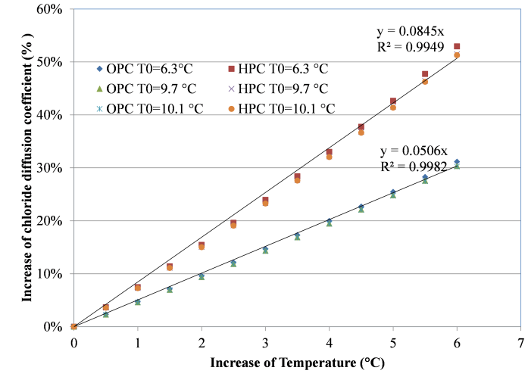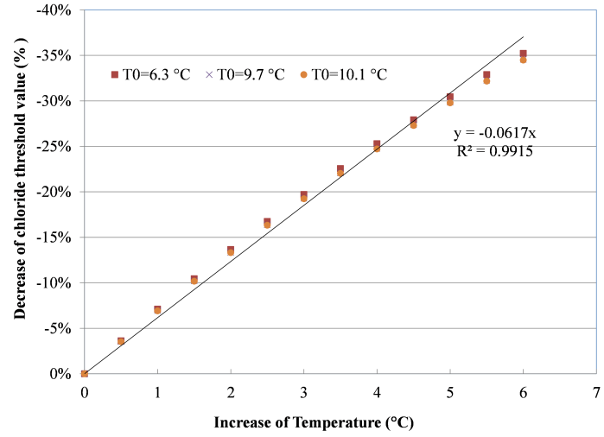

Figure 2: Chloride diffusion coefficient (left) and chloride threshold value (right) with temperature rise

A practical range of *Cth/Cs* ratio between 0.25 and 0.69 is studied for service life *Ti* designed from 15 to 75 years, including the 30 years of design service life used in this study. The range covers the use of OPC and HPC with the concrete cover depth of 50 mm following normal practice; for example, when using an HPC with *D* of 10-12 m2/s, the *Cth/Cs* ratio can be as low as 0.25 for a *Ti* of 30 years, and when using an OPC with *D* of 8*10-12 m2/s, the *Cth/Cs* ratio should be at least 0.69, based on four different exposure conditions (Zhang and Lounis 2009).

As the *Cth/Cs* ratio increases from 0.25 to 0.69, Figure 3 shows that the design service life is reduced significantly. When the *Cth/Cs* ratio is 0.25, the reduction of *Ti* is about 8-19%, but when it is close to 0.69 the reduction of *Ti* is as high as 30-50%. A design of *Ti*=30 years using OPC can be achieved by using carbon steel under a light exposure to de-icing salts with the *Cth/Cs* ratio being 0.69, or using stainless steel under a severe exposure. In such circumstances, a slight variation in the chloride threshold value such as by climate change will result in a significant change in the design service life. It should be noted that a design with a higher *Cth/Cs* ratio is still more desirable as it leads to a longer service life, which on the other hand will be more sensitive to the temperature change.

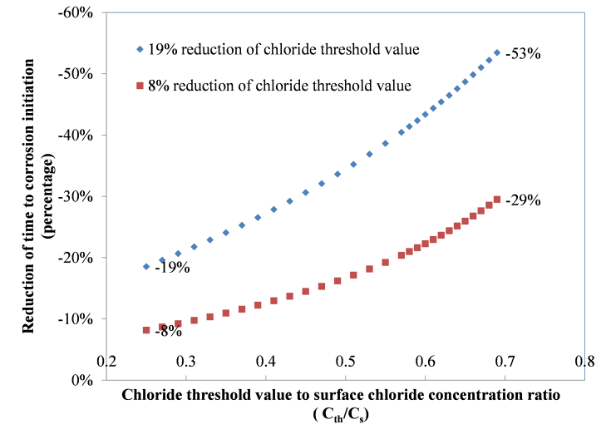

Figure 3: Reduction of time to corrosion initiation with design parameters of C*th*/Cs

## Change in Time to Corrosion Initiation

The above have illustrated that annual average temperature rise predicted for the next 30 years will increase the chloride diffusion coefficient *D* (Eq.4) and decrease the chloride threshold value *Cth* (Eq.5) both linearly for a temperature rise within 6 °C, and both lead to a reduction in the design service life *Ti* as discussed above. This section examines the reduction of design service life by both parameters under climate change, and more discussions are focused on a temperature rise of 1.5°C. Due to the high nonlinearity of *Ti* vs. *Cth/Cs* ratio, in this section three scenarios of design service life *Ti* targeted at 30 years are examined by using two different *Cth/Cs*, two different concretes. Different *Cth/Cs* ratios are from using different steel types under four different exposure conditions (Zhang and Lounis 2006).

1. Case1: design parameters: *Cth/Cs*=0.29, HPC with *D*=10-12 m2/s, *d*c=50 mm; an example of using carbon steel under Light Chlorides Exposure.
2. Case 2: design parameters: *Cth/Cs*=0.29, HPC with *D*=10-12 m2/s, *d*c=50 mm; an example of using galvanized steel under Moderate Chlorides Exposure.
3. Case 3: design parameters: *Cth/Cs*=0.70, OPC owith *D*=8*10-12 m2/s, *d*c=50 mm; an example of using stainless steel SS304 rebar under Severe Chlorides Exposure.

Case 1 and Case 2 use the same HPC and same *Cth/Cs* ratio, but galvanized steel in Case 2 intends to be used in an environment with more chlorides considering its chloride threshold values is 2 to 2.5 times higher than carbon steel in Case 1. Case 3 uses stainless steel SS304 in a severe environment due to its high chloride threshold value and OPC that meets the required design life *Ti* of 30 years. The reduction in the service life with a rise of annual average temperature is presented in Figure 4. It shows that the higher the *Cth/Cs* ratio, the greater the impact is on service life from the temperature rise. For an annual average temperature rise of 1.5 °C, a design service life of about 30 years could drop by 21% in Case 1 and Case 2, and as high as 39% for Case 3. Among the three scenarios, the greatest impact is on Case 3 which uses SS304 rebar under severe exposure, even though it uses OPC which is less influenced by temperature rise than HPC used in Case 1 and Case 2.

As the chloride threshold value of rebar is getting close to the surface chloride content of a bridge deck, the higher the impact on service life reduction would be expected by a temperature rise. It implies that between the two approaches of achieving the same design service life, either by using a rebar of greater chloride resistance in OPC or using a rebar of less chloride resistance but HPC, the former using OPC will be affected much more by a temperate rise. Therefore, for same service life design under the same exposure conditions, an HPC could be preferred in the design to reduce the impact of climate change. However, the final selection of the design option should be based on a life cycle costs analysis of all options and select the option with the lowest life cycle costs in a given planning horizon.

In the above cases, the activation energy (E=48 kJ/mol) is used in Eq. 3 to estimate the chloride threshold value reduction with temperature; the sensitivity to this value is thus analyzed and also illustrated in Figure 4 for Case 3 as well but with E=24 kJ/mol. For example, for a rise of 1.5 °C, the design service life could drop by 39% if ECth=48 kJ/mol and by 27% if ECth =24 kJ/mol. Clearly, this fundamental chloride resistance of rebar with temperature change needs to be studied in order to incorporate the temperature effect on design service life, as well as for more accurate service life assessment in a changing climate.

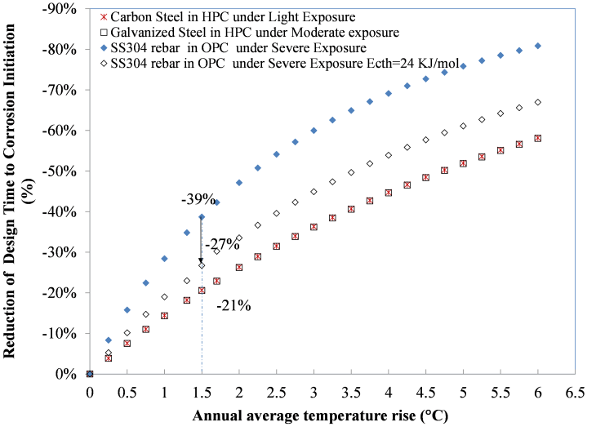

Figure 4: Decrease of time to corrosion initiation with annual average temperature rise

## SUMMARY AND DISCUSSION

This paper presented a study of design service life based on the temperature data of the past 30 years (1987-2016) that could be reduced significantly by using the temperature data of next 30 years (2017-2046) predicted by the Canadian regional climate model of CanRCM4. The chloride diffusion coefficients of concrete of three 28-day compressive strength grades were found to follow the Arrhenius’ law. It increases linearly with temperature rise within 6 °C, but increases much more significantly in HPC than in OPC. This alone will reduce the time to corrosion initiation by 6- 14% for OPC decks and 10-21% for HPC decks, if designed by on the basis historical temperature data of the last 30 years. The chloride threshold value (*Cth*) could decrease proportionally with temperature rise within 6 °C, assuming it follows the inverse of Arrhenius’ law, and this linearity depends greatly on the value of activation energy that is less known. An annual average temperature rise of 1.3-3.1 °C may decrease a rebar’s expected chloride threshold value by 8-19%.

The impact of climate change on a design service life of 30 years was illustrated by three design scenarios of using two different *Cth/Cs*, two different concretes of OPC and HPC, and three types of rebars, under three different exposure conditions. It shows that achieving the same design service life, either by using a rebar of greater chloride resistance in OPC or using a rebar of less chloride resistance but in HPC, the service life of the former a will be affected much more than the latter, 21% versus 39%, by a temperate rise of 1.5°C. Therefore, for same service life under the same exposure conditions, HPC could be preferred in the design to reduce the impact of climate change. A final selection requires a detailed life cycle costs analysis. A sensitivity study showed that the activation energy for chloride threshold value has a significant impact on the level of reduction of the design service life due to a temperature rise. The fundamental dependence of materials and corrosion properties on temperature needs to studied and understood better in order to incorporate the temperature effect on design service life, as well as for more accurate service life prediction in a changing climate.

## Acknowledgements

The authors acknowledge the financial support of Infrastructure Canada to the Climate-Resilient Buildings and Core Public Infrastructure Project.

## References

Andrade C., Alonso C., and Sarria, J. 2002. Corrosion rate evolution in concrete structures exposed to the atmosphere. *Cement and Concrete Composite*, 24: 55-64.

Bastidas-Arteaga. E., Schoefs, F., Stewart, M.G., Wang, X.M. 2013. Influence of global warming on durability of corroding RC structures: A probabilistic approach. *Engineering Structures*, 51:259–266.

Dhir, R.K., Jones, M.R. and Elghaly, A.E. 1992. PFA concrete: exposure temperature effects on chloride diffusion*. Cement and Concrete Research*, 23:1105-1114.

Gastaldi, M. and Bertolini, L. 2014. Effect of temperature on the corrosion behavior of low-nickel duplex stainless bar in concrete. *Cement and Concrete Research*,56: 52-60.

IPCC Climate Change 2014. Synthesis Report. Contribution of Working Groups I, II and III to the Fifth Assessment Report of the Intergovernmental Panel on Climate Change. IPCC, Geneva, Switzerland.

Mekis, É. and Vincent, L.A. 2011. An overview of the second generation adjusted daily precipitation dataset for trend analysis in Canada. *Atmosphere-Ocean*, 49 (2): 163-177.

Nilsson LO. 2002. Long-term moisture transport in high performance concrete. *Materials and Structures,* 35:641–9.

Peng, J. and Stewart, M.G. 2008. Carbonation-induced corrosion damage and structural safety for concrete structures under enhanced greenhouse conditions. Centre for Infrastructure Performance and Reliability Research Report No. 270.11.2008.

Peng, J. and Stewart, M.G. 2009. Climate change, deterioration and time-dependent reliability of concrete structures. *Futures in Mechanics of Structures and Materials*, London.

Peters, G. P., Andrew, R. M., Boden, T., Canadell, J. G., Ciais, P., Le Quéré, C. and Wilson, C. 2012. The challenge to keep global warming below 2 C. *Nature Climate Change*, *3*(1), 4.

Ryu, D.W., Jeong-Won Ko, J.W. and Noguchi T. 2011. Effects of simulated environmental conditions on the internal relative humidity and relative moisture content distribution of exposed concrete. *Cement and Concrete Composites*,33:142–153.

Saetta, A.V.,Scotta, R.V., and Vitaliani, R.V. 1993. Analysis of chloride diffusion into partially saturated concrete. *ACI Materials Journal*, 90(5), 441-451.

Scinocca, J.F., Kharin, V.V., Jiao, Y., Qian, M.W., Lazare, M., Solheim, L., Flato, G.M., Biner, S., Desgagne, M. and Dugas, B. 2016. Coordinated global and regional climate modeling. *Journal of Climate,* 29 (1): 17-35.

Stewart, M.G., Wang, X.M., and Nguyen, M.N. 2012. Climate change adaptation for corrosion control of concrete infrastructure deterioration. *Structure Safety,* 35: 29-39.

Tuutti, K. (1982). Corrosion of steel in concrete, CBI Research Report 4:82, Swedish Cement and Concrete Research Institute, Stockholm.

Van Vuuren, D. P., J. Edmonds, M. Kainuma, K., Riahi, A. Thomson, K. Hibbard, G. C. Hurtt, T. Kram, V. Krey, J.-F. Lamarque, et al. 2011. The representative concentration pathways: an overview. *Climatic Change*, 109(1-2): 5–31.

Wang, X., Nguyen, M., Stewart, M.G., Syme, M. and Leitch, A. 2010a. Analysis of Climate Change Impacts on the Deterioration of Concrete Infrastructure – Part 1: Mechanism, Practices, Modelling and Simulations. Published by CSIRO, Canberra, Australia.

Wang, X., Nguyen, M., Stewart, M.G., Syme, M. and Leitch, A. 2010b. Analysis of Climate Change Impacts on the Deterioration of Concrete Infrastructure – Part 3: Case Studies of Concrete Deterioration and Adaptation. Published by CSIRO, Canberra, Australia.

Weyers, R. E., Prowell B. D., and Sprinkel, M. M. 1993. Concrete Bridge protection, repair, and rehabilitation relative to reinforcement corrosion: a methods application manual, SHRP-S-360.

[Zhang](javascript:visitAuthor(%22J_Zhang%22)), J. and [Lounis](javascript:visitAuthor(%22Z_Lounis%22)), Z. 2006. Sensitivity study of control parameters for onset of corrosion induced by chloride diffusion. *Cement and Concrete Research*, 36: 1312-1323.

[Zhang](javascript:visitAuthor(%22J_Zhang%22)), J. and [Lounis](javascript:visitAuthor(%22Z_Lounis%22)), Z. 2009. Nonlinear relationships and relative sensitivities of service life parameters of concrete structures exposed to chlorides. *Cement and Concrete Composites*, 31:591-600.