|  |  |
| --- | --- |
| Building Tomorrow’s Society  *Bâtir la Société de Demain* | csce_logo |
| Fredericton, Canada  June 13 – June 16, 2018/ *Juin 13 – Juin 16, 2018* |

**DURABILITY OF ADVANCED CEMENT-BASED MATERIALS USED AS REPAIRS FOR DETERIORATED CONCRETE**

Tahmureszadeh, Keikhosrow1,3, Shehata, Medhat2

1 Ryerson University, Canada

2 Ryerson University, Canada

3 [ktahmure@ryerson.ca](mailto:ktahmure@ryerson.ca) (corresponding author email)

**Abstract:** With advanced technology and knowledge in the concrete industry, production of strong and durable construction material becomes more feasible. However, use of such materials as repairs on top of existing concrete (substrate) is challenging. There are limited research on the durability and sustainability of bond strength under cycles of freezing and thawing in the presence of de-icing salt. Hence, this research is designed to evaluate and compare the bond strength of two repair materials – commercial specialized repair material with self-consolidating properties (SRM) and normal conventional concrete (NC) – casted on top of NC substrate. In order to achieve this objective, the study adopts three different evaluating test methods (pull-off, slant shear, and splitting tensile) with different surface texture (rough and smooth) through four cycles of freezing and thawing with de-icing salt (0, 5, 15, 25). The results showed that although the bond strength for SRM initiated at the higher value for all the evaluating tests, its value started to decline significantly compared to the NC under the effect of freezing and thawing in the presence of de-icing salt. Running statistical T-test analysis demonstrated that the difference between rough and smooth surface is statistically significant with the rough surface showing higher bond strength in all.

# Introduction

Many aged concrete buildings and infrastructures in North America are suffering severe deterioration due to external causes like aggressive environmental exposure. These types of structures are in high demand for sustainable and long-lasting repair materials. Nowadays, with advanced technology, production of strong and durable construction material becomes more feasible. Therefore, there is more motivation in the industry to replace the normal conventional concrete (NC) with new advanced cement-based materials although NC for several decades was the primary selection for restoration of deteriorated structures. The main reason behind this motivation is that NC did not perform satisfactorily in some conditions mainly due to its pores structure such as harsh environmental exposure – e.g. freezing and thawing cycles with or without de-icing salt (Cai and Liu 1998; Hanjari, Utgenannt, and Lundgren 2011). However, the use of advanced cement-based materials as repair on top of existing deteriorated concrete (substrate) is challenging, since repair relies not only on the quality of the material but also on the interaction and compatibility of such material with the substrate. Various factors directly influence the behaviour of bond interface strength between repair product and substrate such as material characteristics of repair products, substrate surface texture, the moisture content of substrate at the time of applying repair, type of stress acting on the bond interface, and the conditions of specimens.

Mechanical, chemical, electromechanical, and permeability characteristics of the new advanced cement-based material (repair overlay) compare to the old concrete (substrate) are significantly essential in the selection of repair. Properties such as level of alkalinity, electrical resistivity, compressive and tensile strength, compressive strength, modulus of elasticity and rupture, drying shrinkage, thermal movement, creep, etc., directly affect the behaviour of repair products and the bond interface strength between repair and substrate (Emmons, Vaysburd, and McDonald 1993).

Substrate preparation in terms of surface texture, moisture content, and deterioration conditions before and at the time of applying repair is another major factor that directly influences the bond interface strength and durability of repair product. Increasing the substrate surface texture up to certain degree was proven by most of the researchers that have a direct positive impact on improving the bond interface performance. This bond strength enhancement is mainly due to increasing the mechanical interlock, enlarging the contact area of the repair product with a substrate, and providing the repair material with a higher amount of voids to penetrate and bond (Wang, Xu, and Liu 2016; Duarte, Nuno, and Santos 2011; Courad 2000). On the other hand, some researchers believe that the bond strength is not significantly affected by the surface roughness. They claim that preparation of substrate surface texture in most cases could damage the substrate and produce micro-cracks which reduce the bond performance overall (Lukovic et al. 2013).

The second significant parameter in the surface preparation is the moisture content of the substrate at the time of applying repair. Shin and Wan (2010) examined the bond performance of new and old concretes under two different substrate conditions: (i) dry and (ii) saturated surface dry (SSD). They concluded that substrate with SSD conditions produces almost twice bond strength compared to the substrate in dry condition. In the case of dry substrate, part of mixing water which was optimized for the repair mix will be taken by the substrate, reducing the level of hydration. On the other hand, wet substrate is not recommended for two main reasons: (a) the capillary voids are filled with water; therefore, the hydration products of repair materials will be significantly reduced at bond interface, and (b) the extra water available at the surface of substrate increases the water to cement ratio (W/C) of the adjacent repair products at bond interface, as a result reduce the bond strength (Austin and Robins 1995). In an effort to mimic field conditions, substrate conditioning in the laboratory is another important aspect of substrate preparation.

There are different types of tests available to measure the bond strength between repair and substrate. The tests are divided into three main categories based on the type of stress acting on the specimen by Saucier et al. (1991): (1) direct tensile stress (e.g., pull-off test), (2) indirect tensile stress such as splitting tensile method, and (3) combine shear and compression stress like slant shear method. It is important to mention that the results measured by each of these tests might be completely different from one to another due to the nature of acting force and geometry of samples (Momayez et al. 2005). It was reported by Momayez et al. (2005) that the slant shear and pull-off test provide the highest and lowest bond interface strength, respectively.

In the rehabilitation and repair of deteriorated concrete structures, the bond between the substrate (old concrete) and new repair is most of the time the weakest interface in the structure. Therefore, it requires a considerable attention and testing (Momayez et al. 2005). This paper aims to provide investigation and comparison on durability and sustainability of the bond interface behaviour of two different repair materials – commercial specialized repair material with self-consolidating properties (SRM) and normal conventional concrete (NC) – under freezing and thawing cycles in the presence of de-icing salt. The three different assessment testing methods explained above were adopted to better evaluate the bond interface strength between new and old concrete.

# Materials and Experimental Details

The experimental program was divided into two major phases: (I) mechanical characteristics, and (II) bond strength. Phase-I examines and compares the mechanical characteristics of two repair materials (SRM and NC) including compressive strength, and static modulus of elasticity to have a basic understanding of the repair products compatibility with their substrate. The second major phase (Phase-II) was designed to study the bond strength behaviour of repair materials with the substrate under cycles of freezing and thawing in the present of de-icing salt. This phase represents one of the main sources of deterioration in Canada which includes exposure to severe weather in winter seasons.

## Materials

### Concrete Substrate

Normal conventional concrete mix was selected for substrate with the class exposure of C2 (non-structurally reinforced concrete exposed to chloride and freeze-thaw cycles), nominal maximum size of coarse aggregate 20 mm crushed limestone, design slum of 75 mm, cement type GU (Table 3), W/C of 0.42, air category 1 (5-8% air entrainment), and minimum specified compressive strength of 32 MPa (CSA A23.1/CSA A23.2 2014).

### Repair Products

**Normal conventional concrete (NC):** The similar mix design used for substrate was implemented for this repair. The only change was through the nominal maximum size of coarse aggregate (NMSA) which was reduced from 20 mm to 16 mm. CSA 23.1 (2014) defines the allowable NMSA with certain limitation. As it was stated by the CSA 23.1 the NMSA should be less than one-third of the repair thickness. The thickness of repairs was selected to be 50 mm; therefore, 20 mm is higher than the limitation (one-third of 50 equals to 16.67). To avoid this problem, the aggregates passing sieve 16 mm were used. The aggregate properties and the mix proportions of concrete substrate and NC are summarized in Table 2Table 1, respectively. Table 3 lists the chemical composition of General Use Portland cement used in this study (GU PC).

**Commercial specialized repair material with self-consolidating properties (SRM):** the SRM was selected to have a comparison between the repair materials under research and available repair product in the market. The NMSA was reported by the commercial company as 10 mm.

Table 1: Aggregate properties

|  |  |  |  |  |  |  |  |  |  |  |  |
| --- | --- | --- | --- | --- | --- | --- | --- | --- | --- | --- | --- |
| **Mixture ID** | **Coarse Aggregate** | | | | |  | **Fine Aggregate** | | | | |
| **NMSA1 (mm)** | **Abs2 (%)** | **MC3 (%)** | **SG4 Dry** | **DRD5**  **(kg/m3)** |  | **NMSA (mm)** | **Abs (%)** | **MC (%)** | **SG Dry** | **FM6** |
| Substrate | 20 | 0.81 | 0.07 | 2.73 | 1623.54 |  | 5 | 1.30 | 0.25 | 2.54 | 2.8 |
| NC | 16 | 0.81 | 0.08 | 2.73 | 1581.82 |  | 5 | 1.30 | 0.28 | 2.54 | 2.8 |

1 Nominal Maximum Size of Aggregate – 2 Absorption – 3 Moisture Content – 4 Specific Gravity – 5 Dry Rodded Density – 6 Finesse Modulus

Table 2: Mix design properties (kg/m3)

|  |  |  |  |  |  |  |
| --- | --- | --- | --- | --- | --- | --- |
| **Mixture ID** | **W/C** | **Cement** | **Water** | **Coarse Aggregate** | **Fine Aggregate** | **Air1 (%)** |
| Substrate | 0.42 | 440 | 184 | 1023 | 584 | 7 |
| NC | 0.42 | 440 | 184 | 949 | 652 | 7 |

1 Air content, both mixtures were designed for 7%; however, the range of air content between 5 to 8% was accepted.

Table 3: Chemical properties of General Use Portland cement (GU PC)

|  |  |  |  |
| --- | --- | --- | --- |
| **Chemical Composition** | **(%)** | **Chemical Composition** | **(%)** |
| Calcium Oxide (CaO) | 62.39 | Sulfur Trioxide (SO3) | 4.03 |
| Silicon Dioxide (SiO2) | 19.54 | Free Lime | 1.33 |
| Aluminium Oxide (Al2O3) | 5.21 | Total Alkali (Na2O eq.) | 0.95 |
| Ferric Oxide (Fe2O3) | 2.16 | Loss on Ignition (LOI) | 2.36 |
| Magnesium Oxide (MgO) | 2.39 |  |  |

## Substrate Preparation

### Substrate Casting and Surface Texture

To evaluate the effect of surface roughness on the bond strength for slant shear and splitting tensile tests, two different surface textures – rough and smooth – were tested. To minimize the damage caused by surface texture preparation such as grinding, hammering, milling, sand-water blasting, wire-brushing, etc., samples were textured while they were fresh. In order to achieve this goal, special moulds were prepared as illustrated in Figure 1. Two different technics of surface preparation for fresh cylindrical specimens were implemented: (1) the surface of specimens were trowelled by a wooden float and broomed to slightly texture the substrate according to MTO LS-412 (1997). Figure 2a demonstrates the final surface fabrication of substrates which was classified as smooth texture. (2) For the rough texture, the specimens were not trowelled; So, some portion of cement coated coarse aggregates were left on the surface to provide extra roughness (Figure 2b). For the direct pull-off test, slab specimens (300 x 300 x 75 mm) with only smooth surface texture were used considering the insignificant impact of roughness under direct tensile force.

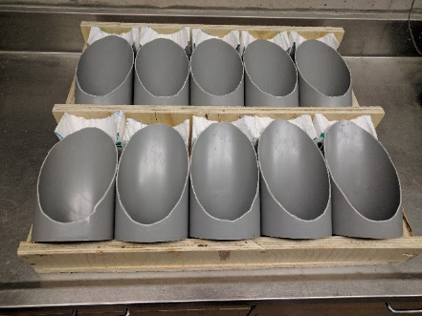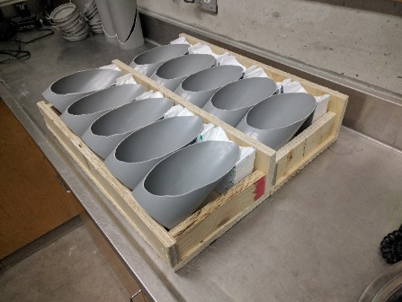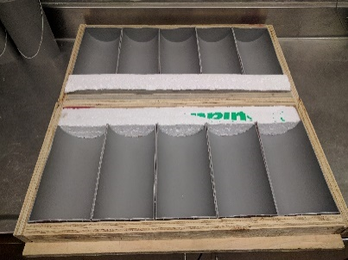

***(b)***

***(a)***

***(a)***

Figure 1: Substrate moulds preparation for surface texture (a) slant shear and (b) splitting tensile test

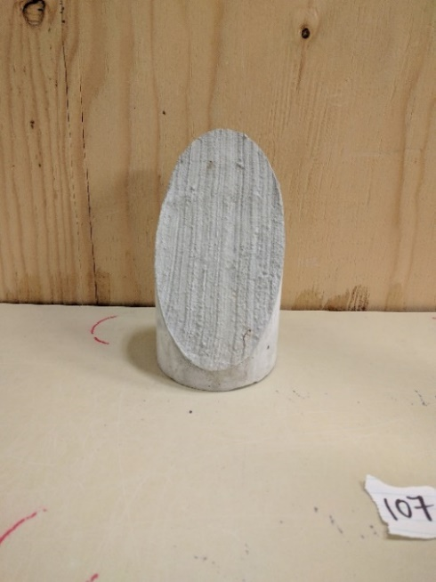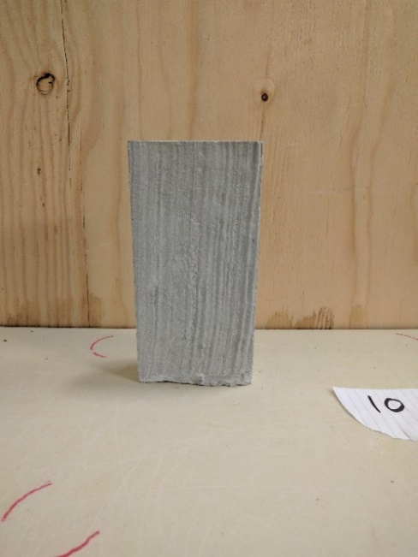 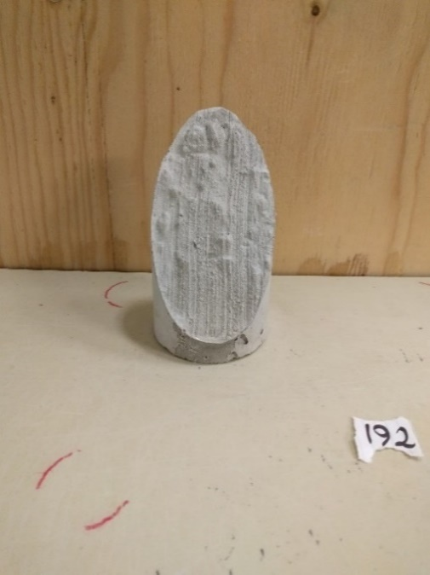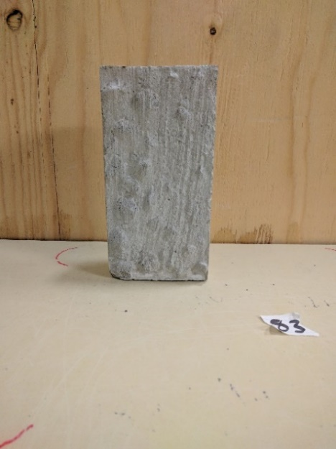

***(b)***

***(a)***

Figure 2: (a) Smooth and (b) rough surface texture for slant shear and splitting tensile tests

### Stabilizing the Substrate Shrinkage

Allowing the substrate to shrink in a laboratory is essential since deteriorated concrete (substrate) under service condition is usually experienced most of its shrinkage. Therefore, to better simulate the life condition of substrate and stabilize its shrinkage, substrate was casted with conventional concrete, stored in the moist curing room (RH>98%) for 14 days to gain its specified strength, then relocated to the shrinkage room (46%<RH<54% and 21⁰C<Temperature<25⁰C) for 2 months before applying repair materials. The condition of shrinkage room and rate of evaporation was checked as specified by CSA A23.2-21C (2014).

### Substrate Moisture Condition at the Time of Applying Repairs

During the casting of repair materials, it was decided to keep the substrate in SSD condition. Hence, the substrate was sprayed with water one day prior to casting and transferred to curing room. Finally, an hour before casting to make sure the substrate is in SSD condition, it was moved outside of curing room.

## Applying Repairs and Conditioning

After finishing the substrate preparation, repair products were casted on top of the substrate. Afterward, samples were kept in the moist curing room for 14 days to cure the repair materials. Immediately following, they stored in the shrinkage room for 2 months to allow repairs to shrink. Then the initial bond strength was evaluated on the specimens and named as a zero cycle of freezing and thawing. Next, it was followed by freezing and thawing cycles in the presence of 3% sodium chloride (NaCl) solution. The cylindrical samples were completely submerged in the salt solution while slab specimens were covered by 6 mm salt solution (Figure 4a) according to MTO LS-412 (1997). In order to ensure that the specimens experience complete cycles of freezing and thawing, the samples were stored in a freezer at -18 ± 2 ⁰C for 24 ± 2 hours and thawed at room temperature (23 ± 2 ⁰C) for another 24 ± 2 hours. At the end of thawing cycles, if any loss in solution due to evaporation was observed, the de-icing salt solution was added to ensure that samples are completely submerged. Finally, to evaluate the durability of repair products, the bond strength testing (slant shear, splitting tensile, and pull-off) was performed on the samples after 5, 15, and 25 cycles of freezing and thawing in the presence of de-icing salt.

## Mechanical Characteristics (Phase-I)

Compressive strength was measured following the method specified by ASTM C39 (2017). For each test, three standard cylindrical specimens were used and the average value was reported. The static modulus of elasticity was measured according to ASTM C469 (2014) using three cylindrical specimens (100 x 200 mm) with two longitudinal strain gauges at two sides of the cylinder with another transverse strain gauge at the middle of the specimen.

## Bond Strength under Cycles of Freezing and Thawing with De-icing Salt (Phase-II)

The bond strength was evaluated by three methods, namely: slant shear, splitting tensile, and pull-off test.

The slant shear test was performed per ASTM C882 (2013). Three cylindrical specimens (100 x 200 mm) at the loading rate of 0.25 ± 0.05 MPa/s were tested for each repair products (Figure 3a). The substrate bond interface in the slant shear test is prepared with a 60-degree angle from the horizontal line. According to the ASTM C882, slant shear strength is equal to applied force divided by slant bond interface area.

Splitting tensile method is the test used for measuring the indirect tensile strength of concrete as outlined in ASTM C496 (2011). The value calculated by this method is approximately 10 to 15 percent higher than the direct tensile strength (Mehta and Monteiro 2006). This test was carried out using standard cylindrical specimens (100 x 200 mm) at the loading rate of 0.7 to 1.4 MPa/min (Figure 3b).

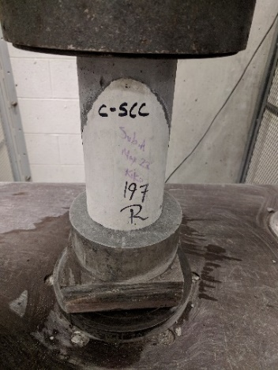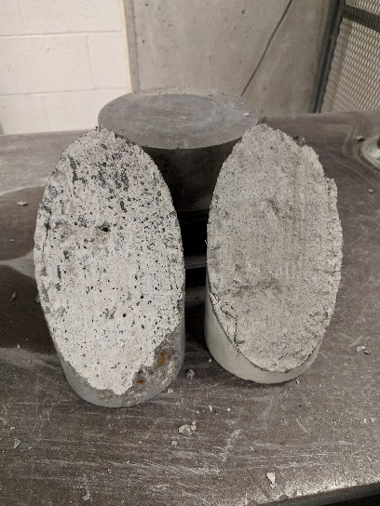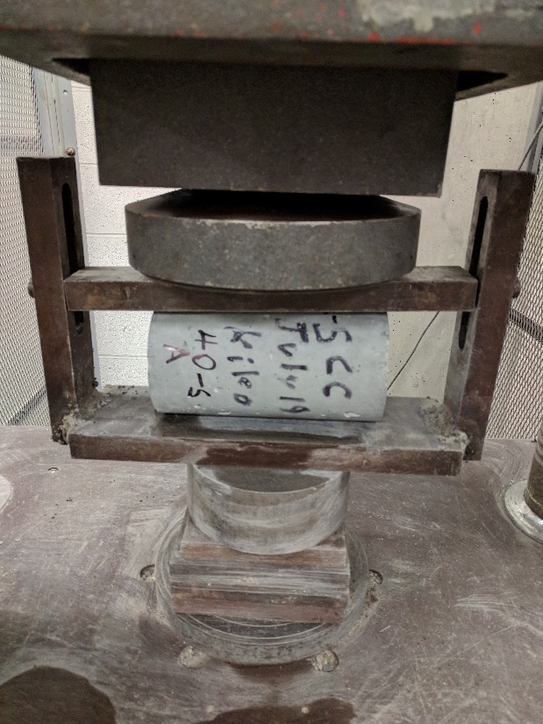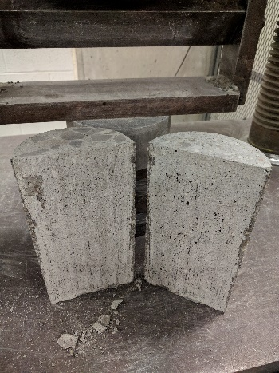

***(a)***

***(a)***

***(b)***

***(b)***

Figure 3: (a) Slant shear and (b) splitting tensile test

Pull-off test is a more practical test on site as a quality control tool. This test is appropriate for field and laboratory to measures the direct tensile strength of thin layer of overlay materials if the failure happens exactly at the bond interface (Bonaldo, Barros, and Lourenc-O 2005). Coring of repair material and part of the substrate prior to testing is one of the major disadvantages of the pull-off test. Excessive vibration of the coring machine, not placing it perpendicular to the surface of sample, size, and depth of coring can significantly affect the results. To eliminate the coring disadvantages and investigate the impact of the freezing and thawing cycles with de-icing salt at the bond interface, four small cylindrical repair specimens with a diameter of 75 mm and height of 50 mm were casted on top of slab substrate (Figure 4a). Slabs with repair samples were sealed with dense Styrofoam on each side (Figure 4a) to be able to condition them with the cycles of freezing and thawing in the presence of de-icing salt (Figure 4b). At the end of each cycle (0, 5, 15, and 25), the pull-off test was performed as specified by ASTM C1583 (2013).

**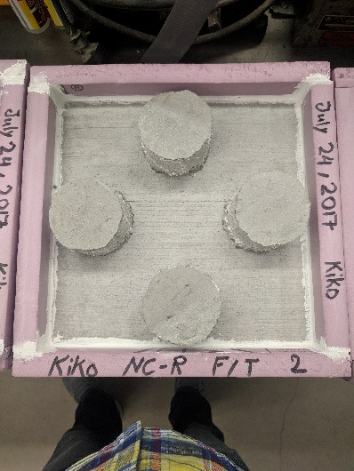**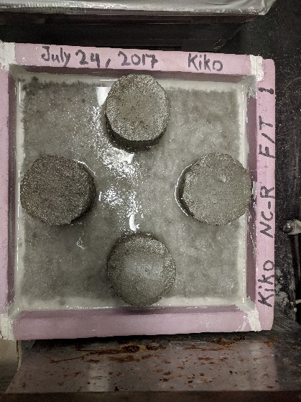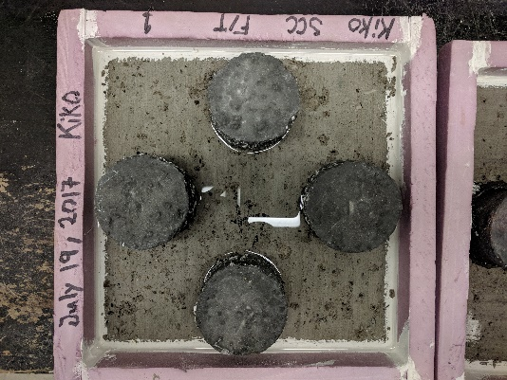 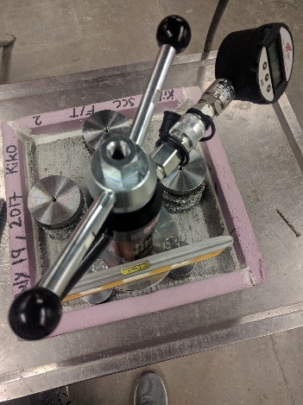

***(c)***

***(b)***

***(b)***

***(a)***

Figure 4: (a) Preparation, (b) conditioning of slab – freezing/thawing, and (c) testing the bond strength

# Results

## Mechanical Characteristics (Phase-I)

Figure 5a illustrates the difference between the SRM and NC in terms of compressive strength development. SRM was able to almost reach twice the strength of NC at each curing period. For both repair products, the compressive strength development almost stops increasing at 56 days of moist curing. Figure 5b shows that the SRM and NC have a very close stress-strain behaviour, particularly before failure. The static modulus of elasticity for SRM and NC were calculated and found to be 31.94 and 33.66 GPa, respectively. This close behaviour of these two materials in terms of static modulus of elasticity is mainly due to having coarse aggregates of similar properties.

Figure 5: (a) Compressive strength development and (b) modulus of elasticity (Phase-I)

## Bond Strength under Freezing and Thawing Cycles with De-icing Salt (Phase-II)

The results of slabs and cylindrical samples are summarized in Figure 6 for pull-off, slant shear, and splitting tensile test. Zero cycle of freezing and thawing in Figure 6 correspond to initial reading which was measured immediately after 14 days of moist curing and 56 days of being maintained in the shrinkage room.

According to Figure 6a, for the pull-off test, the NC had almost half the bond strength of that for SRM before exposure to cycles of freezing and thawing. With the cycles, however, the bond strength of SRM declined at the faster rate reaching half that of the NC at 15 cycles. For slant shear test (Figure 6b), the rough surface had the higher bond strength for both materials after any number of cycles. The reduction in the strength after freezing and thawing cycles occurred at the higher rate for SRM applied on the smooth surface. For splitting tensile test, rough and smooth, shown in Figure 6c and 6d, the rough surface demonstrated higher bond strength for both repair products. In addition, the degradation in strength of the SRM was higher than that of NC. Hence, NC in comparison to SRM showed better durability under the freezing and thawing cycles in the presence of de-icing salt although SRM started with higher initial bond strength measurement. In addition, since the change in the bond strength between SRM and NC appeared at faster rate for pull-off test (Figure 6a), and later for slant shear (Figure 6b), the testing methods can be arranged from high to low based on the effect of freezing and thawing cycles with de-icing salt on the bond strength as follow: (1) pull-off, (2) slant shear, and (3) splitting tensile test.

Figure 6: Test results of (a) pull-off, (b) slant shear, (c) splitting tensile rough, & (d) splitting tensile smooth

The stress loss (σL) was calculated as a percentage of bond strength measurement reduction at three different cycles of freezing and thawing (5, 15, and 25) in comparison to the initial bond strength (measured at zero cycles of freezing and thawing). The stress loss (σL) results listed in Tables 4 and 5 mathematically confirm the observation from the graphs for pull-off (Figure 6a) and slant shear test (Figure 6b). For instance, the stress loss for NC under pull-off test at 15 cycles was calculated to be much lower than SRM (47.1% compared to 90.1%) and similar behaviour was seen for slant shear test (rough and smooth) at 25 cycles of freezing and thawing which is another reason that NC performs better under higher cycles of freezing and thawing.

To demonstrate the effect of surface roughness on the bond strength, the stress improvement (σIm.) between rough and smooth surface was calculated for both slant shear and splitting tensile tests (Table 5). As it can be seen, the rough texture in all cases enhances the bond strength. The surface roughness effect is more significant at the higher cycles of freezing and thawing. For example, at 25 cycles the stress improvement for slant shear test was reported to be 323.5% and 210.3% for SRM and NC, respectively. By comparing the stress improvement between these two different tests, slant shear test is influenced more by the surface roughness in comparison to splitting tensile test. This significant difference between these two tests is mainly due to the nature of the acting load on the specimens.

For all the tests in this paper, the coefficient of variation (CV) between specimens within the samples was calculated and reported in Tables 4 and 5. The reported CVs for slant shear and splitting tensile tests were less than 11.5% and 16%, respectively which suggests a very close degree of variation between results. Moreover, all the calculated CVs for the pull-off test are reported to be less than 20%. The increasing value of the CVs between the slant shear, splitting tensile, and pull-off tests could be due to the different geometry, type of load, and human errors (Momayez et al. 2005). For the pull-off test, in particular, not being able to keep the applying load at the constant rate or properly aligning the instrument influence the range of results.

In addition to CV, the P-value (calculated probability) based on T-test between rough and smooth surface texture for the same evaluating test (slant shear or splitting tensile) and each cycle of freezing and thawing was calculated. Since the bond strength results after each cycle of freezing and thawing measured to be less than the initial reading, one tail and unpaired data were selected. According to the calculated P-value reported in Table 5, the slant shear and splitting tensile tests for both SRM and NC demonstrate the statistically significant difference between rough and smooth texture with 95% level of confident (α < 5%). The only exception was for SRM under splitting tensile during 5 and 15 cycles where non-statistically significant results were observed. This is mainly because of very close bond strength between rough and smooth texture for splitting tensile test particularly at 5 and 15 cycles of freezing and thawing (Figure 6a). The small stress improvement (σIm.) between the smooth and rough surface at these two cycles (1.9% and 5.4%) confirms this behavior.

Moreover, the P-value was calculated between two different materials (SRM and NC) for each method of testing and results are listed in Table 4. The results indicate that there is no statistically significant difference between repair products under the slant shear test for both rough and smooth texture. For pull-off test the results were significantly different except for cycle #15 and beyond. This indicates that the use of SRM over NC does not necessarily provide any advantages under higher cycles of freezing and thawing. However, splitting tensile tests showed the statistically significant difference between the two repair materials throughout the tested cycles (up to 25 cycles).

Table 4: Pull-off test results and statistical analysis between different repair products

|  |  |  |  |  |  |  |  |  |  |  |  |  |  |  |
| --- | --- | --- | --- | --- | --- | --- | --- | --- | --- | --- | --- | --- | --- | --- |
| **Cycles** | **Direct Tensile (Pull-off) Test** | | | | | | | |  | **P-Value**4 | | | | |
| **SRM** | | |  | **NC** | | | **P-Value**4 | **Slant Shear Test** | |  | **Splitting Test** | |
| **σL1 (%)** | **CV2 (%)** | **N3** |  | **σL1 (%)** | **CV2 (%)** | **N3** | **Rough Texture** | **Smooth Texture** |  | **Rough Texture** | **Smooth Texture** |
| **0** | 0.0 | 12.99 | 4 |  | 0.0 | 11.91 | 4 | 0.001 |  | 0.313 | 0.214 |  | 0.031 | 0.004 |
| **5** | 36.1 | 13.49 | 4 |  | 14.7 | 11.64 | 4 | 0.027 |  | 0.915 | 0.009 |  | 0.009 | 0.000 |
| **15** | 90.1 | 20.00 | 3\* |  | 47.1 | 10.41 | 3\* | 0.116 |  | 0.103 | 0.128 |  | 0.005 | 0.000 |
| **25** | 100.0 | n/a | 0\*\* |  | 100.0 | n/a | 0\*\* | n/a |  | 0.965 | 0.630 |  | 0.002 | 0.006 |

1 Stress Loss – 2 Coefficient of variation – 3 Number of tested samples – 4 P-value calculated by running T-test between SRM & NC

\* One samples failed before test & did not considered – \*\* All four samples failed before finishing the 25 cycles of freezing & thawing

Table 5: Results and statistical analysis of slant shear and splitting tensile tests

|  |  |  |  |  |  |  |  |  |  |  |  |  |  |  |  |  |
| --- | --- | --- | --- | --- | --- | --- | --- | --- | --- | --- | --- | --- | --- | --- | --- | --- |
| **Repairs** | **Cycles** | **Slant Shear Test**a | | | | | | |  | **Splitting Tensile Test**a | | | | | | |
| **Rough Texture** | |  | **Smooth Texture** | | **σIm.**1**(%)** | **P-Value**2 |  | **Rough Texture** | |  | **Smooth Texture** | | **σIm. (%)** | **P-Value** |
| **σL (%)** | **CV (%)** |  | **σL (%)** | **CV (%)** |  | **σL (%)** | **CV (%)** |  | **σL (%)** | **CV (%)** |
| **SRM** | **0** | 0.0 | 6.64 |  | 0.0 | 5.20 | 42.5 | 0.003 |  | 0.0 | 2.44 |  | 0.0 | 7.26 | 10.9 | 0.049 |
| **5** | 12.8 | 5.13 |  | 4.7 | 8.35 | 30.4 | 0.005 |  | 27.8 | 7.24 |  | 21.5 | 5.95 | 1.9 | 0.370 |
| **15** | 15.2 | 6.63 |  | 36.3 | 9.86 | 89.7 | 0.001 |  | 38.7 | 8.05 |  | 35.4 | 3.09 | 5.4 | 0.196 |
| **25** | 29.7 | 8.93 |  | 76.4 | 7.28 | 323.5 | 0.002 |  | 47.0 | 3.91 |  | 54.6 | 13.36 | 29.7 | 0.024 |
| **NC** | **0** | 0.0 | 1.97 |  | 0.0 | 11.29 | 52.6 | 0.006 |  | 0.0 | 10.61 |  | 0.0 | 10.34 | 39.5 | 0.012 |
| **5** | 9.0 | 8.81 |  | 23.7 | 9.96 | 81.4 | 0.002 |  | 32.7 | 4.99 |  | 46.7 | 8.69 | 76.3 | 0.000 |
| **15** | 19.8 | 5.34 |  | 40.5 | 4.07 | 105.2 | 0.001 |  | 51.3 | 9.97 |  | 53.3 | 6.65 | 45.6 | 0.009 |
| **25** | 26.4 | 8.38 |  | 45.9 | 13.65b | 210.3 | 0.022 |  | 54.2 | 8.07 |  | 59.7 | 2.96 | 58.6 | 0.006 |

1 Improvement between rough & smooth texture for the same test – 2 P-value calculated by running T-test between rough & smooth

a 3 samples were tested for each rough & smooth texture – b One of the smooth samples was failed before test & did not considered

# Conclusions

Based on the experimental program and the materials tested in this research, following conclusion are drawn:

1. Increasing the substrate surface roughness was proven to enhance the bond strength no matter the method of testing, type of repair materials, and cycles of freezing and thawing with de-icing salt. The improvement of substrate surface roughness on bond strength at higher cycles of freezing and thawing was found to be more significant.
2. The surface roughness effect (σIm.) on the slant shear test observed to be much higher than the splitting tensile test.
3. For both repair products, the minimum stress loss (σL) due to freezing and thawing cycles in the presence of de-icing salt was found for the slant shear test with the rough texture.
4. The impact of freezing and thawing cycles with de-icing salt determined to be more severe and critical on the pull-off test carried out here.
5. The NC was proven to perform better than SRM under higher cycles of freezing and thawing with de-icing salt under both pull-off and slant shear tests. However, the same behaviour was not concluded for splitting tensile test method. For this particular test, similar behaviour can be expected at higher cycles of freezing and thawing.
6. The P-value results comparing the rough and smooth texture under slant shear test for both repair products provide statistically significant difference with a level of confidence of 0.05.
7. The P-value results comparing two repairs for slant shear indicate no statistically significant difference. The same can be said for pull-off but only under higher cycles of freezing and thawing.

**Acknowledgment**

This research project is supported by the Natural Sciences and Engineering Research Council of Canada (NSERC) grant. The authors highly acknowledge the financial support of NSERC.

**References**

ASTM C1583. 2013. “Standard Test Method for Tensile Strength of Concrete Surfaces and the Bond Strength or Tensile Strength of Concrete Repair and Overlay Materials by Direct Tension (Pull-off Method).” *American Society for Testing and Materials*, 1–4. doi:10.1520/C1583\_C1583M-13.

ASTM C39. 2017. “Standard Test Method for Compressive Strength of Cylindrical Concrete Specimens.” *American Society for Testing and Materials*, 1–7. doi:10.1520/C0039.

ASTM C469. 2014. “Standard Test Method for Static Modulus of Elasticity and Poisson’s Ratio of Concrete in Compression.” *ASTM International*, 1–5. doi:10.1520/C0469.

ASTM C496. 2011. “C496/C496M-11. Standard Test Method for Splitting Tensile Strength of Cylindrical Concrete Specimens.” *American Society for Testing and Materials*, 1–5. doi:10.1520/C0496.

ASTM C882. 2013. “Standard Test Method for Bond Strength of Epoxy-Resin Systems Used With Concrete by Slant Shear.” *American Society for Testing and Materials*, 1–4. doi:10.1520/C0882.

Austin, Simon, and Peter Robins. 1995. “Tensile Bond Testing of Concrete Repairs.” *Materials and Structures* 28: 249–59. https://journals-scholarsportal-info.ezproxy.lib.ryerson.ca/pdf/13595997/v28i0005/249\_tbtocr.xml.

Bonaldo, Everaldo, Joaquim A O Barros, and Paulo B Lourenc-O. 2005. “Bond Characterization between Concrete Substrate and Repairing SFRC Using Pull-off Testing.” *International Journal of Adhesion & Adhesives* 25: 463–74. doi:10.1016/j.ijadhadh.2005.01.002.

Cai, H, and X Liu. 1998. “FREEZE-THAW DURABILITY OF CONCRETE: ICE FORMATION PROCESS IN PORES.” *Cement and Concrete Research* 28 (9): 1281–87. https://journals-scholarsportal-info.ezproxy.lib.ryerson.ca/pdf/00088846/v28i0009/1281\_fdocifpip.xml.

Courad, L. 2000. “Parametric Study for Creation of the Interface between Concrete and Repair Products.” *Materials and Structure* 33: 65–72. https://orbi.uliege.be//bitstream/2268/17611/1/Parametric study.pdf.

CSA A23.1/CSA A23.2. 2014. *A23.1-14 Concrete Materials and Methods of Concrete Construction / Test Methods and Standard Practices for Concrete*. Mississauga: CSA Group.

Duarte, Miguel, Eduardo Nuno, and Brito Santos. 2011. “Factors Affecting Bond between New and Old Concrete.” *ACI Materials Journal* 108 (August): 449–57.

Emmons, Peter H., Alexander M. Vaysburd, and James E. McDonald. 1993. “A Rational Approach to Durable Concrete Repairs.” *Concrete International* 15 (9): 40–45. http://imcyc.com/biblioteca/ArchivosPDF/Reparacion de Estructuras/4 A rational approach to durable concrete repair.pdf.

Hanjari, Kamyab Zandi, Peter Utgenannt, and Karin Lundgren. 2011. “Experimental Study of the Material and Bond Properties of Frost-Damaged Concrete.” *Cement and Concrete Research* 41: 244–54. doi:10.1016/j.cemconres.2010.11.007.

Lukovic, M., E. Schlangen, G. Ye, and B. Savija. 2013. “Impact of Surface Roughness Onthe Debonding Mechanism in Concrete Repairs.” *Proceedings of the 8th International Conference on Fracture Mechanics of Concrete and Concrete Structures, FraMCoS 2013*.

Mehta, P. Kumar, and Paulo J M Monteiro. 2006. *Concrete: Microstructure, Properties, and Materials*. *The McGraw-Hill Companies*. 3rd Editio. The McGraw-Hill Companies. doi:10.1036/0071462899.

Momayez, A., M. R. Ehsani, A. A. Ramezanianpour, and H. Rajaie. 2005. “Comparison of Methods for Evaluating Bond Strength between Concrete Substrate and Repair Materials.” *Cement and Concrete Research* 35 (4): 748–57. doi:10.1016/j.cemconres.2004.05.027.

MTO LS-412. 1997. “LS-412 Method of Test for Scaling Resistance of Concrete Surfaces Exposed to Deicing Chemicals.” *Ministry of Transportation, Ontario (MTO)*, no. 17: 5.

Saucier, F, J Bastien, M Pigeon, and M Fafard. 1991. “A COMBINED SHEAR-COMPRESSION DEVICE TO MEASURE CONCRETE-TO- CONCRETE BONDING.” *Experimental Techniques*, 50–55.

Shin, Hak-Chul, and Zhifu Wan. 2010. “Interfacial Properties between New and Old Concretes.” *Second International Conference on Sustainable Construction Materials and Technologies*.

Wang, Bing, Shilang Xu, and Fei Liu. 2016. “Evaluation of Tensile Bonding Strength between UHTCC Repair Materials and Concrete Substrate.” *Construction and Building Materials* 112. Elsevier Ltd: 595–606. doi:10.1016/j.conbuildmat.2016.02.149.